ALTMETRICS AND THE HUMANITIES
Nick Canty, UCL Centre for Publishing

Note: The author would like to thank Euan Adie & Natalia Madjarevic, Altmetrics, James Hardcastle, Taylor & Francis and ALSPS for their assistance and approval for the slides to be reproduced in this article.

Introduction

This article seeks to explain altmetrics (alternative metrics) to the Arts & Humanities communities. Altmetrics are non-traditional metrics that cover not just conventional citation counts but others methods such as downloads, social media shares and other measures of research impact such as inclusion of academic work in policy documents (Wilsdon et al 2015 : 5). Although the application of altmetrics started in the Sciences and had an initial focus on the journal article, recent technological developments among the providers of altmetric indicators and a widening of the scope of altmetrics to include books and book chapters makes this a subject with which researchers across A&H disciplines now need to engage. The presence of the multi-coloured donut ring seen alongside academic articles in university repositories and on journal articles is ubiquitous and the article explains what these symbols mean and how they are provided.
Peer review is the long-established and recognised method of judging academic quality that is used in the UK and around the world but the use of metrics is a newer approach that has gained ground in the last 20 years as a way of measuring research quality and impact (Wilsdon et al 2015 : 2). Research conducted within the arts and humanities differs from much of the research conducted in the sciences in that it is often published in books and other outputs which are harder to measure quantitatively (e.g. objects, films and ephemeral works) and as a consequence it is difficult to introduce quantitative metrics to work that is undertaken over a long period of time and is slow to develop and work that is often directed at a non-scholarly readership (Wilsdon et at 2015 : 55, British Academy, AHRC). This is particularly relevant where the impact of a work might be the size of the audience for a production or the reception of a work. Nevertheless, there is increasing pressure from funders and governmental bodies to evaluate the wider societal impacts and benefits of research as was reflected in REF2014 and altmetrics provide a means of assessing impact beyond the academy (Haustein 2016). Wider use of quantitative measures is part of a transition to a more open and transparent research system, although how best to use metrics in academic evaluations and management is of considerable debate.
This article outlines what altmetrics are and, how they work, their advantages and disadvantages and how they might be used in academic management and assessment exercises. Practical advice is suggested for researching wanting to learn more about altmetrics.
What are altmetrics?

From the mid-1990s as advances in technology created new ways for researchers to network and engage with each other and share and discuss their work, interest grew in using new indicators that were suited to electronic communication (Wilsdon et al 2015 : 13). As a result of web technologies expressions of scholarship were becoming more diverse as researchers sought to share datasets, codes and designs but at the same time there was no way to capture ‘nano-publication’ such as when the unit getting the attention was an argument or passage rather than the entire article, and there was widespread self-publishing through blogs. These initial alternative metrics which included web citations in digital scholarly documents such as blogs, eBooks and associated documents have been followed more recently by altmetrics from social media platforms. This includes social bookmarks, comments, shares and tweets among others about academic work. The term altmetrics is gaining ground as the catch-all term for all web-based metrics (Wilsdon et al 2015 : 13, 39). At their most simple, altmetrics track online attention to scholarly outputs across peer-reviews, news sites, policy documents, blogs, social media and online reference management tools like Mendeley and Citeulike (Hardcastle & Madjarevic 2016).

- Research output metrics - to find out how often an output, or a group of outputs, has been cited by others.
- Author metrics - to explore the impact of an author, or a group of authors, based on the citation rates of their outputs (includes h-index).
- Journal metrics - to assess the impact of a journal and to compare journals.
- Altmetrics - measures based on social web data rather than traditional citation counts

Table 1. The different types of metrics (Source: ucl.ac.uk)

The term altmetrics is attributed to Jason Priem who in 2010 as a doctoral student at the University of North Carolina at Chapel Hill, began investigating the social aspects of the web and the spread of scholarship online (Roemer and Borchardt 2015). Shortly afterwards Priem and colleagues launched their ‘altmetrics manifesto’ and defined altmetrics as ‘the creation and study of new metrics based on the Social Web for analysing, and informing scholarship (altmetrics.org). Writing in 2012 Priem et al (2012) refined his definition of altmetrics to ‘the study and use of scholarly impact measures based on activity in online tools and environments.

The 2015 HEFCE review of metrics in research assessment and management (also known as the Wilsdon report) acknowledges that definitions and terminology around assessment and metrics are difficult and contested. This is partly because there is an increasingly wide range of ways measuring quality and impact such as peer-review, citation counts or measures of impact such as research funding or student numbers (Wilsdon et al 2015 : 4). Furthermore what is metric in one environment may not be in another – citations are a metric count but they do not measure impact. The Wilsdon report defines altmetrics thus: ‘…non-traditional metrics that cover not just citation counts but also downloads, social media shares and other measures of research outputs’.

There is consequently no agreement beyond abstract terms on what constitutes an altmetric between authors, publishers and altmetric aggregators and there is further confusion around altmetrics and article level metrics (ALM) (Haustein 2016). As a result ‘altmetrics are indeed representing very different things’ (Lin & Fenner, 2013, p. 20). To bring some stability to this landscape and placing altmetrics in the wider spheres of informetrics, scientometrics and webometrics, Haustein (2016) defines scholarly metrics as ‘ indicators based on recorded events of acts (e.g., viewing, reading, saving, diffusing, mentioning, citing, reusing, modifying) related to scholarly documents (e.g., papers, books, blog posts, datasets, code) or scholarly agents (e.g., researchers, universities, funders, journals)’.

Publisher Sage describes them thus ‘Article metrics are an additional view into the impact a journal article is having among its community of readers. This alternate view is in addition to the already existing filters such as citation counting, the Impact Factor, and peer-review. Our new altmetrics display includes information on comments and shares made by readers via social media channels, blogs, newspapers, etc.’ (Sage).

[NISO - two-phase initiative to explore, identify, and advance standards and/or best practices related to a new suite of potential metrics in the community.]

The growth of altmetrics

The early work of Priem was founded on the belief that developments in information technology and scholarly communication offered new ways of measuring impact across the web for academics, libraries and publisher. Priem and colleagues were driven by a belief that the traditional filters deployed to measure scholarly output were failing. Early manual filters for ranking the quality of scholarly outputs, had by the mid-20th century begun to break under the volume of post-war scientific outputs until Eugene Garfield pioneered automated filters built around the judgements of scientists themselves which aggregated citations as “pellets of peer recognition.” (Priem et al 2012, Merton 1988).

The 2015 Wilsdon report is entitled The Metric Tide, a term that captures the ‘powerful currents’ driving the metric movement. These currents include the pressure for audit and evaluation of public spending in Higher Education, demands from policy makers for strategic intelligence on research quality and impact, the need for institutions to manage their research activities as they compete among each other and for prestige, staff and resources, and the availability of ‘big data’ on research uptake with tools to analyse data (Wilsdon et al2015 : 2). Funding bodies in the UK and elsewhere are examining the role of metrics and digital identifiers in funding bids and post-project evaluation.

As bibliometrics has developed so the range of evaluation systems and data providers has grown and those involved in the production of data indicators now includes government agencies, universities, research groups, publishers and consultants. Major publishers including Elsevier, Wiley, Springer and Nature Publishing Group have all added article-level altmetrics to their journals. The main altmetric data providers are Altmetric (part of Springer Science in the Macmillan group of companies), Plum Analytics (part of EBSCO). It is important to note that as part of large for-profit publishers, Altmetric and Plum Analytics have commercial interests in highlighting the value of altmetrics (Haustein 2016).

Perceived problems with existing evaluation methods

For advocates of new ways of measuring academic output the conventional processes have problems. Peer-review doesn’t hold reviewers to account and papers rejected in one journal would likely be published elsewhere and in so doing the process fails to halt the ever increasing quantity of scholarly publications. Citation measures were useful but slow and first citations make take years to accrue while influential work may never be cited and citations ignore the impact of scholarly work outside the academy. Citations only reflect formal acknowledgment and thus provide only a partial picture of the academic system while ignoring how scholars may discuss, annotate, recommend, refute, comment, read and teach a new finding before it ever appears in the formal citation registry (Priem et al 2012). Their last complaint was against the Journal Impact Factor (JIF) which while widely used, fails as it measures average citations per article but the JIF is incorrectly used to assess the impact of individual articles (altmetrics.org).

Further limitations with the existing metrics were observed, particularly with how the metrics can be gamed. Journals could achieve a higher impact factor by publishing short review pieces or controversial editorials, both of which could boost the JIF unfairly. One highly cited paper in a journal could alone increase the JIF, presenting a poor journal in a favourable light it might not deserve. Furthermore, pressure might be put on researchers not to publish the best papers for their discipline but to work towards publishing the best article in the journal with the highest JIF, to the benefit of the individual but to the detriment to the discipline as their best work may not find a home. The ten top ways the JIF can be manipulated in science journals can be found in Table 2.

1. Requiring revision of the manuscript references section and inclusion of articles published in the editor’s journal or affiliate journals
2. Publishing summaries of articles with relevant citations to them (usually in the form of “what was published in the journal last year”)
3. Inflating self-citation through editorials and readers’ comments on published articles
4. Publishing articles that add citations to the nominator but which are not counted as “citable”
5. Publishing a larger percentage of review articles over less-cited articles, including original research and, especially, case reports
6. Rejecting negative studies, regardless of their quality
7. Rejecting confirmatory studies
8. Favouring the acceptance of articles originating from large and scientifically active research groups as well as articles with a large number of authors
9. Attracting the work of renowned scientists and leaders of research regardless of the real quality 10. Publishing mainly popular science articles that deal with “hot” topics

Table 2. Top-ten in journal IF manipulations (Source: Falagas, Vangelis, Alexiou 2008)

Added to this was a sense that existing metrics had a narrow coverage, just capturing journal papers while being unable to cope with developing digital formats such as datasets, code, designs, videos, installations or instalments. The scope was also narrow as it failed to take account of the broader impact a scholarly output might have on the wider world through inclusion in policy documents or the attention it gathered on the social web. The metrics failed to empower readers, authors or editors as a consequence.

Who Provides Altmetric Data?

There are a number of companies that aggregate altmetric data and these are described below.

Altmetric (altmetric.com)

Altmetric.com is a data science company that tracks attention to research outputs delivering output level metrics via online tools (altmetric.com). The company was founded in by bioscience researcher Euan Adie who had previously worked on Postgenomic.com, an open source scientific blog aggregator founded in 2006. Adie won an Elsevier-sponsored competition for apps for science and the Altmetric was launched in 2012 and additional investment came from Digital Science, a division of Macmillan Science and Education
in the same year.

Altmetric.com devised the donut score which shows the attention around a paper, not its impact. The score reflects the ‘noise’ a paper is getting whether it is positive or negative.

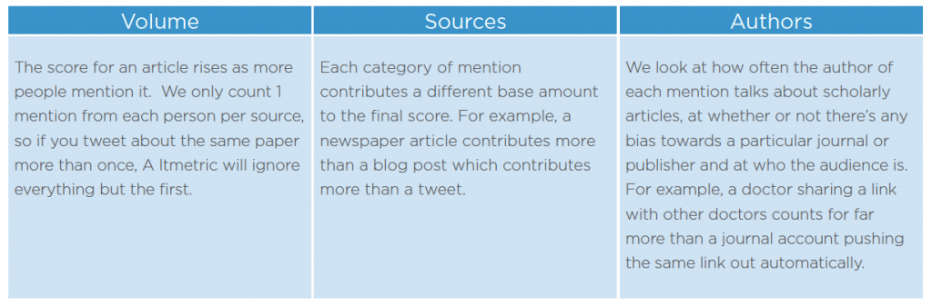Table 3. The factors on which the Altmetric score is calculated (Source: altmetric.com)

The donut score is subjective in that Altmetric decide the weighting given to sources where a paper or an academic output is discussed, e.g. a mention in New York Times would get a high rating. They also make subjective decisions to delete spam bots which generate attention around a paper on Twitter. These are deleted on the advice of Twitter but it is a manual judgement. However Altmetric is objective in that they show all the attention everywhere and they don’t remove negative comments (Adie 2016). The purpose of the donut score is to help people sift through a large number of articles and decide which ones to focus on. The score must be understood in the context of the research output and the discipline. The colours of the donut change to reflect the different sources where there has been attention to a research output. A predominately light blue donut indicates that most attention has been on Twitter for example.

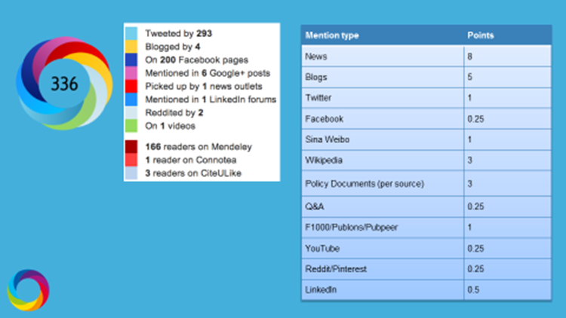

Figure 1. The significance of the donut colours.

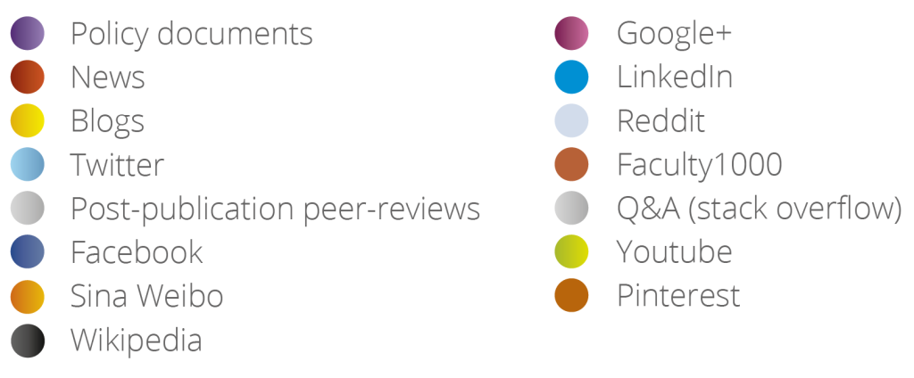

Figure 2. Colours of the Altmetric donut explained

Altmetric data is embedded in a number of academic databases and services including
Scopus, Science Direct, The Cochrane Library, Wiley Online Library, Highwire Press Journal, Springerlink Journals, Nature Journals (ucl.ac.uk). These sites display the donut next to articles.

The Altmetric embeddable badges can be embedded on researcher pages for those who wish to embed the donut badge on their websites. Instructions are given here:
https://www.altmetric.com/products/free-tools/

The Altmetric Explorer tool can be used to filter and browse through five million articles and see the attention each has gained and allows a comparison of the altmetrics performance of different journals.

Plum Analytics (plumanalystics.com)

Plum analytics was founded in 2012 with the aim of ‘modern ways of measuring research impact to individuals and organizations that use and analyse research’ (plumanalytics.com). In 2014, Plum Analytics became a part of for-profit EBSCO Information Services.

PlumX metrics can be embedded in institutional repositories (IR) and can be embedded on other sites by researchers. Metrics are displayed in the Plum Print shows all of the metrics about research outputs. Figure 4 shows the Plum Print symbol.

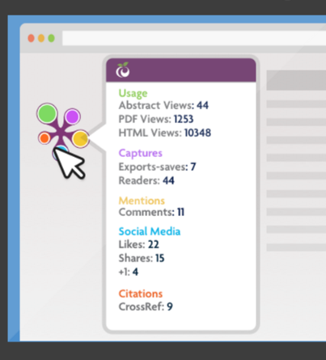
Figure 3. The PlumX metrics symbol

Plum Analytics claim to have the most comprehensive metrics product available. They track metrics from other 30 sources and can track over 20 different types of output from articles to videos and much of this uses data sourced within EBSCO.

Research output is hosted on multiple platforms including publisher sites, discipline-based pre-print repositories, institutional repositories, and aggregated databases. In addition research is referenced on web sites such as faculty pages, department and lab sites, CVs, and abstracting and indexing databases. PlumX provides metrics widgets for all of these types of resources which can be embedded in websites. Plum categorizes the metrics in 5 categories so users can make sense out of the data: citations, usage, mentions, captures, and social media.

Author services

There are a number of companies that provide altmetric services for authors which show the attention their academic outputs may have acquired. Two companies are described below.

ImpactStory (impactstory.org)

ImpactSource was founded in 2011 by Jason Priem and Heather Piwowar. The idea for the company came from a community hackathon and it is today funded by the US National Science Foundation and the Alfred P. Sloan Foundation with support from JISC and it operates as a non-profit corporation (impactstory.com). ImpactStory brings together impact metrics from Altmetric, CrossRef, Figshare and Mendeley among others and in so doing produces an impact story around research outputs showing where research received attention and commentary across the web. Their metrics display greatest hits, follower frenzy and the global reach of your research. The list of mentions on Twitter is particularly impressive as it picks up discussion otherwise unknown if you are not tagged in the posts.

Researchers can build a free trial profile but there is a subscription charge thereafter. With a profile created altmetric data can be imported using an ORCID record which then displays where research was mentioned across online sources. Setting up a free profile and importing the data provides a powerful example of where your work received attention. Instructions on this is available here https://impactstory.org/

Figure 4. Sample ImpactStory researcher profile.

Kudos (growkudos.com)

Kudos enriches articles with impact statements and in so doing ‘helps researchers and their institutions and funders to maximize the visibility and impact of their published articles’. The company partners with Altmetric, CrossRef and ORCID and won the 2016 Association of Learned and Professional Society Publishers (ALPSP) award for innovation. Researchers who want to increase the visibility of their work can explain their research is simple summaries which can then be shared across social media and the results measured on the Kudos dashboard. The basic service is free for researchers. An example of Kudos metrics is shown in figure XXX

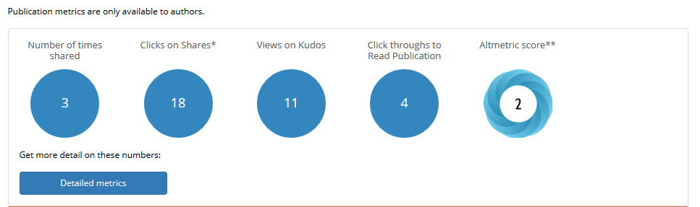
Figure 5. The Kudos metrics dashboard

How do Altmetrics Work?

To work meaningfully altmetrics require data systems that are open and transparent (Science as an open enterprise 2012 : 63). Underpinning this is a system is that has a unique identifier attached to the research output and an author identifier. These two issues are discussed below.

Unique identifier

For an indicator to be reliable it has to collect all the data attached to the research output. Considering citations as an indicator it is obvious that all articles have to be checked across all databases to check to see how many times the article in question has been cited. The most commonly used identifier is the Digital Object Identifier (DOI) (doi.org). To put this in context, of the 191,080 outputs submitted to REF2014 across all panels, 149,670 of these were submitted with DOIs although their use is less common in the Arts & Humanities (Wilsdon et al 2015 : 17).

DOIs are commonly attached to articles, conference proceedings and datasets while journals use the International Standard Serial Number (ISSN) but identifiers attached to publishers and institutions are problematic (Wilsdon et al2015 : 17). The International Standard Name Identifier (ISNI - rhymes with Disney) is becoming the preferred method of identifying publishers compared to the UK-centric UK Provider Reference Number (UKPRN).

Other digital identifiers tracked by altmetric providers include PubMedID, ArxivID, SSRN ID, ISBN, Handles, Clinical Trials Records and URN.

Author identifiers

These are important to ensure the work of a researcher can be attached to their academic outputs, particularly as individuals are not always easy to identify as personal names are rarely unique, names can changes and there are cultural differences in name order. The ORCID system is regarded as the best system and is growing in the UK and internationally (isni.org, Wilsdon et al 2015 : 18). ORCID is a mandatory requirement for Wellcome Trust funding applications from August 2015 (wellcome.ac.uk). A JISC study in 2012 recommended the UK adopt ORCID and this is supported by Research Councils UK (Wilsdon et al 2015 : 18, JISC 2012).

ORCID launched in 2012 is run by as an independent not-for-profit organisation and its board includes representatives from CERN, Massachusetts Institute of Technology, the Wellcome Trust and the publishers Elsevier and Wiley & Sons among others. ORCID ‘provides an identifier for individuals to use with their name as they engage in research, scholarship, and innovation activities’ (ORCID.org). ORCID is a subset of ISNI and the two organisations cooperate and it is possible for an individual to have both an ISNI and an ORCID identifier. At the time of writing, there are 2,260,396 live ORCID ids across 13,595,940 work activities (publications, databases and other research outputs) at 170,005 institutions. It is free for an individual to set up a profile and obtain an ORCID id. Researchers can then assign their ORCID id to their publications from an aggregator such as Crossref.

How altmetrics work

From the research output and its digital identifier, altmetric companies then capture the attention the output gets across a range of attention sources. These sources cover:

- News outlets and blogs
- Post-publication peer review sites such as Publons and Pubpeer
- Policy documents
- Reference management tools
- Other sources such as Wikipedia, YouTube, Reddit and F1000
- Social media

altmetric data companies follow a list of domains such as lse.ac.uk and nature.com and search for links to these domains from the attention sources referenced above. From this, attention is collated and disambiguated across different versions of a research output if necessary (for example pre-print articles) to produce an altmetric score which is represented in a symbol. ResearchGate and Adademia.edu both do not allow access to their sites and altmetric companies therefore cannot track attention to research outputs on these sources and it is for this reasons these websites have their own research impact score.
Advantages of Altmetrics

Altmetric data providers claim a number of advantages for using altmetric data in research evaluation and management, particularly in relation to engagement and impact. Using conventional quality control through peer-review altmetrics can demonstrate research reaches the right people and makes a difference (Figure Table 7). This may be particularly important where there is a lack or low volume of citations as may occur in some Humanities and Social Sciences.

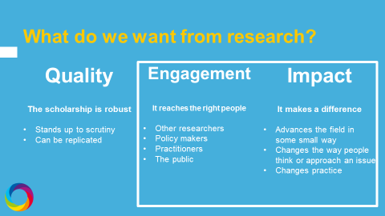

Figure 6. How altmetrics can be used in research engagement and impact

- Publication cycles for traditional metrics are slow to accrue citations whereas altmetrics are immediate – as soon as a research output is available online and has a digital identifier the output can be tracked. Data at Altmetric.com is updated live except for policy documents and news items which take a day to come through. Altmetrics can therefore provide real-time feedback on the attention scholarly content is generating. A schedule of update frequencies is provided here: https://help.altmetric.com/support/solutions/articles/6000060968-what-outputs-and-sources-does-altmetric-track-
2. Altmetrics are more accessible as they capture the attention research receives in government and policy makers, special interest groups, funders, corporates, education, media, general public, academia and practitioners
3. Altmetrics can capture a variety of formats including: images, videos, presentations, software, procedures, blogs, audio files, datasets, eBooks – essentially everything but print. For Arts and Humanities researchers Figure 8 gives examples of how altmetrics scores can be given to two examples of non-traditional research outputs namely a dataset of dance experimentation and 3D images of a dinosaur.

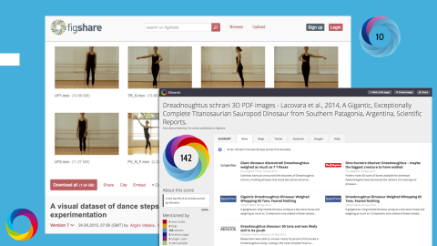
Figure 7. Example of altmetrics applied to a dataset of experimental dance
and to 3D PDF images

4. Altmetrics can cope with the volume of research outputs. A research output is mentioned online every 1.8 seconds or 47,000 mentions a day and altmetrics help track some of this online activity.
5. Altmetrics capture more diverse ‘flavours’ of impacts than citation-based metrics
6 Altmetrics can demonstrate impact for researchers, publishers and for funders
7. Altmetrics are subjective but they can take the hard work out of compiling impact case studies by selecting evidence across media which might otherwise be forgotten or neglected.
8. Researchers can use altmetrics to track research and uncover unknown conversations about their work and use this information in future grant applications and funder reporting

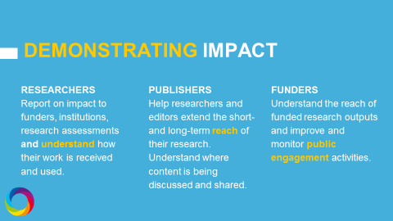
Table 8. Altmetrics and research impact

Limitations of Altmetrics

As altmetrics can be harvested in an automated way as all data can there is the danger that altmetrics data can be manipulated and as well as being susceptible to spam (Wilsdon et al 2015 : 42). Such is the perceived threat of manipulation, whether real or imaginary the Wilsdon report does consider altmetrics suitable as a management tool to objectively measure, evaluate and manage research (Wilsdon et al 2015 : 43). A concern from critics is that altmetrics focus on what is measurable at the expense of what is important (Wilsdon et al 2015 : 43).

1. Altmetrics don’t tell the whole story. They can complement conventional methods but they don’t replace informed peer review and citation based metrics
2. Like any metric, they can be gamed for example through Twitter bots or Wikipedia pages citing a researcher’s work. Altmetric data providers have measures in place to identify and correct gaming but these are not fool proof and the data providers stress the need to look at the underlying qualitative data.
3. There is a lack of evidence that social media events can serve as appropriate indicators of societal impact (Haustein 2016)
4. Altmetrics are relatively new and more research around them is needed.

Altmetrics and book-based disciplines

For many humanities and social science disciplines, the monograph remains the principal and most highly valued method of scholarly publication (British Academy 2006).
Counts of article citations dominate traditional citation indexes and evaluating book-orientated fields is challenging as these methods are insufficient to assess the impact of books, and journal citations on their own might miss about half of the citations to books making books difficult to track automatically (Wilsdon et al 2015 : 40, Adie 2016). Further problems lie in tracking the different editions of a book and identifying individual chapters for multi-authored works. Altmetric.com do not currently track the Amazon or Goodreads sites but they do track links to publishers and Google Books book pages across their attention sources. An example is someone tweeting about their new book which has been published and the inclusion of a link to book’s page on Amazon (Adie 2016).

The main source of altmetric impact for books are:

- Book reviews in academic journals and other media
- The extent to which academic books are being used in teaching. Having a book on the syllabus of a Higher Education Institute demonstrates the impact of a book. Altmetric are working with Open Syllabus to aggregate data from what are mainly North American institutions. This data will inform how many institutions use a book across the number programmes as well as how many modules use a book
- Although not yet possible there are plans for altmetric data providers to track when academic books have been cited in mainstream books.

The Wilsdon report (2015 : 40) recognises that the main source of citations in Humanities books are other books and traditional citation counts for books for cultural purposes such as poetry and novels may be inappropriate and their merits cannot be reflected in traditional bibliographic methods. The Scopus and Web of Science databases contain few books which leads to problems for citation impact assessment in book-based disciplines (Wilsdon et al 2015 : 41).

Altmetrics and publishers

Altmetric data allows marketing and editorial departments to see what is their most popular content and investigate why it is being mentioned and then re-post material across social media channels as a way of providing value to authors (Hardcastle & Madjarevic 2016). Altmetrics also give publishers a benchmark for judging the success of a marketing campaign and identifying areas for development and new groups of readers. This data and provide journal editors with details of the articles receiving the most attention in their journal and monitor competitor journals. In REF2014, books (authored books, edited books, scholarly editions and book chapters) were more frequently submitted to Main Panels C and D (29.4%) than to Main Panels A and B (0.4%) (Wilsdon et al 2015 : 41).

One of the first publishers to add Altmetric’s data across their journals was Taylor & Francis. Users will be able to see bibliographic information, demographics for Twitter and Mendeley, and simplified ‘score in context’ information. Alerts are also more prominent, so authors (and anyone else) can keep track of every new mention of an article, via a daily e-mail summary (altmetric). Routledge, like Taylor & Francis part of the Informa group of companies, has added Altmetric data to ebooks in its Social Science and Humanities lists and although this is a recent initiative initial results confirm that there is much less activity than with books in science disciplines (Adie 2016).

Altmetrics in future academic evaluation exercises

The Metric Tide (The Wilsdon Report, 2015)

The stated policy of Research Councils UK (RCUK) is that metrics will always require expert review to ensure appropriate interpretation and moderation and that ideally metrics should challenge assumptions in peer-review and stimulate debate (Wilsdon et al 2015 : 98, HEFCE 2014). They also state that publication and citation metrics bibliometrics are limited in the breadth of their applicability; they cannot be applied equally across all disciplines and context is therefore vital (Wilsdon et al 2015 : 99). RCUK’s priorities for the future in relation to metrics are the continued use of the Researchfish approach to ensure data and its exchange is as simple as possible and usage increases, while calling for further studies to understand the link between research and impact.

The Wilsdon review considered the role of metrics in future academic evaluation exercises and it produced a series of recommendations on possible ways forward. A theme from this stage of the research was the real and perceived cost and burden of the REF and the reduction in workload was the major reason for pursuing the increased use of metrics in future assessments (Wilsdon et al 20156 : 118). REF2014 allowed citation data to inform peer review judgements although this was limited to journal articles and conference proceedings. From the evidence collected for the Metric Tide the Wilsdon review concluded that quantitative indicators alone are not feasible for assessing the quality of research outputs. Its recommendations on using metrics in the next REF are outline in Table 4.

1. In assessing outputs, we recommend that quantitative data – particularly around published outputs – continue to have a place in informing peer review judgements of research quality. This approach has been used successfully in REF2014, and we recommend that it be continued and enhanced in future exercises.

2. In assessing impact, we recommend that HEFCE and the UK HE Funding Bodies build on the analysis of the impact case studies from REF2014 to develop clear guidelines for the use of 14 quantitative indicators in future impact case studies. While not being prescriptive, these guidelines should provide suggested data to evidence specific types of impact. They should include standards for the collection of metadata to ensure the characteristics of the research being described are captured systematically; for example, by using consistent monetary units.

3. In assessing the research environment, we recommend that there is scope for enhancing the use of quantitative data, but that these data need to be provided with sufficient context to enable their interpretation. At a minimum this needs to include information on the total size of the UOA to which the data refer. In some cases, the collection of data specifically relating to staff submitted to the exercise may be preferable, albeit more costly. In addition, data on the structure and use of digital information systems to support research (or research and teaching) may be crucial to further develop excellent research environments

Table 4. Wilsdon report recommendation on using metrics in the next REF.

The Stern Review (2016)

The Stern Review was an independent review of the Research Excellence Framework REF. The review was launched by Universities and Science Minister Jo Johnson in 2015 and the steering group was chaired Lord Stern, President of the British Academy. After the consultation period closed in March the review was published in July 2016.

In the context of future research assessment exercises the Review notes the following points in relation to metrics:

- Metrics capture only some dimensions of output quality

- Metrics on research intensity must be appropriately contextualised and assessed at a disciplinary level

Recommendation 4: (REF) Panels should continue to assess on the basis of peer review. However, metrics should be provided to support panel members in their assessment, and panels should be transparent about their use

Strategies for researchers for improving online reach of their outputs

Researchers can work deploy a number of strategies that will get their work noticed online.

- The first step is to talk about your research across social media – tweet, blog and share the research as widely as possible
- Write a short summary of the research written for a lay audience in mind. This will give some context to the work and explain its validity for a non-expert audience and gives authors the opportunity to present a story – a summary that says the article was mentioned in a major newspaper and a policy document is more compelling and meaningful than an abstract altmetric score. A summary that explains what the research is about and why it’s important can be used on growkudos.com to increase discoverability.
- Share data and files and include a link.
- Researchers should always link to a page that include the unique digital identifier of the work (such as the DOI) on a publisher’s page. The link needs to be in the main body of the post – links in headers or other sections are not picked up.
- Check the metadata on an article. This is done by right-clicking the page source on an article. Items to check are citation_doi, citation_author, citation_title, citation_online_date, citation_issn
- Create an ORCID id and use this to see the attention given to your work through an author service such as ImpactStory.

Bibliography

AHRC, 2006. Use of research metrics in the arts and humanities. Report of the Expert Group set up jointly by the Arts and Humanities Research Council and the Higher
Education Funding Council for England. https://www.jiscmail.ac.uk (Accessed 6 June 2016)

Adie, E. Personal communication. 20/5/2016.

British Academy, 2006. http://www.britac.ac.uk/policy/peer-review/chap-6.cfm#4 (Accessed 7 June 2016) OI http://www.doi.org/ (Accessed 3 June 2016).

Altmetrics.org http://altmetrics.org/about/ (Accessed 25 May 2016).

Falagas1, M and Alexiou, V. Impact factor manipulation. Archivum. Immunologiae et Therapiea Experementalis. 2008, 56, 223–226 doi: 10.1007/s00005-008-0024-3

Hardcastle, J and Madjarevic, N. Journal metric analysis and measuring impact. ALPSP training course. May 2016.

Haustein, S. 2016. Grand challenges in altmetrics: heterogeneity, data quality and dependencies. Scientometrics. doi: 10.1007/s11192-016-1910-9

HEFCE http://www.rcuk.ac.uk/documents/submissions/hefcemetricsfinalrcuk-pdf/ (Accessed 3 June 2016).

Merton, R. The Matthew Effect in Science, II. 1988. ISIS 79: 606–623. doi: 10.1086/354848

Priem, J, Groth, P, Taraborelli, D. The Altmetrics Collection. 2012 http://dx.doi.org/10.1371/journal.pone.0048753

JISC http://www.serohe.co.uk/wp-content/uploads/2013/10/Clax-for-JISC-rID-validation-report-final.pdf (Accessed 3 June 2015).

Lin, J & Fenner, M. Altmetrics in evolution: Defining and redefining the ontology of article-level metrics. Information Standards Quarterly, 25 (2) (2013), pp. 20–26 doi:10.3789/isqv25no2.2013.04

Piwowar, P (2013) Altmetrics: value all research products. Nature 493, 159 doi:10.1038/493159a

Roemer, R.C and Borchardt, R. Altmetrics and the Role of Librarians. Library Technology Reports51.5 (Jul 2015): 31-37,2.

Sage. http://online.sagepub.com/site/sphelp/altmetricFAQ.xhtml (Accessed 28 May 2016)

Science as an open enterprise The Royal Society Science Policy Centre report 02/12
Issued: June 2012 DES24782

The Stern Review. https://www.gov.uk/government/uploads/system/uploads/attachment_data/file/541338/ind-16-9-ref-stern-review.pdf

Wellcome Collection. https://blog.wellcome.ac.uk/2015/06/30/who-are-you-recognising-researchers-with-orcid-identifiers (Accessed 3 June 2016).

Wilsdon, J., et al. (2015). The Metric Tide: Report of the Independent Review of the Role of
Metrics in Research Assessment and Management. doi: 10.13140/RG.2.1.4929.1363

