‘A vague stretch of remoteness’:
Brian Graham’s paintings of Egdon Heath

Lecture to the 24th Thomas Hardy Festival and Conference
Dorchester, 13th July 2021

SIMON OLDING

My very first piece of research – using archives as a source of information – took place a stone’s throw away from here. I was writing a long essay for my History A level. My subject was the representation of rural work in Hardy’s novels and the use of these depictions accurately to date the texts. I booked time in the library and research room of the Dorset County Museum; travelled by coach from Exeter to Dorchester and spent a day looking at nineteenth-century local newspapers.
I was delighted to base this research on Hardy, since I was beginning to read the novels voraciously, and I had The Mayor of Casterbridge as a set text for my English A level. I mention this for symmetry rather than defence since I am very aware of my amateur status in front of an audience of literary experts. This symmetry is simply set out. As I near the end of my professional career, it is an honour for me to address this conference, and to reflect again on Hardy, this time linking his work to the visual arts. It is something of a full circle.
I want to look at and around a singular exhibition. The exhibition ‘The Great Heath’ presented a new body of work by the painter Brian Graham and was held at Sladers Yard Gallery in West Bay, Dorset, under the curatorial care of Anna Powell, the gallery owner and director in 2019. It was an outstanding show. I want to lead up to considering the works in that show by setting it into a context; and reflect on the marginalised and little studied history of fine art that consciously depicts the Dorset heath. I start with the illustrations that appeared in the serialisation of The Return of the Native and work through to contemporary painters who have based their landscapes in, and of, Dorset. By doing this we can see how significant Brian Graham’s paintings are as a unique, grand-scale illumination of, and meditation on, the imagined and real tract of land bearing Hardy’s title of Egdon Heath.
I also want to try and link the practice of fine art with music and poetry. So, I will touch on Holst’s tone poem ‘Egdon Heath’, which was influential as a soundtrack to Graham’s paintings; and I shall, with her kind permission, read from the remarkable poetry of Elisabeth Bletsoe, whose work specifically considers, analyses and gives voice to the heath. And I will conclude with a counterpoint: the presentation of unseen paintings of Egdon Heath that Brian Graham has been making during the pandemic, with a well-known watercolour by Hardy himself, depicting this same ‘vague stretch of remoteness’.
The local historian John Chandler remarks in Wessex Images that ‘the heath was identified by Hermann Lea, a contemporary commentator (who wrote handbooks to Hardy’s Wessex) as “that vast expanse of moorland which stretches, practically without a break, from Dorchester to Bournemouth”’. It is a rural swathe, a real place, with a more or less precise geography. It might be mapped, from the ancient county town to the brash, villa’d coast. For Hardy, and through his texts to Brian Graham, it is a place of personal, lived, significance, and as much a metaphor as a heath and brackened site. It is ground that Brian Graham has, one might say, descended into.
Hardy’s first home at Higher Bockhampton was framed by Thorncombe Wood, hazel coppice and then beyond it to the then huge area of heathland where he found in his childhood a solitary contentment; walking deep in the bracken, basking in its summer heat or using the soil as a grounded base, from which to peer through his telescope. It was a place of deep locality, of precise particularity, from which one could yet see a universe. Where time stopped or swoops to ancient pasts. Where a natural geography might be glimpsed or reconfigured, in Graham’s case, sometimes in the same painting. Graham describes Egdon Heath in a manner that is more lyrical than Hermann Lea:
As evidenced by an abundance of tumuli that populate its barren, spare, appearance, the Great Heath was primarily the result of Bronze Age activity.
First emerging just to the east of Dorchester and now much interrupted by outbreaks of conifer, large tracts of heather, gorse and fern, still compel with their quiet majesty. Birch and pine tread warily on the sands, clays and gravels, which reach towards the outer suburbs of Poole, Bournemouth and beyond, where their Dorset manifestation ends.
My childhood experiences and memories are coloured by time spent here [so] my need to make these paintings [is] profoundly autobiographical.
Egdon Heath (or to give it Graham’s title ‘The Great Heath’ with its proposition of size and significance) is also a place of the observed and trodden natural world; where recent history is like a loam-layer over ancient human habitations and the geography is one of shifts and instabilities in a place of widespread and slow erosions. It is a place steeped into his past, used to compel an artistic response in his full adulthood, as if his memory lies vested, waiting for its long, late, concentrated moment of creative endeavour. The paintings both draw on his childhood memory; and they recall his recent visits there.
Brian Graham’s series of paintings are in the main abstract works. They may occasionally refer to a seemingly observed and particular place; but they are site-evocative rather than site-specific. They perform a very different role as a description of Egdon Heath than the twelve illustrations commissioned for The Return of the Native included in the serialisation in Belgravia in 1878. These illustrations, which favoured humans over landscape, were done by Arthur Hopkins, the brother of Gerard Manley Hopkins – giving us our first, if coincidental, heath-link between the visual arts and poetry. These illustrations focus on the characters in the novel and their interconnections. Hardy corresponded with Hopkins during the year of the serialisation, remarking on what he liked and what he didn’t like. He was, so to speak, both literary and art critic of his own work. He thought that Eustacia Vye in February should have been ‘more youthful in face, supple in figure, and, in general, with a little more roundness and softness than have been given her’.
But by August, Hopkins had taken the hint, and ‘the rebelliousness of her nature’, Hardy writes, ‘is precisely caught’. The illustrations foreground the characters. They help us to visualise the novel at key junctures and provide a handy aid to the reader’s imagination. They also test what the reader might be thinking of the physical appearance of the characters. Phillip Allingham remarks that:
the serial illustrations do not necessarily curtail the imaginative experience. Rather, they fix certain scenes in the mind as benchmarks of the story’s action, telegraphing to the reader what one sensitive reader (a graphic artist, whose perception had sometimes in turn been corrected or influenced by that of the writer himself, has felt is memorable in the coming instalment.
These illustrations are clearly specific to, and dependant on, a close reading of the text, and they are presented as co-existent to it. The image has become inseparable from the word. The visual art is functional, above all. The artist, Hopkins, is both co-presenter and interpreter, and as Allingham concludes: ‘the collaborative project of an illustrated, serialised story required personal harmony and aesthetic agreement between the two’. Because this accord is plot driven, Egdon Heath is observed only coincidentally, as a frame to character and action, observed as a melodramatic back drop, with stunted and spectral vegetations giving mood and tone to the narrative progression. The art of the heath is backgrounded. It is certainly not ‘colossal and mysterious in its swarthy monotony’. It is subservient and secondary.
Hopkins depicts Egdon Heath as a place that might, in truth, be anywhere. It needs the novel to frame it as a living part of Wessex. Yet Dorset did provide rich material for artists in the late nineteenth and early twentieth centuries. Two important studies track this narrative: Peter Davies’s Art in Poole and Dorset and Gwen Yarker’s Slade Painters in Edwardian Wessex. A third valuable text is provided by Vivienne Light and her studies of Dorset painters in the last quarter of the twentieth century. Gwen Yarker observes that:
towards the end of the nineteenth century, the Dorset countryside seemed almost indistinguishable from the writings of Thomas Hardy…Dorset became defined as “Hardy Country” emulating ‘Shakespeare’ or ‘Constable’ country. Conscious of the explicitly local nature of his work, Hardy evoked the ancient kingdom of Wessex as the territorial definition that offered him a broad context in which to place his work, which was often steeped in folk-lore, adding to its wildness, mystique and sense of pre-history’ (virtues, we might say, of interest to Brian Graham).
Hardy himself reviewed the artist’s interpretations of ‘his’ landscape through their exhibitions and Yarker proposes that ‘arguably, his encouragement contributed to the influx of landscape painters working in the county en plein air, as the favoured method of capturing the landscape’. Frederick Whitehead, for example, commented on the need for alertness in the field, depicting a land of cottages, streams and heath: ‘if one wishes to paint Nature one must study her not only under the conditions for which one on any particular occasion seeks, but always and under any fickle change’. He sounds like a painter who has been caught out in a storm more than once.
William Collins’s oil painting ‘Arne Heath’ of 1903 had Hardy’s work in mind with its ‘dramatic portrayal of bleak moorland amidst a rain squall that shows a covered horse-drawn carrier advancing over the sombre heath’. Egdon was being watched. Peter Davies says that Frederick Whiteread ‘married into a Dorset family and encouraged by Thomas Hardy spent many years living and working in a touring caravan’, and his work, therefore, depended in part on his travels across the heath. His ‘gipsy lifestyle gave him a close intimacy with the nooks and crannies of the south Dorset heathlands and Purbeck hillsides’.
These landscapes were broadly representational – if sometimes moody - and where the Heath appears, it is as a real place. The artist was clearly situated in front of an actual site, and their presence (and thus interpretation) is central to its meanings and characteristics. As artists look at Dorset in recent times, the view of what is in front of them in the rural county is often modulated, abstracted and reconfigured. Hardy provides a subtext, rather than being a driver of the painting. Peter Davies remarks that ‘the occurrence of modern art in Dorset since the 1950s has primarily been a sporadic and fortuitous phenomenon, but abstract artists no less than their landscape-oriented forerunners, have been drawn to the area’s scenic beauty and character and its ancient landmarks…particularly near the coast with the geological and archaeological features’ there’. Today’s Jurassic Coast is an art coast.
George Dannatt’s ‘Eggardon Hill’ is one example of a Dorset scene which takes a highly geometric approach to the known, walked on, physical landscape. Dannatt and his wife Ann were drawn from London (where George worked as a music critic) to Wessex specifically because of their intense interest in Thomas Hardy’s writing. Through frequent visits to Dorchester, as Vivienne Light notes, ‘they became deeply involved in the land and history of Dorset and Wiltshire…They explored these revealing landscapes, frequently following the scenes of Hardy’s novels and poems, but with no car and very restricted bus services in the early years after the War’. ‘Eggardon Hill’ (Michael Short says that Hardy derived the name Egdon from this location in West Dorset) has become a cool, Ben Nicholson-esque abstraction, less a view of landscape and more of a jigsaw, a place to be mapped out and highly regulated, with the strata more important perhaps than the vista.
John Hubbard’s ‘Dorset landscape’ of 1965 is a more romantic, emotionally charged work, its swooping colours apparently merging cloud, sky and verdant green fields or vegetation into one turmoiled place. Hubbard, the American born artist recalled that ‘I had learned about Dorset’s outstanding landscapes from reading an old Life magazine article about “Hardy country”. We first came to Dorset via a route which must have been devised by the gods: through Cranborne Chase and the Piddle Valley, then over Eggardon Hill just after a rainstorm’. He had driven along roads passed through by George and Ann Dannatt a decade or so beforehand. Hubbard’s paintings of Dorset are ‘superficially non-representational works’ which as Peter Davies goes on to say ‘relate very directly and powerfully to the landscape around him: the picture surfaces are an intricate web of calligraphic brushmarks that together conjure up a feeling of undergrowth, moving streams or trees’.
Hubbard himself said that his Dorset landscapes show place ‘like a wonderful, extraordinary piece of sculpture. It’s got such a sense of movement and a kind of determination. It’s this incredible mixture of natural and man-made’. We may call this viewpoint to mind when we come to consider Brian Graham’s paintings of Egdon Heath. But before we get there, I want to look briefly at two other contemporary painters have made long studies of the Dorset landscape. Jeremy Gardiner says that ‘Dorset is the baseline for all my work, the one place I go back to…It’s important to leave and then to return in order to understand a place properly - you’ve got the contrast and context then’. Gardiner’s work is often located on the edge, on that littoral place between the sea and the fracturing, sometimes collapsing Jurassic coastline. His painting ‘Durdle Door to Bat’s Head’ is a literary site: the place where Troy swims out to sea in Far from the Madding Crowd. Gardiner has also specifically located other paintings as places drawn from text. As with his whole body of Dorset-based work, he has recalibrated and reconnected specific places, as if intending to describe not just the scene in front of him, but to allude what cannot be seen: the geological underground; and what can only momentarily be seen: the changing light. These are works of an epic drama, where time is both held still and delved back into. These are specific places with known geological structures, observed coastal perimeters, and places for Hardy. They are paintings of literature as well as geology.
The art historian Christiana Payne observes that Gardiner ‘understands the rock formations that he paints, and his particular techniques of layering and scraping down mimic the geological processes that have led to their present formation… For Gardiner it is the land which is the main focus of interest, with its power to suggest abstract forms as well as the passage of time’. With his ‘Hardy’ paintings, Gardiner adds a stratum of prose-observation.
The final visual artist whose work I want to consider before turning to Brian Graham’s virtuoso sequence ‘The Great Heath’ is Frances Hatch. Her work is undertaken literally in the field, or on the beach, or beside a waterfall, or deep in the landscape. She will utilise the raw materials to hand: sands, gravels, stones, detritus, geological waifs and strays; her water may also be sourced on the spot; so her landscapes are not only descriptive of the site, they are the site. In the case of the painting ‘Studland Heath above Old Harry’ (2020) the work, composed of burned gorse and site earth, is dependant on the present Dorset heath. This is a Dorset heath painting borne (or burned) from its own place. It is a work made of the common ground, the title that Hatch gave to an exhibition she curated at the Crafts Study Centre, where her paintings were placed in telling juxtaposition with contemporary ceramics, where makers – Jack Doherty, Kyra Cane – for example, think and use their raw materials in ways that are also expressive of singular place.
In 2019, Brian Graham held a solo exhibition at Sladers Yard Gallery in West Bay, Dorset, at the invitation of Anna Powell. He showed over fifty paintings, mainly large acrylic on canvas paintings with several smaller works of acrylic paint on Fabriano paper. This exhibition distilled many themes that Graham had brought into his prior work. It was an exhibition of departure and continuation. The consideration of time, archaeology, and natural history are all embedded in the new works, as they have been for many years. Graham is deeply interested in the markings on landscape made in a past time that can only be referenced through archaeological finds, geological time framings and meditations on history and prehistory. What he names ‘The Great Heath’ is a site, where, as Anna Powell remarks, ‘the ancient River Solent ran and evidence of early human habitation has been found which may date back half a million years. By clearing trees, Neolithic farmers began to create heathland which is a “cultural landscape” or one which requires human maintenance’.
What is left of the heathlands is ancient, despite its fragmentations and human incursions, and the Bronze Age tumuli are markers of these interventions, as much as the modern or drove roads. If you look hard or deep enough, you can see the ancient and the recent past, within the context of one framed piece. Graham has made a body of works that are both connected to, and about as far away as you could get from, Arthur Hopkins’s illustrations for The Return of the Native. The connecting point is the novel. Hopkins’s illustrations are titled by quotations from the text; so are Graham’s. But where the Victorian illustrator uses the quotation as a marker of significant plot activity, Graham I think has little interest in narrative movement. He wants instead to elicit a complex, emotionally charged envisaging of a place: a profound micro-reading. Hardy’s words become prompts and gestures rather than instructions.
Nothing in Brian Graham’s paintings is explicit about place; everything is explicit about mood and tone and time. These are particular places that Graham has stood in front of and deeply observed; and he may have sketched them, too. But the full realisation of each painting is done as if from memory, in the Swanage studio, with a view of the Dorset coast and the fine Swanage sands. In ‘An aged highway, and a still more aged barrow’ [Figure 1] we are guided by the novel’s text and asked to contemplate the ancient route like a time-torn marker, as well as a route still in use. This is a painting about incremental time rather than specific journeying; it is about all the traded, weary trudging, for work or life passage, that has taken place in sight of the barrow, watching over relentless passage. In ‘Flint and Birch’, the trees are seen as if decapitated, un-whole, their bark-markings contrasting with the scrabbled hard soil. The trees are an inevitable partner to the flinty soil, as if they could have grown from nothing else.

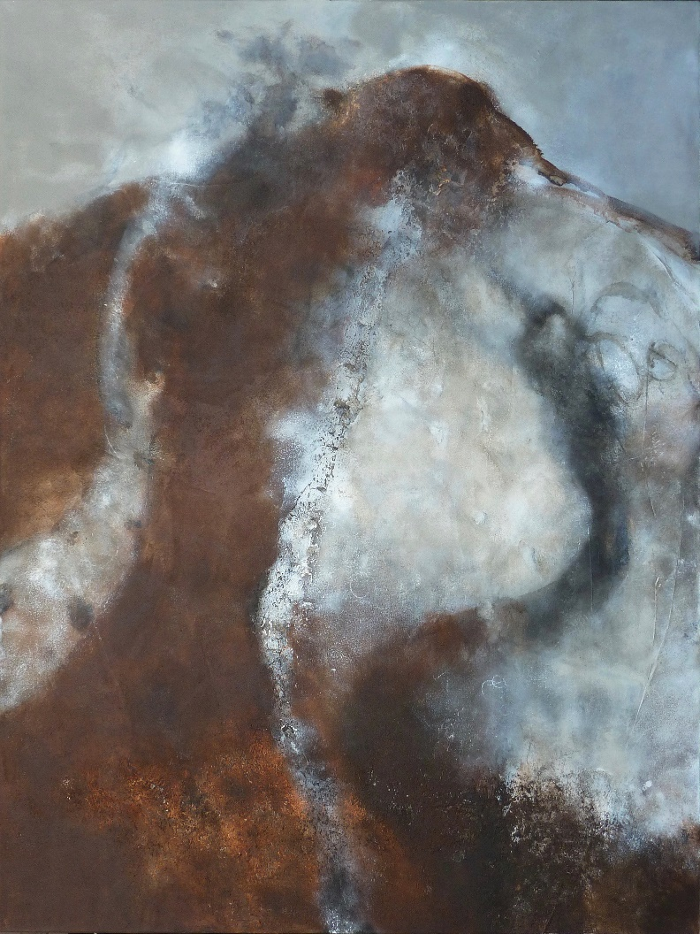
Figure 1. Brian Graham, ‘An aged highway, and a still more aged barrow’. Acrylic on canvas. 122 x 91.5 cm, 2018. Photo by Robert Field, courtesy of Sladers Yard.

In the related paintings ‘Civilisation was its enemy I and II’, we see the heath obscured and foggy, with outlines both in sight and disappearing as if the heath itself is battling for its natural anonymities, dogged and obscurant in the relish it can make of immeasurable time, and in the inevitable passage that time and human engagement must make, however trivial these passing emotions might be. The Heath is a place for the shattering intensity of tragedy or pain; and a place where the human activity is of miniscule moment. We see all this through the natural history of the heath, for no humans are seen in this long sequence of paintings.
There are moments of drama and upsurge too. In ‘Above the plain rose the hill, above the hill rose the barrow’, a painting of an uncommon bracken-green hue (for most of the paintings favour a chalk-flinty white; a fire-red; a peaty-brown palette) the horizon line is now clear, suggesting the physical proximity and hard-climbed effort required to reach the barrow, with an almost alpine sharp edge. The heath line is more undulating and softer in the signature painting ‘Colossal and mysterious in its swarthy monotony’. [Figure 2] Graham has depicted Egdon Heath as a brooding symbol. The bumpy, hard worked, layered and excavated surface of his canvas might be a metaphor for understanding time through the painter’s archaeological enquiry, done by its own scrapings and tool workings.

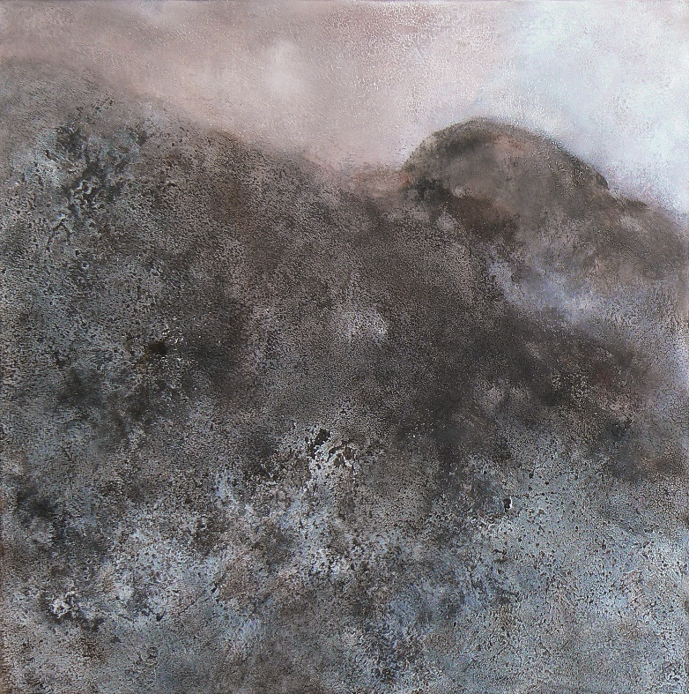
Figure 2. Brian Graham, ‘Colossal and mysterious in its swarthy monotony’. Acrylic on canvas. 61 x 61 cm. 2017. Photo by Robert Field, courtesy of Sladers Yard.

As with some of Graham’s previous series, for example the works that describe Hengistbury Head, an upper Palaeolithic site on the Eastern edge of Bournemouth, the place is resonant for its found artefacts and sites, and for its musical tonalities. The Hengistbury Head paintings were informed by Tippett’s ‘Concerto for Double String Orchestra’, which he was listening to at the time. As Charlotte Mullins observes:
the music - in part based on medieval church madrigals – acted as a bridge between the past and the present, and allowed him to imagine the site as it had been all those years ago…this heightened experience…was the first time he felt absolutely connected to his subject matter and he knew from that moment that he would explore this rich seam of archaeology and palaeontology in much of his future work’.
The paintings ‘are not literal evocations of landscape or place. They are allusive, poetic, suggestive’.
We can see ‘The Great Heath’ as the late flowering of Graham’s specific concerns as an artist, this time mediated less by the archaeological find and more by the land at his feet, or in his viewings across and beyond, or in his delving down-sight. And it is precisely informed by a specific literature, namely chapter one of book the first of The Return of the Native, ‘A face on which time makes but little impression’.
In paintings such as ‘It could best be felt when it could not clearly be seen’, Graham avoids any sense of the horizon; he may be looking down or across, perhaps from that place sunk in the bracken and gorse where he was photographed for his exhibition catalogue, into a gloaming darkness. The heath takes on a character life of its own, personified in the painting ‘Nothing save its own wild face was visible’, as if Egdon Heath was in fact human, if feral and unkempt. The sense of watchfulness, of the heath as an organic, sentient site, where nature is alert and acutely present, is his theme for ‘The place became full of a watchful intentness’[Figure 3], and its anthropomorphic quality is also captured in ‘The Heath appeared slowly to awaken and listen’.

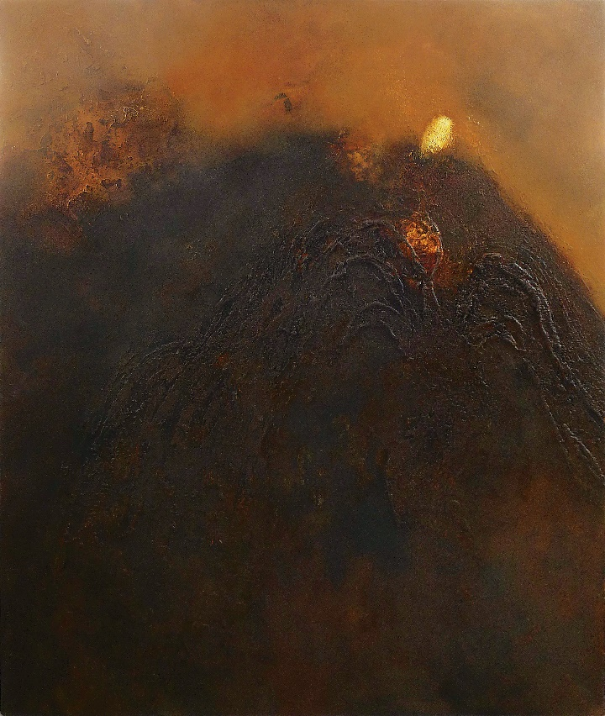
Brian Graham, ‘The place became full of a watchful intentness’. Acrylic on canvas. 101 x 86 cm. 2018. Photo by Robert Field, courtesy of Sladers Yard.

It is a site where human endeavours, however rash, feeble, ordinary or heroic, will go observed but not cared about. In Graham’s depiction of ‘Rainbarrows’ [Figure 4] the bumpy outline is lit by an orange-yellow sky, almost magical in its intensity, a colour better described as ‘Wounded Gold’ to take another of Graham’s evocative titles for this major series of works.
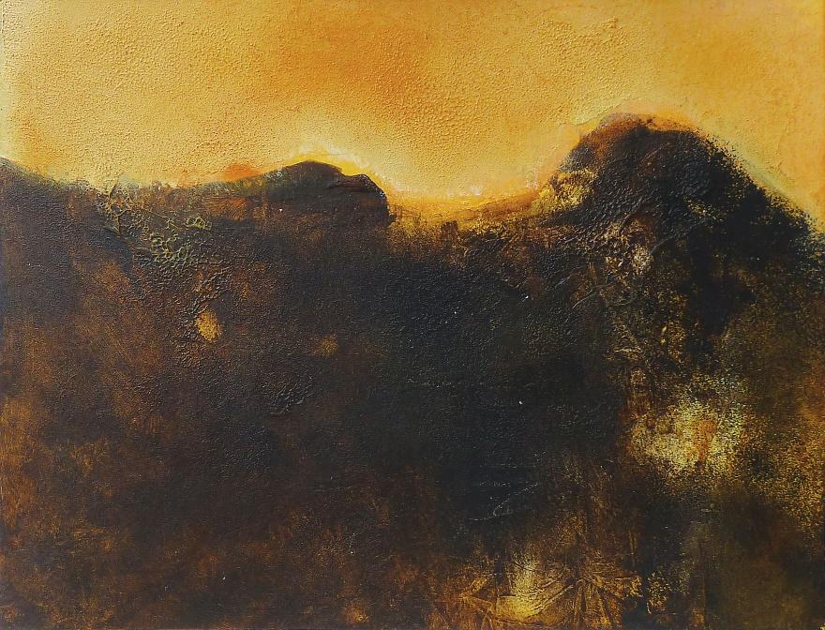
Figure 4. Brian Graham, ‘Rainbarrows’, Acrylic on paper, 23 x 30 cm. 2018. Photo by Robert Field, courtesy of Sladers Yard.

Alternatively, the great heath is a place that resides entirely in the novel, as a factual account given the painter’s imaginative freedom. ‘The sun had branded the whole heath with its mark’, however, is not a lyrical, pastoral ode. The heath is a place not only for romantic sunlight reflections, but a place where the land, like the sheep, are inexorably stamped, and where the stamping is in the hue of the reddleman, or the incipient blaze of the heath’s dry and scorching beacon fires.
The final work I will illustrate from Graham’s series ‘The Great Heath’ has a winter’s chill. This is ‘Turbaria Bruaria’. [Figure 5] Hardy talks of Egdon Heath as an ‘obscure, obsolete, superseded country [that] figures in Domesday. Its condition is recorded therein as that of heathy, furzy, briary wilderness – “Bruaria” …and that “Turbaria Bruaria” – the right of cutting heath-turf – occurs in characters relating to the district’. Graham’s painting has the chilly and downtrodden aspect of a work ‘slighted and enduring’, a work whose palette and appearance are also woebegone.
. 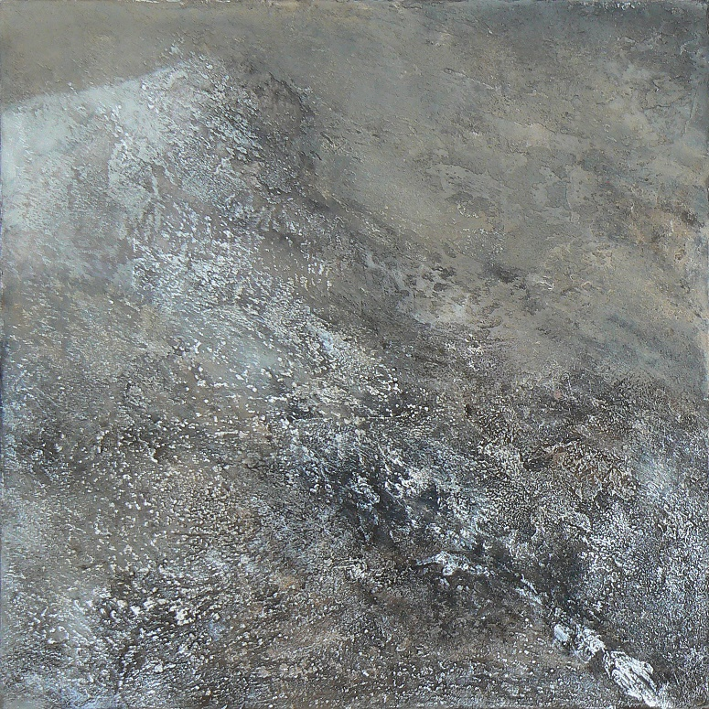
Figure 5. Brian Graham, ‘Turbaria Bruaria’. Acrylic on canvas. 51 x 51 cm. 2017. Photo by Robert Field, courtesy of Sladers Yard.

Or perhaps we might think of Tubaria Bruaria as the poet Elisabeth Bletsoe does at the start of her long poem ‘BRUARIA’ which begins with Hardy’s own spare lines, moves into definitions (as if her poem is a dictionary) then returns to sparsity and short, cut words, severed like the turf itself:
obscure

obsolete &
superseded country

broca 1st decl. Latin variant for,
or an error for, Latin brucus
(whence brucaria, bruaria)
Fr. bruyère, brushwood, heathland

a land replete with thorns
con cave deeply
set re
sounding.
Claire Tomalin talks of Hardy ‘Dreaming the Heath’, and we can think of Graham doing the same. She continues ‘all his novels have elements of poetry, but [The Return of the Native] is the first in which, although he has made his concepts into fiction, essentially he is setting down a poetic dream’. ‘The Great Heath’ has used the literature as the foundation for a meditation on an imagined place, alive in words and expressed in colour, in places that are both deeply real and entirely speculative, seen and drawn on the heath but transmuted in Graham’s studio, a place where the heath is both absented and absolutely present.
We have seen how music was important to Graham’s practice (and I think the daily round of his life) in his Hengistbury Head series. I want to make a turn or pivot in my lecture to reflect for a moment on the music that can be considered as the backdrop to ‘The Great Heath’: Gustav Holst’s tone poem ‘Egdon Heath’ (1927). During the writing of the music, Holst met and walked with Hardy across part of the Dorset heath between Wool and Bere Regis. Holst put this quotation from The Return of the Native at the head of the score: ‘A place perfectly accordant with man’s nature – neither ghastly, hateful, nor ugly: neither commonplace, unmeaning, nor tame; but, like man, slighted and enduring; and withal singularly colossal and mysterious in its swarthy monotony’.It is a text to link all three artists: Hardy, Graham and Holst.
Edwin Evans, writing in The Musical Times in 1934 noted that ‘the effect is not vague in the musical sense. It is the emotion that sets the ear guessing. It is one more frequently expressed by painters. One is reminded of those landscapes which at first present a flat monochrome surface and come to life gradually as the eye probes into them’. Evans links the music with painting; and in this work by Brian Graham, he too explicitly connects his art to Holst’s music. The painting is ‘Scherzo for Gustav Holst’, and it was exhibited in a series called ‘Towards Music’ held at Salisbury Museum in 2018, described as by Graham as ‘the painter’s meditation on how our need for music and dance may have first emerged in the human evolution’.
Holst conducted the Bournemouth Municipal Orchestra (as it was then known) in 1926 and ‘after the concert he set out on a walking tour through Dorset and Wiltshire, passing over Wareham Heath… and finishing up… in Salisbury’. Holst described it as ‘the perfect walk…Four days in Dorset and Wilts; 2 miles per hour with 30 min rest for each 60 walking when fresh and the reverse when not; Only 4 miles main road to 50 grass and about 12 lanes and woodland paths: no collar, lots of cider and cheese and only one blister’.
It is pleasing to think of Holst himself deep in Egdon Heath, like Brian Graham ahead of him, immersed in the landscape with musical thoughts stirring, as the cider and cheese sustained him, and as he, too, forensically read the first chapter of The Return of the Native. Graham recalls first hearing Holst’s music on an old 78 vinyl record brought for him by his father. This was ‘Mars’ from The Planets. His personal adjacent section of Egdon Heath was Canford Heath in Poole, and as he got to know Holst’s music better, he took the chance with a relish to listen to the BSO play ‘Egdon Heath’ in the late 1960’s or early ’70’s (perhaps directed by the Romanian Principal Conductor Constantin Silvestri), and this concert also ‘cemented something powerful for me, so that I could see Holst and Hardy on the heath’. The idea of painting the heath as an ode or tone poem to this deep memory and personal metaphor, finally took shape and hold’.
50 large oil paintings on a single subject represents several things, some prosaic and some poetic. Sheer hard physical work – the layering, scraping; reworking, scouring and brush workings – over many hours of high concentration is one type of labour. Then there is the deeply considered mental concentration; the holding on to thematic distinctions and the ‘literary criticism’ as we might put it, where the painter takes his cue from the text, where what is required is the adroit selection of the most effective of Hardy’s framing and gestural phrases, giving clue and licence to these landscape-derived works: a place and an idea at one and the same time. Finally, there is the forecasting of art: the seeing of the series as it evolves and develops, making sure that any repetitions are there for chordal impact; and that any contrasts stand out as abrupt as a full orchestral phrase.
You might have thought that his work on the heath was done.
But over the past year, in lockdown, Graham has carried on his investigations of the remembered Great Heath, finding related subject matter form his sketches and inner sightings, and using the power of recall to produce a new, associated series of heath-paintings. It is as if the heath, in all its incremental changings and subtleties of line, of seasonal variation, of weather-response, and even the prospect of new geological or archaeological findings, might inspire an inexhaustible body of work. This is work with a forward trajectory as well as a reflective memorialising.
I want to bring this lecture to a conclusion by considering the impact of Graham’s suite ‘The Great Heath’, and then consider, briefly, Thomas Hardy’s own visualisation as a painter of Egdon Heath, for it seems fitting in this special conference that Hardy has both the first and the last responding words and images.
I am going to start with poetry. This is taken from Elisabeth Bletsoe’s poem ‘Rainbarrows’, where she voices Eustacia Vye, and creates a scholarly, enigmatic vocabulary for the character’s reading of Egdon Heath and the tribulations she finds there. Bletsoe has turned the novel upside down. The natural landscape provides the imagery for much of her (Vye’s) enquiries and reflections. Eustacia is the central character: observant, deeply aware of her sexual strengths and emotional agency, turning her hopes into the tense, sparse-yet-resonant vocabulary that Bletsoe creates for her: where very little means a very great deal. Here is Egdon Heath. Eustacia is in ‘“a raw state” dreaming/the black stone of the self’:
a few ounces of gorse flowers
and several parts each
gravel, sand, clay
spread by glacial drift
gravel-caps
plateaux separated by
slope-clays, loam-clenched fistfuls of
shrub-tree
cremation burials
an internal grit of crushed flint,
fragment of flanged bowl with
painted wavilinear bands:’.
Eustacia, we might conclude, is poet, natural historian, geographer, and ceramic specialist. She has looked Egdon deep-down, and walked it intensely, for, as she goes on to say, ‘my stride devours the vell of the heath’. Bletsoe and Graham have both done this to, it seems to me.
Two summers ago, Elisabeth, Frances Hatch, Brian Graham and I met in Sherborne. We talked about Frances’s exhibition for the Crafts Study Centre and Elisabeth signed for me my treasured copy of Landscape for a Dream, with its sequence of poems ‘Maiden Castle’, Melbury Bubb’ ‘Cross-in-Hand’ and ‘Rainbarrows’, where the female voice of Hardy’s characters rings with deep, complex, analytical interrogation. Elisabeth and Frances had both seen Brian’s exhibition at Sladers Yard. They subsequently returned to Egdon Heath. Bletsoe takes up the story in the preface to her poem ‘BRUARIA’ published in Long Poem Magazine. Hardy’s heath influenced Holst; and here is new work that pays accord to Graham. But now the work is both investigative and performative. Bletsoe notes:
Taking as my starting point Brian Graham’s 2019 exhibition The Great Heath, which in turn was informed by the opening chapter in Thomas Hardy’s The Return of the Native, I retuned myself to this landscape of my childhood…I started the process by walking on Parley Common, now a site of Specific Scientific Interest. Habitation, encroachment and workings there stretch back to Bronze Age clearances, with their own rights and ways of being…I set myself exercises of composing in situ and capturing fleeting impressions that are simultaneously distorted by imperfect memories; taking no more than ten minutes on each section in an attempt to mirror/ create a sense of this landscape that is both anciently managed and yet fragile, with some of its marginalised people, flora and fauna. They come together to form a whole of which this is only a part. An artist friend and collaborator, Frances Hatch, has been inspired to start creating rapid sketches as illustration, keeping within the same spirit of time limit and using only the soils and materials she finds there.
So here is Egdon Heath again: mesmeric, useful, and art-inspiring still; in prose, poetry, music and paint. It has become a cultural landscape.
For Hardy himself, the heath was primarily the subject of the novel and the short story. But he considered it, too, as a painter, in the watercolour titled ‘Egdon Heath’ done in 1870, and then a year later in his watercolour ‘Rainbarrow and the Heath’. Both works are held in the collections of the Dorset Museum, and the earlier work is currently on display in the wonderfully upgraded and extended museum. Hardy shows Egdon Heath as a place of rural, romantic quiet. The chalky road turns out of view, as if across an infinite place. There is brooding to the light. But there is also just enough blue sky to offer the weary traveller some hope of respite from the gathering cloud. Scrappy trees frame the upper reaches of the heath. A deep puddle suggests rain past and to come. The heath is a place of isolation, its antiquity suggested by the managed landscape (the tumuli) and contemporary interventions (the flattened pathway). Hardy must have felt the need to record this significant place though the image of it must also have been forever in his mind’s eye. Maybe it is a place of solace as much of fatefulness.
Hardy, we may surmise, painted what he saw; but he also captured what he felt about the heath before he wrote his ode to its transmuting poetic power. His two watercolours are, I assume, private and introspective works. Brian Graham’s virtuoso sequence ‘The Great Heath’ and its afterworks, are, as he said, autobiographical. They tell us what he finds deeply significant in the place, and they resound with his memories of childhood as well as his present walking over the place. His latest works offer a musing about the fate of the heath, for it has been radically encroached over time. He says: ‘I am not an eco-warrior, but I want to reclaim the heath, and do so in consort with my fellow artists. I want to keep this place in a special focus, and my paintings reflect not only what the heath is now, but what it would be like if we returned to its deeper past, removing its pines and later additions so that it could become untrammelled and evocative’.
This is Egdon Heath, to subvert the formal conservation designation, as a site of ‘special artistic interest’.
This would be the place that Hardy himself would have known and cherished because of its deep intransigent moods, its slow time shiftings and imperceptible changes.
A place fit for natural histories, life-stories, beacon-fires, reddle, furze-cropping and resonant painting.

NOTES

Thomas Hardy, The Return of the Native (London: Macmillan and Co, 1925).
John Chandler, Wessex Images (Stroud: Alan Sutton Publishing, 1990), p. 156.
The photograph of the painter by Robert Field illustrated on the back inside cover the catalogue The Great Heath: Brian Graham shows him surrounded by bracken.
Brian Graham, (2019) The Great Heath: Brian Graham, Swanage: privately published. unpaginated
Quoted in Philip V. Allingham,‘Appendix G: Arthur Hopkins’s Illustrations for the Monthly Serialization of Thomas Hardy’s The Return of the Native in Belgravia’ www.victorianweb.org/authors/hardy/native/illustrations.html p.493. Accessed 25 June 2021.
Ibid.
See https://victorianweb.org.art/illustrations/hopkins/2.html
Allingham, ‘Arthur Hopkins’s Illustrations for the Monthly Serialization of Thomas Hardy’s The Return of the Native (1878)’.
Ibid.
Hardy, RN, p. 6.
Gwen Yarker, Slade Painters in Edwardian Wessex: Inquisitive Eyes (Bristol: Sansom& Co, 2016), p. 10.
Ibid.
Quoted in Yarker, Slade Painters, p. 11.
Yarker, Slade Painters, p. 61.
Peter Davies, Art in Poole and Dorset Poole (Poole Historical Trust, 1987), p.24
Davies, Art in Poole, p. 133
Vivienne Light, (2001). Re-inventing the Landscape: contemporary painters and Dorset (Brook: Canterton Books, 2001), p. 22. For further writing about artists in Dorset, see Light, V, Circles and Tangents: art in the shadow of Cranborne Chase (Morecombelake:Canterton Books, 2011).
John Hubbard, John Hubbard: remaking landscape (Norwich: Unicorn Press, 2018), p. 16.
Davies, Art in Poole, p. 141.
Light, Re-inventing the Landscape, p. 47.
Ian Collins, (2013) ‘Deep mining in Dorset’, in The Art of Jeremy Gardiner: unfolding landscape (Farnham: Lund Humphries, 2013), pp. 11-12.
Christiana Payne, ‘Landscape in Four Dimensions’ in The Art of Jeremy Gardiner: unfolding landscape, p. 104.
Brian Graham’s paintings from ‘The Great Heath’ series can be seen of the website of Sladers Yard at https://sladersyard.wordpress.com/brian-graham/. The photographs are by Robert Field.
Anna Powell, ‘The Great Heath: recent paintings by Brian Graham’. www.sladersyard.wordpress.com.
Charlotte Mullins, Brian Graham: flint and flame (London and Nottingham: Hart Gallery, 2008), p. 14.
Hardy, RN, p. 3.
Hardy, RN, p. 6.
Elisabeth Bletsoe, ‘BRUARIA’ in Long Poem Magazine, 25 (Spring 2021), p. 7.
Claire Tomalin, (2012) Thomas Hardy: The Time-Torn Man (London: Penguin Books, 2012), p. 163.
Ibid, p.165.
Hardy, RN, p.6.
See Edwin Evans, ‘Gustav Holst’ The Musical Times, 75 (July,1934), p. 593.
See Brian Graham (2017) Towards Music: Brian Graham Swanage: privately published.
Michael Short, Gustav Holst: The Man and His Music (Hastings: Circaidy Gregory Press, 1990), p. 158.
Conversation with Brian Graham, July 2021.
Bletsoe, Landscape from a Dream (Exeter: Shearsman Books Ltd, 2008), p. 76.
Bletsoe, Long Poem Magazine, 25 (Spring, 2021), p. 7.
Conversation with Brian Graham. July 2021.
As Elisabeth Bletsoe has also done with her phrase ‘Site of Specific Scientific Interest’. See footnote 37.

