Designing Location-Specific 3D Printed Vessels Using Mobile-Based Multi-Sensor Data Fusion

Paul D. Found, Industrial Design Group, Institute of Applied Arts, National Yang Ming Chiao Tung University, 1001 University Road, Hsinchu, Taiwan, 30010; School of Architecture, University for the Creative Arts, New Dover Road, Canterbury, Kent, CT1 3AN, U.K.

Email: <paul.found@uca.ac.uk>.

Chun-Cheng Hsu, Industrial Design Group, Institute of Applied Arts, National Yang Ming Chiao Tung University, 1001 University Road, Hsinchu, Taiwan, 30010.

Email: <chuncheng@mail.nctu.edu.tw>.

See <www.mitpressjournals.org/toc/leon/XX/X> for supplemental files associated with this issue. <*Editor will fill in the X’s>*

*Submitted: <17 October 2020>*

Abstract

**This paper presents an innovative creative process for designing ceramic vessels. The authors detail how three disparate concepts – mobile device-driven creativity, digitally designed and fabricated ceramics, and multi-sensor data fusion – are unified and applied to an emerging practice where sensor data are used to generate vessel designs via a prototype smartphone app. A pilot study is presented, where users in a variety of locations tested the app and their designs were 3D printed, with location becoming a tangible parameter. Results show the feasibility of using data-fusion, mobile devices, and digital fabrication to create physical, location-specific artefacts. Broad implications and potential ways forward are then discussed.**

Exploration of digitally fabricated ceramics and vessels is increasingly common [1--3]. Recent work has touched on location-specific design and digital manufacturing, notably Stratigraphic Manufactury [4] where the same digital files were sent to different ceramic 3D printing centres so that each printed cup was unique due to different production conditions, or errors. In Adaptive Manufacturing [5] information measured by external sensors controls a 3D printer, and in Solid Vibration [6] sound waves cause a 3D printer bed to vibrate during the manufacturing process, creating Moiré patterns in printed vessels.

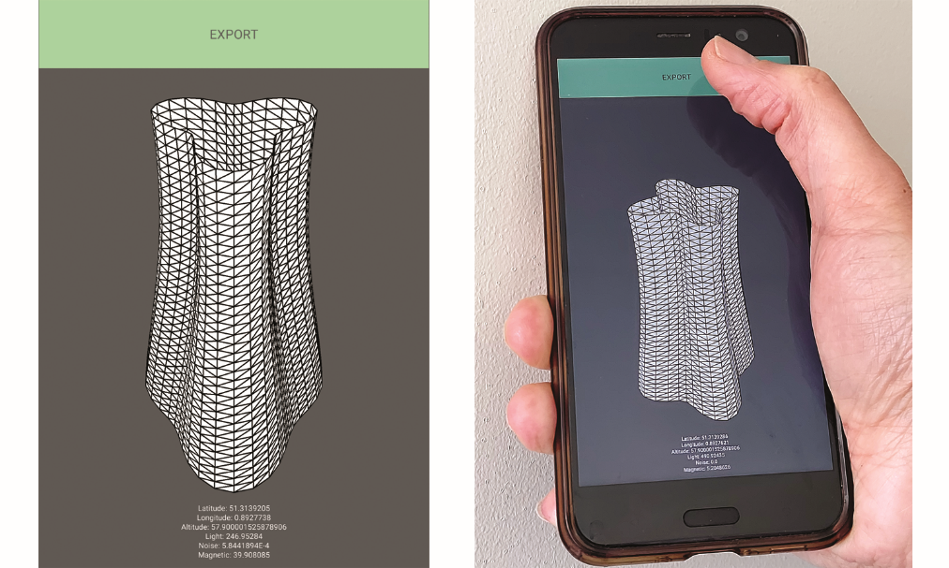

Fig. 1. The smartphone app interface. (© Paul D. Found.)

In contrast to these, we take inspiration from mobile music creation, where the in-built capability of mobile devices to record, process, and display data from multiple sources is at the core of a creative process and location, and sensed data from this location, are the fundamental drivers of form. Our aim is to build on this work to further explore location as a tangible parameter in digital fabrication.

Mobile Music

For more than a decade, mobile phones have been used as the creative tool for music [7], in part because they are ubiquitous, portable, and powerful enough to allow the creation of music anywhere [8]. By democratizing access to sensor technology, they allow new cultural contexts for interaction [9] and new forms of expression [10]. Rather than using the phone to mimic an existent musical instrument, the mobile device *becomes* the instrument, and data derived from its sensors directly enable the creative output, with location becoming a tangible parameter [11]. The use of mobile devices in specific design contexts offers similar benefits, and the device has the potential to become a portable, convenient, self-contained modelling tool that facilitates intuitive interaction anywhere, anytime.

Multi-Sensor Data Fusion

Data fusion is broadly defined as combining data from multiple sensors to achieve improved accuracies and more specific inferences than could be achieved by using a single sensor [12,13]. Within this there are 5 levels, of which Data In–Data Out (DAI-DAO) fusion is the least sophisticated [14]. DAI-DAO fusion is sufficient for this research, as the inputs are data from various sensors, fused together and subsequently output as physical artefacts. While smartphone-based sensor fusion has been used in a wide range of applications [15-17], the use of sensor fusion in interfaces for music creation is a rare example of its use in creative practice [18].

App Design

To create the prototype app, Processing for Android software was used. By design, the app is very simple. Once installed on a mobile device the app can be opened, and the displayed interface consists of only three elements: 1) an accurate 3D representation of the vase form, 2) a text display of the data being read, and 3) an “EXPORT” button which allows the created digital file to be saved to the device’s SD card. When the app is opened, the design of a vessel is generated from real time data – light, sound, longitude, latitude, altitude, and magnetic field – thus capturing a moment in time (Fig. 1). The user presses the EXPORT button to save the design as a stereolithography (STL) format file, ready for 3D printing. No other interaction is needed from the user. The sensor data are mapped to upper and lower limits to prevent extremely abstracted forms being created. While this does restrict the range of forms, it ensures they can be 3D printed.

Pilot Study

The described research uses a mobile device as a generic design tool, and places its portability, ubiquity, and inherent features at the forefront of the design process. To do this, the creative process undertaken in the study aimed to: 1) test the usability and functionality of the prototype app, 2) access and utilise data that contribute to specifying a location, 3) digitally design vessel forms locally, based on those data, and 4) digitally fabricate vases to demonstrate the overall feasibility of the process to make location tangible.

To capture real-time data from a range of different locations, six participants across the world, one each in Germany (I), Singapore (R), and Taiwan (B), and three in the UK (J, P and M), were invited to take part in the pilot study. The app was sent to the participants to install on their own mobile devices. They were tasked with running the app to create a vessel form and sending the created file back to the authors for digital fabrication.

Results

The participants were able to successfully produce and send files using the app. To test whether they were suitable for digital fabrication, test prints were produced in plastic, and then final prints were produced in clay.

Files were not edited or post-processed other than scaling to ensure they fit within the build volume of the 3D printer and slicing to prepare them for fabrication. Black PLA material was used to produce thin-walled prints, 85mm high by 45mm in diameter. The series of six vases printed successfully.

The same STL files were then sent to Yao van den Heerik and Marlieke Wijnakker of VormVrij® | 3D in The Netherlands. Designers and manufacturers of LUTUM® ceramic 3D printers, they produced high-quality clay prints of the vases and fired them to their finished state. The manufacturing process uses a constant flow of material, here red stoneware, pushed through the printer head nozzle by pressurised air, to build up objects layer by layer.

For the vases, a 3mm nozzle was used to expel the clay in 1mm layers. Each vessel measures 170mm high by 100mm in diameter, the size exported by the app. The completed vases (Fig. 2) are left unglazed to avoid hiding their textural qualities, and then kiln fired at 1230°C.

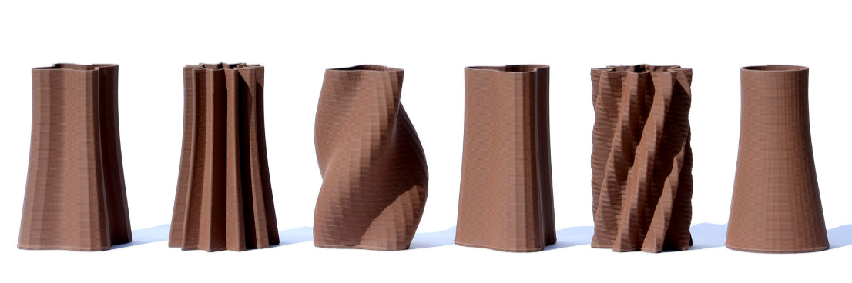

Fig. 2. 3D Printed Ceramic Vases: J, R, B, P, I and M. (© Paul D. Found.)

The layers created by 3D printing, being an integral part of the production process, are not hidden, but are instead part of the design. While retaining detail that demonstrates the differences between each generated form, producing them in ceramic creates artefacts that are of much greater aesthetic and functional quality than those produced in plastic.

Conclusion

The results of this preliminary investigation successfully meet the original aims. The described process demonstrates that data derived from smartphone embedded sensors can be used to create vessels that tangibly represent locations; locations not only in the sense of geographical position, but also some of the environmental attributes that make each of them distinct.

The prototype application produces digital files which can be 3D printed in clay. These are sufficient to conclude that high quality, end-use products can be designed and manufactured using the described creative processes.

While initial results are promising, there are limitations that must be acknowledged. The vases, although derived from the data, and clearly distinct from one another, are influenced strongly by only two of the data sources: light and noise. Light dominates, with the point count – points of inflection around the circumference of the vase – being the most noticeable feature. The choice of data is not arbitrary, and it was never the intention to be able to identify the location from the vase, this may need to be reviewed as more careful consideration of which data are measured, and how they are mapped to the vase form, might allow for the influence of each specific data source to become clearer.

While the users are free to choose a location and time to run the application and can do so as many times as they wish, they have no control over the final output. While intentional, as the data itself must drive the form, there has been no discussion here on what impact this approach has upon notions of creativity and authorship of the design.

Ideally, each vessel would be printed on location, using local materials. This would mean individual vessels become a physical instantiation of a time and location. These are directions for further research.

Future work must address the limitations described but it is hoped this research will inspire more creative applications that combine mobile-based sensor fusion and digital fabrication, affording as it does, the opportunity to create unique, physical objects, locally.

References and Notes

**1.** Michael Eden, Maker, (n.d.), <<http://michael-eden.com/>>, accessed 23 July 2020.

**2.** Joan Hardie and Jack Hardie, Printed Pots, (n.d.), <<http://printedpots.co.uk/home/>>, accessed 23 July 2020.

**3.** Jonathan Keep, Digital Pots, (n.d.) <<http://keep-art.co.uk/digitial_random.html>>, accessed 23 July 2020.

**4.** Unfold Design Studio, Stratigraphic Manufactury (2012), <<http://unfold.be/pages/stratigraphic-manufactury.html>>, accessed 23 July 2020.

**5.** Rickyvan Broekhoven and Olivier van Herpt, Solid Vibrations (2015), <<http://oliviervanherpt.com/solid-vibrations/>>, accessed 23 July 2020.

**6.** Oliviervan Herpt and Sander Wassnick, Adaptive Manufacturing (2014), <<http://oliviervanherpt.com/adaptive-manufacturing/>>, accessed 23 July 2020.

**7.** G.Essl, G. Wang and M. Rohs, “Developments and challenges turning mobile phones into generic music performance platforms”, *Proc. of Mobile Music Workshop* (2008) pp. 11-14.

**8.** G. Wang, G. Essl, and H. Penttinen, “Do mobile phones dream of electric orchestras?”, ICMC (2008) <<http://www.ccrma.stanford.edu/groups/mopho/publish/mopho_icmc2008.pdf>> accessed 23 July 2020.

**9.** A. Tanaka, “Mapping Out Instruments, Affordances, and Mobiles”, Nime.org (2010) <<http://www.nime.org/proceedings/2010/nime2010_088.pdf>>, accessed 23 July 2020.

**10.** A. Tanaka, “Musical performance practice on sensor-based instruments,” *Trends in Gestural Control of Music* **13** (2000) pp. 389-405.

**11.** L. Gaye, L.E. Holmquist, F. Behrendt, and A. Tanaka, “Mobile music technology: Report on an emerging community,” *Proceedings of the 2006 Conference on New Interfaces for Musical Expression* (2006) pp. 22--25.

**12.** D.L. Hall and J. Llinas, “An introduction to multisensor data fusion,” *Proceedings of the IEEE* **85,** No.1 (1997) pp. 6-23.

**13.** P.K. Varshney, “Multisensor data fusion,” *Electronics & Communication Engineering Journal* ***9,*** No. 6 (1997) pp. 245-253.

**14.** B.V. Dasarathy, “Sensor fusion potential exploitation-innovative architectures and illustrative applications,” *Proceedings of the IEEE* **85,** No. 1 (1997) pp. 24-38.

**15.** J.C. Yepes, J. J. Yepes, J.R. Martínez and V.Z. Pérez, “Implementation of an Android based teleoperation application for controlling a KUKA-KR6 robot by using sensor fusion,” *2013 Pan American Health Care Exchanges (PAHCE)* (2013) pp. 1-5.

**16.** O. Walter, J. Schmalenstroeer, A. Engler and R. Haeb-Umbach, “Smartphone-based sensor fusion for improved vehicular navigation,” *2013 10th Workshop on Positioning, Navigation and Communication (WPNC)* (2013) pp. 1-6.

**17.** D. Ahmetovic, “Smartphone-Assisted Mobility in Urban Environments for Visually Impaired Users through Computer Vision and Sensor Fusion,” *2013 IEEE 14th International Conference on Mobile Data Management* **2** (2013) pp. 15-18.

**18.** G. Odowichuk, S. Trail, P. Driessen, W. Nie, and W. Page, “Sensor fusion: Towards a fully expressive 3d music control interface,” *Proceedings of 2011 IEEE Pacific Rim Conference on Communications, Computers and Signal Processing* (2011) pp. 836-841.