Knight & Lee Exhibition Proposal

Title: Select Dream

Select Dream aims to bring local artists from the south coast (and the surrounding areas) together for a temporary street level exhibition. The exhibition will wrap around the ground floor window display areas of the old Knight & Lee department store in Southsea. The artwork would be produced on vinyl and will fill the full frame of the display windows, making it accessible and highly visible within the shopping district. The project also aims to give local residents and shoppers something visually stimulating to look at whilst the building is in transition – especially in the time of Covid when spirits need lifting and museums and galleries remain shut.

The show will bring together artists who either utilise or reference domestic, everyday items, architecture or aspects of day to day living. Perhaps some of the objects, would have been available to buy in the store before closure, however rather than this being a conventional still life show, the objects have somehow transcended their original form. The result of this being surreal, ethereal, humorous, engaging, and impactful from street level.

Duration:

Over the summer until That Group commence renovation work in September 2020

Proposed Line Up of Artists:

Hermione Allsopp
Charlotte Brisland
Ruth Collins
Stephen Cooper
Patrick Galway
Jaye Ho
Naty Lopez-Holguin
Greg Palmer
Iain Rayner
Josephine Rock
Kate Street
Paul Vivian

Selected Images of Artists Work:

Hermione Allsopp

Sculptural work of collected objects and furniture, re-created into new forms or compositions. These are familiar, known, domestic items that have been discarded in charity or junk shops – not, inert materials, but ones that carry collective attachments, memories and meanings. As sculpture, these re-done, or un-done-up objects begin to exist as something else and are intended to raise questions about the value and material nature of everyday objects

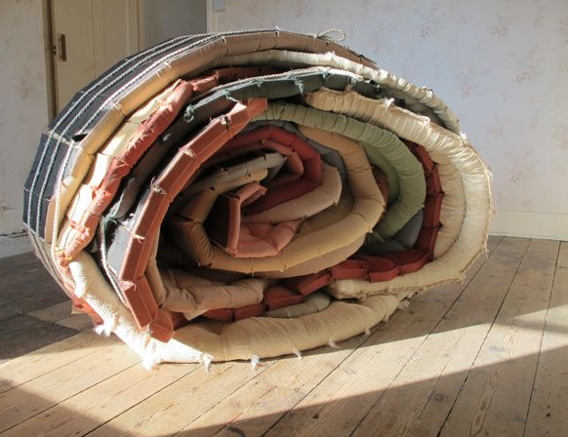
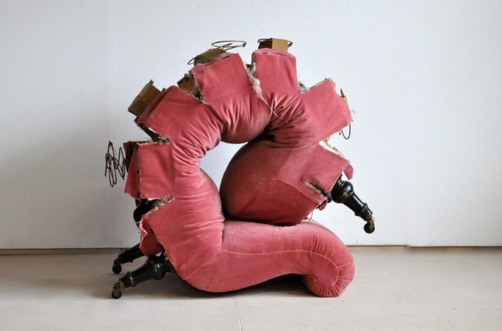

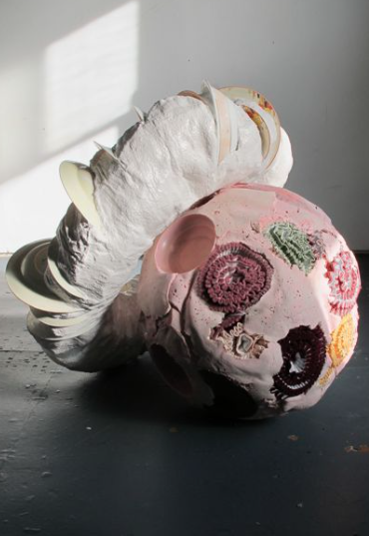
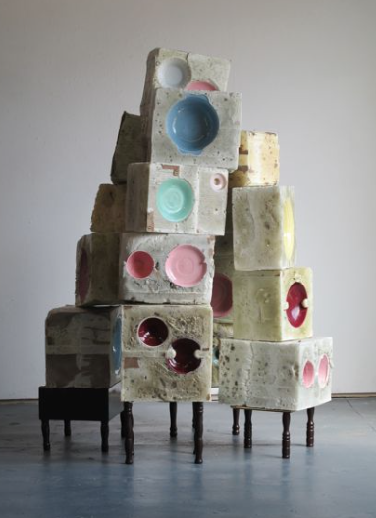

Charlotte Brisland

Paintings depicting houses/buildings from a distance. The spaces are carefully selected, outsider spaces, empty and broad; edgelands in some respect. On first instant they seem tightly painted, on closer inspection the paint becomes more tactile and gestural. Large scale painting that draw would people in to observe the broad brush strokes.

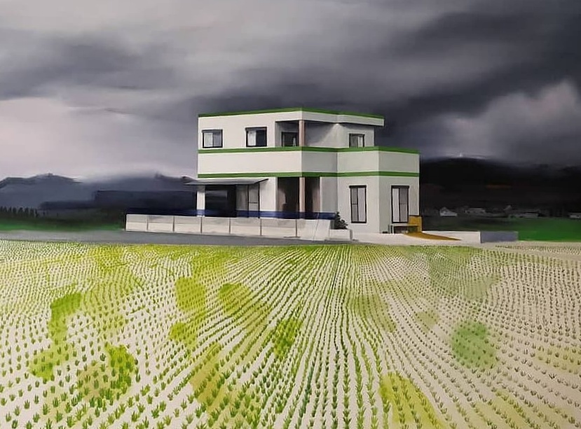

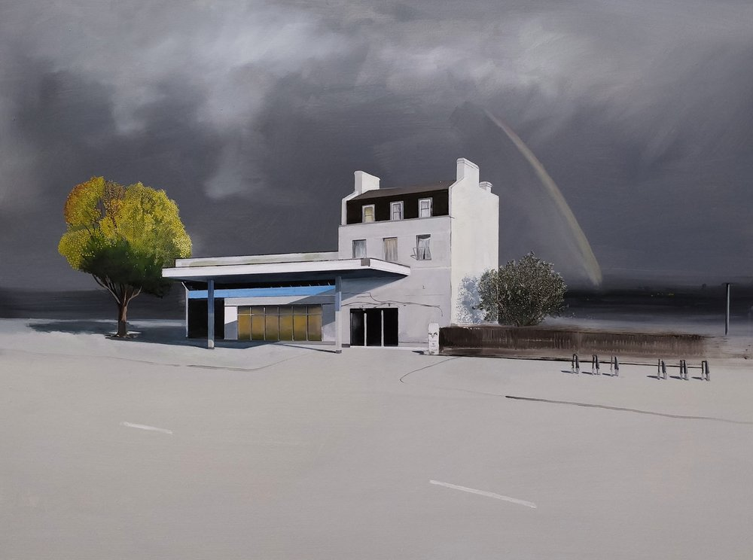
Ruth Collins

Pin hole photography of landscapes and people moving through space (exterior and interior), eerie and beautiful at the same time. Using colour film polarises this into a celebration of light, colour and movement. Yin and yang of storytelling, a different way of looking.

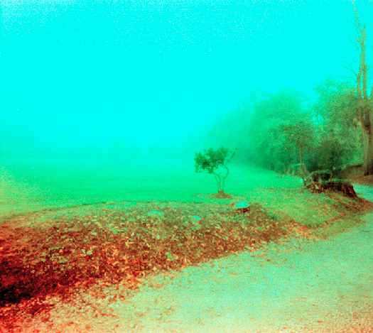

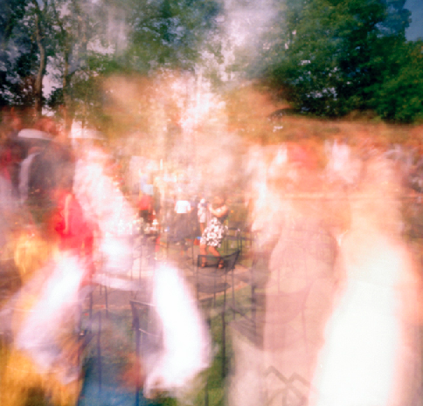

Stephen Cooper

Large scale painting/assemblages that incorporate decorative pattern, domestic objects, signage and broad brushwork. Implicitly, the work is dealing with dialogues around consciousness, perception and aspects of memory. Key concerns with this process is extending and finding relationships between the audience and the environment of the site through immersion, and consequently changing the perception of the viewer.

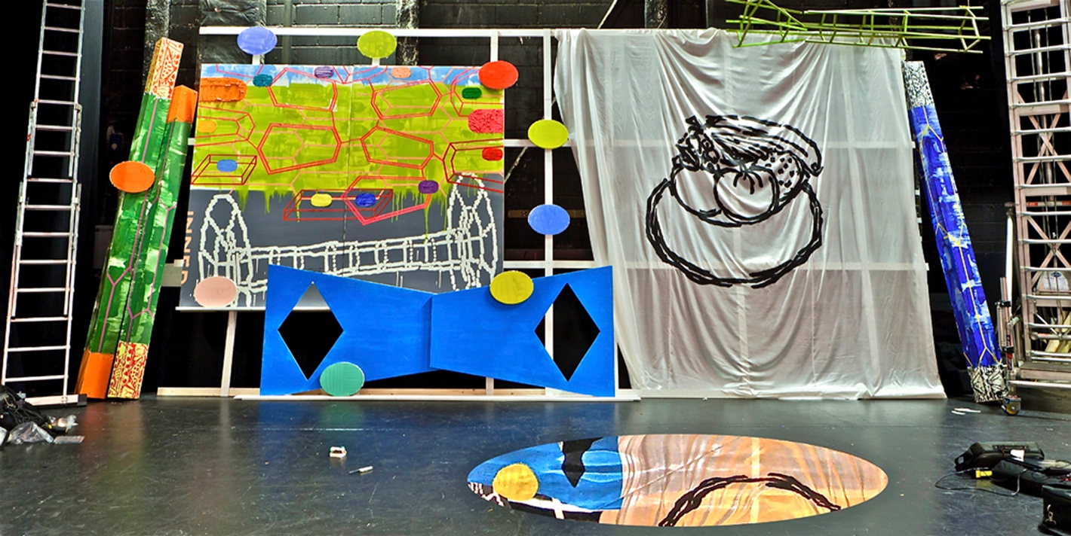

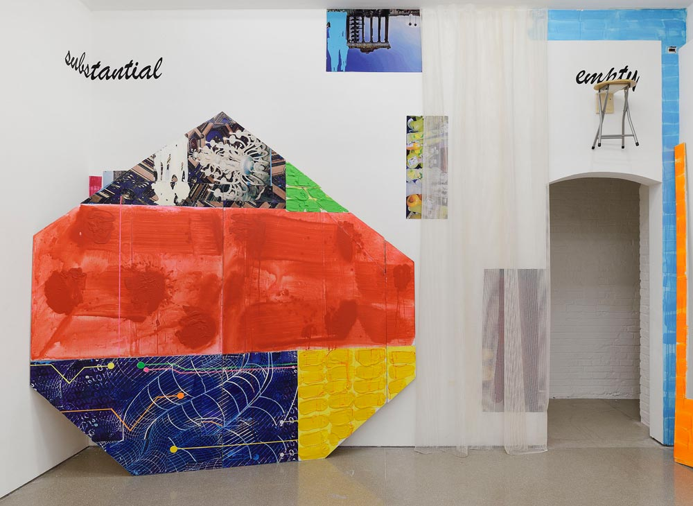

Patrick Galway

Paintings arranged amidst ladders and storage boxes, almost like the paintings themselves are mid move or escaping from storage. Varied every day, or recognisable imagery distilled from media, observation and archives, translated through selective colour, texture and brushwork.

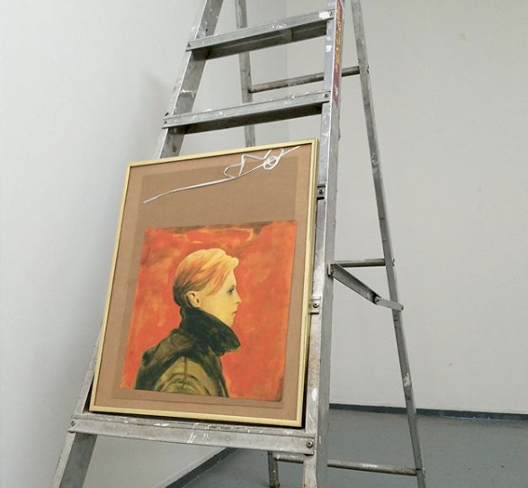
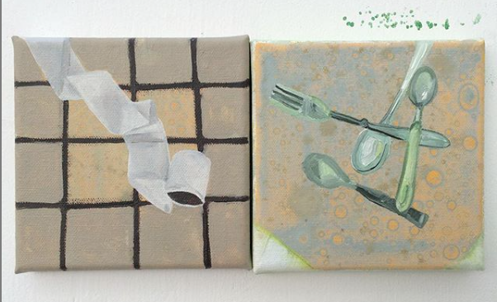
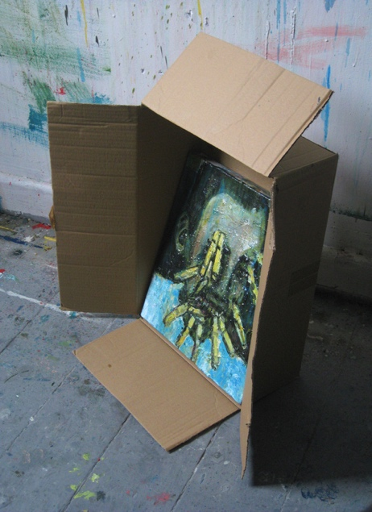

Jaye Ho

Painted room dividers and objects arranged within space, dazzle ship aesthetics for mock-camouflage. Main concepts evolve around misinformation, urban mythology, paradoxes and structures. Ho explores these themes by looking at physical and psychological interactions between man and nature.

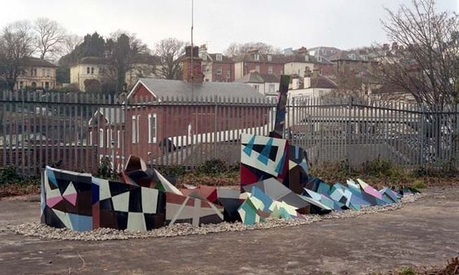

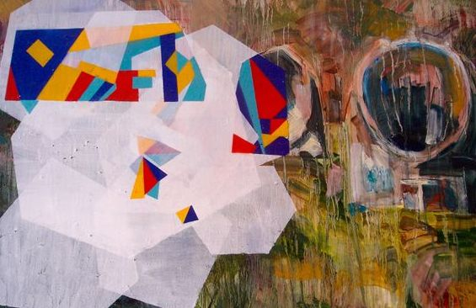
Naty Lopez-Holguin

Work explores issues of worth and value through labour-intensive processes and the use of everyday materials that are often dismissed. She creates sculptures as both singular objects and multiple elements in installations.

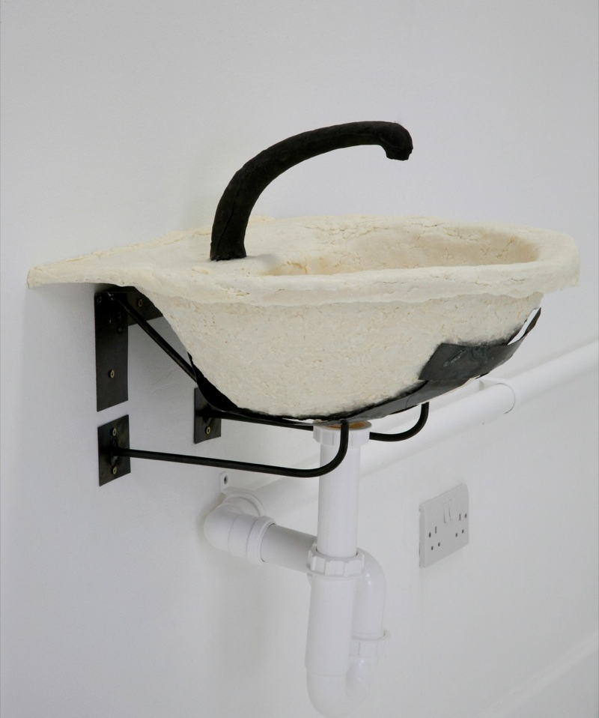

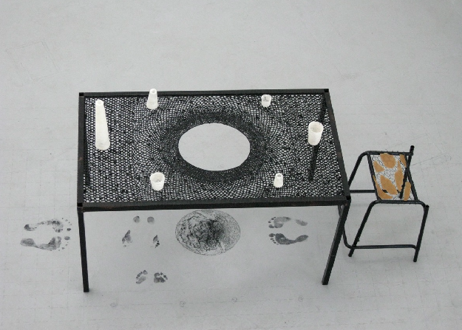

Greg Palmer

Painting on canvas - Commentary on the connection (or lack of connection) between nature and consumerism. He uses a library of symbols and signs “culled” from corporate logos, product design, and children’s books.

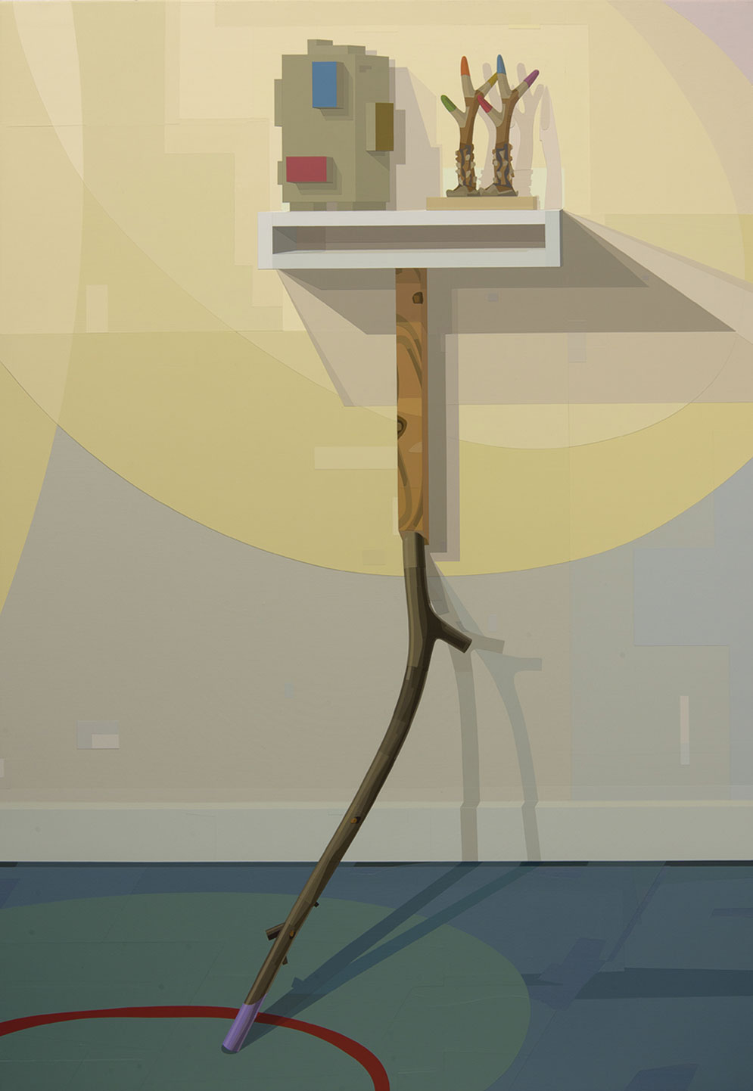

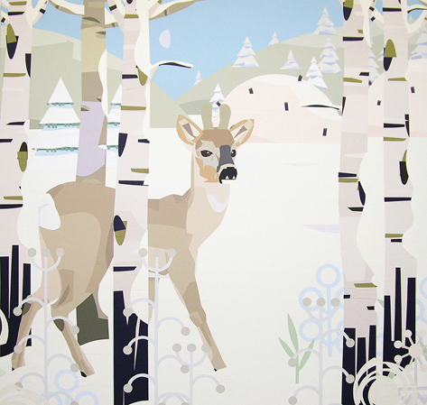

Iain Rayner

Photographic Diptychs or singular images, with a focus upon space, colour, light and ambience. This could be suspended or printed onto self-adhesive vinyl on exterior of building to conceal damaged windows.

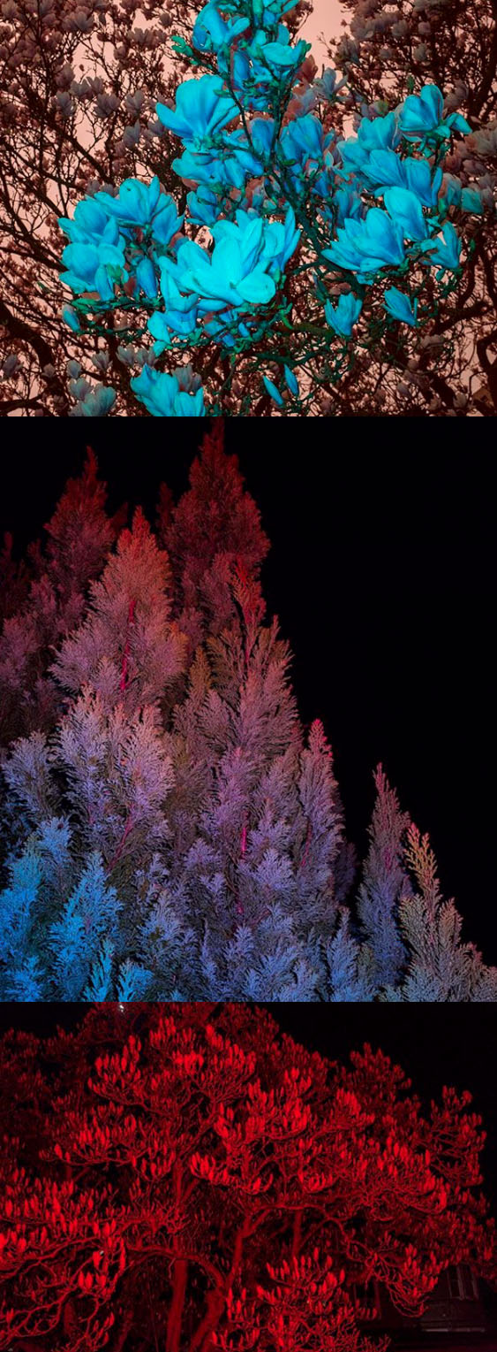
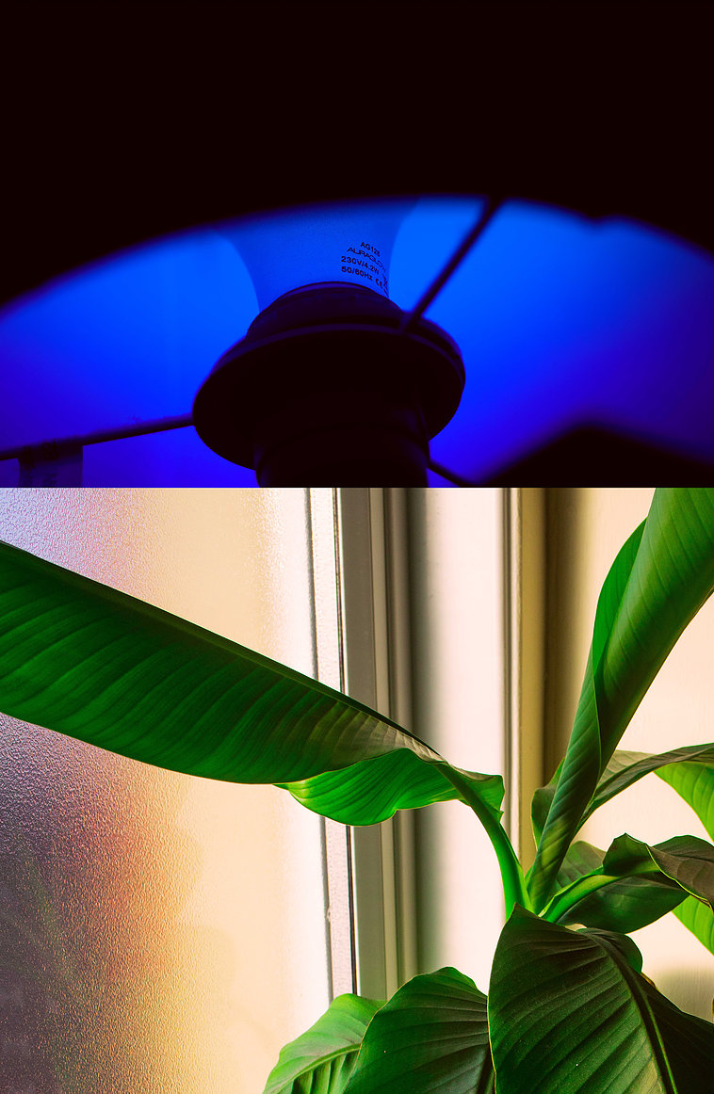

Josephine Rock

Installation incorporating imagery and objects to suggest disruptive narratives. Often Rock uses domestic items in a subversive manner – such as milk bottles with hankies to reference molotov cocktails, all displayed upon yoga matt. Last year Rock won the prestigious Cvan South East Platform Award.

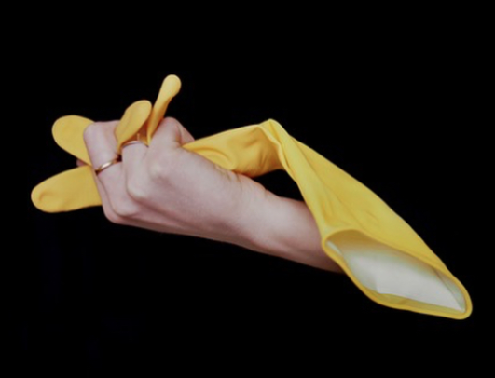

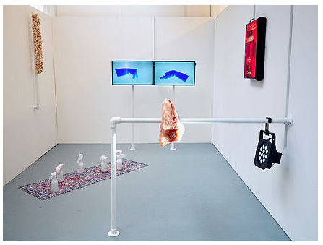

Kate Street

Large format collaged assemblages combined with sculptural props (bobbins, rubber tubing) – arranged in respond to the space. Work often engages with feminist theory and consumer consumption.

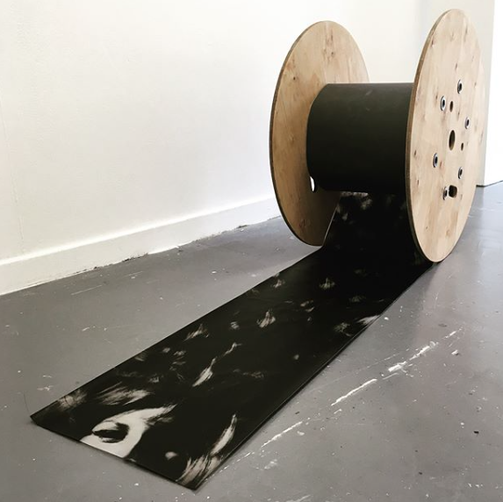
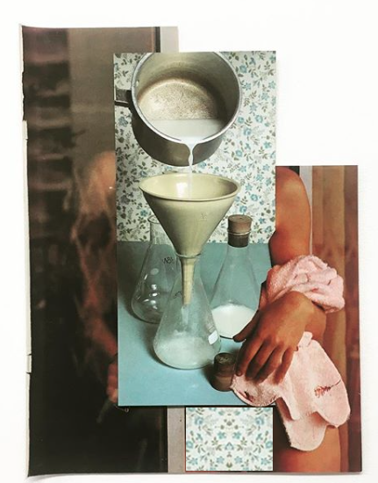

Paul Vivian

Adapted objects, casts, collages and installation – Drawn to the vernacular of the everyday Vivian’s work combines interests in the ritualistic object, the role of assemblage, folk art, materiality and the dialectical potential of things. The work is an attempt to modify objects or images enabling them to become forms of shorthand that explore ideas, referents or speculative concepts greater than their original meaning or application.

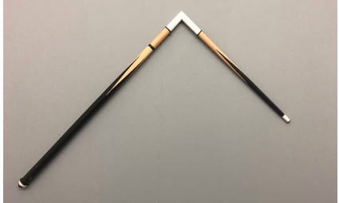

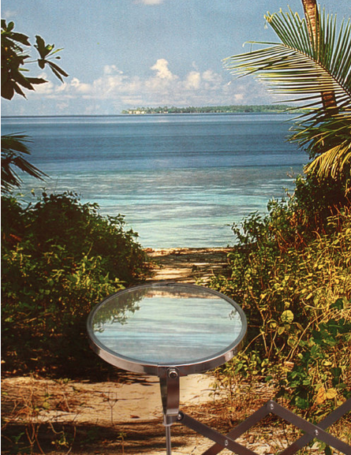
Examples of Store Front Gallery Spaces

Glass Cloud Space, Camden

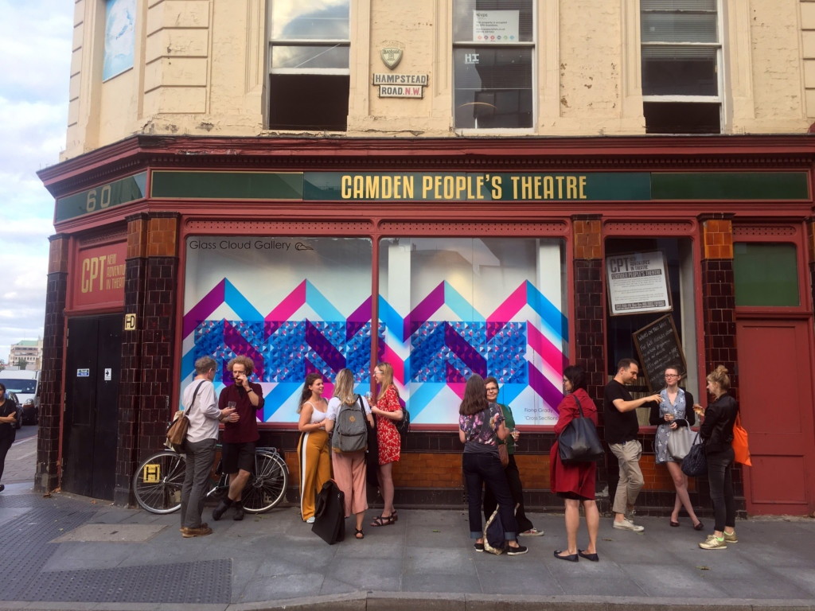

Glogauair, Berlin

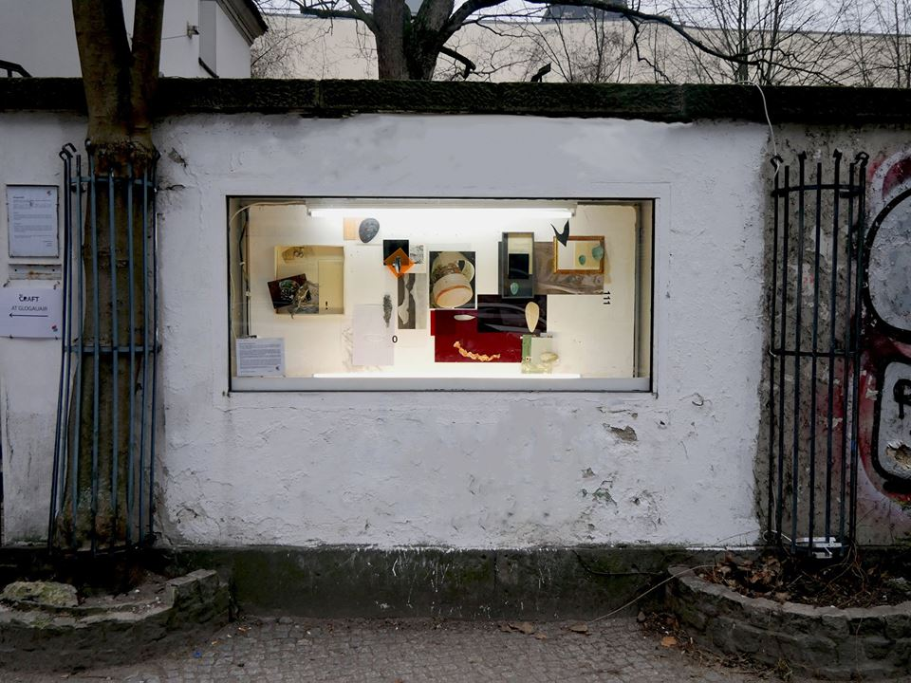

Picnic Gallery, Aylesham Centre in Peckham

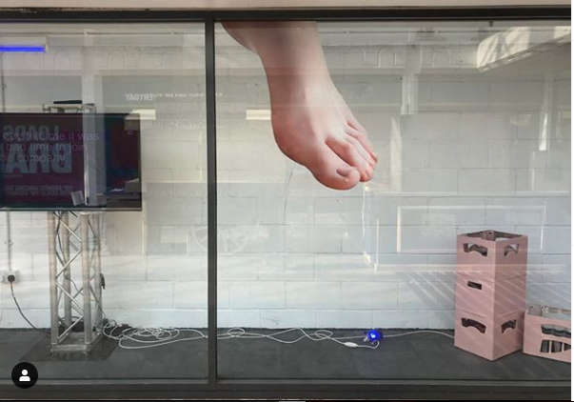
,

Central Saint Martins, archive image of Charing Cross Window Gallery

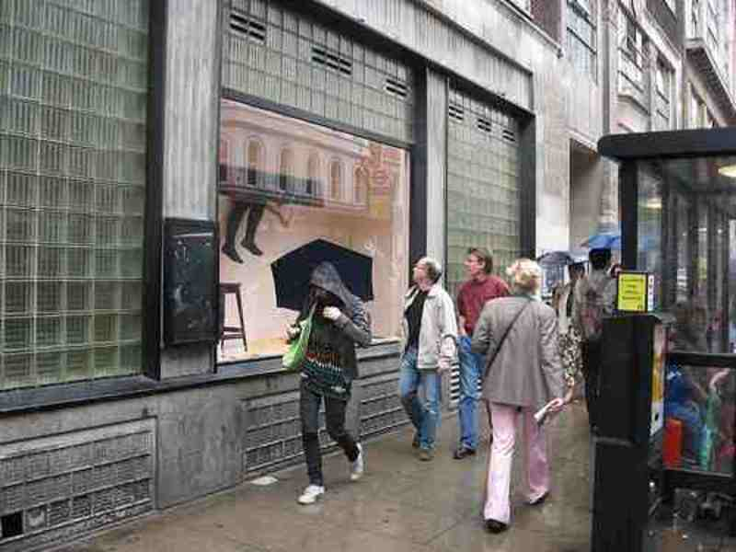

Using Windows as Space – initial visualisations of the proposed exhibition.

