Shima Kara Shima E: A Personal Perspective
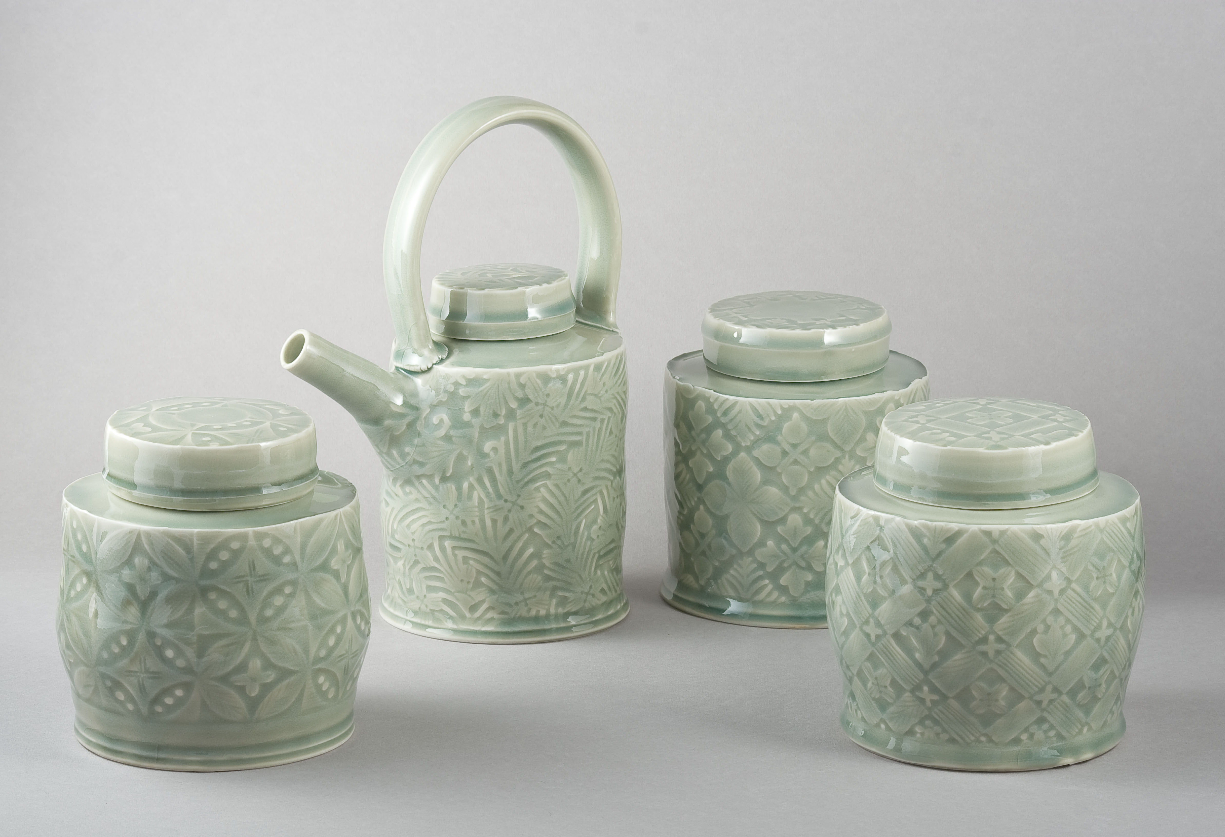
Ashley Howard UCA, Farnham, UK
Porcelain Teapot and Caddies by Ashley Howard and Risa Ohgi

At the ISCAEE (International Society for Ceramic Art Education and Exchange) 2011 exhibition in Japan, I was drawn towards a stoneware dish. I was particularly intrigued by its surface. I discovered Japanese artist, Risa Ohgi had made the piece. We began a series of conversations that led us to work on a joint project, which emerged as Shima Kara Shima E (From Island to Island).

To be part of ISCAEE is a privilege and we both felt it would be a good idea to put into practice the ISCAEE ethos of education and exchange. This provided us with a commitment to try something and we hope it will inspire other members to work more closely together.

As with any project like this getting started was a challenge. It requires the courage to simply try things and see how they develop. Ohgi and I did not know each other very well so we both had to build a relationship between each other as well as our work in order to gain an insight as to how we both approached our practice. At the same time I wanted to use the project to try new things. This I managed to do in the early stages and the experiments I tried have filtered through to my own work of late. However, once we had found a framework within which to operate it was to my earlier training that drew upon.

Given our geographical situations it was clear that initial ideas and work would have to be carried remotely. Ohgi and I spent time looking at images of eachother’s work. I was drawn toward a tiled panel she had created as part of her post-graduate studies. I took an image of this and altered it in Photoshop to create something I could trace by hand into a black and white version. From this I made a transfer. I was then able to try something new to me, which was to use enamels to colour in the resulting pattern. I felt I had made a start and we soon had some objects we could discuss. This is an important part of any project like this. To get something out of the imagination and into physical form is crucial no matter whether it is successful or not.

In February of 2012 Ohgi was able to visit the UK. She spent time at UCA producing a set of bone china stamps. Stamped patterns are a key feature of Ohgi’s work. She is expert at this practice. Seeing her at work was a significant influence on me. Up until then I was focusing on what we might produce and had not given thought as to the way it might be produced. Ohgi’s patient, slow and serene methodology caused me to rethink the way in which I go about making. This was unexpected but vital; a good example of collaboration. I used the stamps she had made to make some examples of tableware in porcelain; again we had more objects to discuss.

On the surface I was unaware of what was taking shape within me, but it now began to emerge. After making the tableware and visiting Japan in 2011, my delight in using handmade ceramics as tableware was sparked back to life. I was trained in production pottery and it formed a large part of my education. This opened up a discussion around function, functional items, rituals, and ceremonies. We had begun to find some focus that led to our eventual theme, that of tea. Ohgi and I worked around the theme of tea drinking and its associated utensils.

We began to examine culturally common areas between our two countries. Historically both nations have proved adept at ‘borrowing’ ideas from others and putting their own stamp upon them. This led me to examine my own cultural heritage, namely Stoke-on-Trent. The dialogue between the East – in particular Japan – and the West is always present in my work. This interest was fostered by my education via potters like Colin Pearson and Geoffrey Whiting.

I began to question my total acceptance that Far Eastern pottery was where my heart lay. The shadow of Bernard Leach stretched extensively across my formative years. This self-examination led me to go over some texts I read during my MA studies by Harold Bloom.

For me the drive behind Shima Kara Shima E is encapsulated in Harold Bloom’s deconstruction of the art of poetry, The Anxiety of Influence. Bloom argued that the influence of previous artists sets up an anxiety that hinders the creative process. In his view, only ‘strong’ artists - essentially, those who are capable of acknowledging rather than copying - can create original work.

I believe that replication has played a significant role in western studio pottery, and that a ‘faux-Japanese’ look and style can become something of a cliché.
Shima Kara Shima E aims to acknowledge the separate ceramic traditions of East and West and explore ways in which they may sit literally side by side. I hope the resulting exhibitions will provoke a re-evaluation of the East-West relationship in ceramics. I realise the above is quite a contentious remark. It raises all sorts of questions around cultural integrity and identity. I am as guilty as the next western potter who has made his or her own versions of a tea bowl and still love doing it and always will.

In the summer of 2012 I visited Tokyo Geidai and worked there to produce the forms that Ohgi would later decorate. The range of stoneware and porcelain tableware I made was loosely inspired by historical industrial designs from Stoke-on-Trent. Cleaner lines and crisper profiles began to emerge, which in turn would provide a more suitable ‘canvas’ for Ohgi to decorate. Due to time constraints the evolution of the project automatically dictated me making forms while Ohgi dealt with the surface. This sets the scene for a possible future project where our roles would be swapped. My own recent work with enamels has been heavily influenced by my involvement in this project.

Over the summer of 2014, I was in Japan again and we produced some more work. The time spans between our making sessions allowed us to attract attention and raise anticipation of Shima Kara Shima E. We had arranged funding for travel, shipment of works and a catalogue that featured main articles by Professors Simon Olding and Fumio Shimada. Dr Bonnie Kemske provided a short article in support. Kempske is a leader in the field of the East/West relationship. Our project captured the imagination of the Leach Pottery in St Ives, Cornwall. Director of the Pottery, Julia Twomlow provided a further article and a most appropriate opening venue. The exhibition then travelled to UCA, Farnham. While showing at UCA, a one-day symposium was arranged to support the issues raised in our project. Our speakers were Professor Simon Olding, Felicity Ayliff, Dr Bonnie Kemske, Namiko Murakoshi and myself.

At a simple level, Shima Kara Shima E has been about just seeing what happens; then to come away with more exciting and stimulating questions rather than seek out any significant answers.

Ashley Howard

