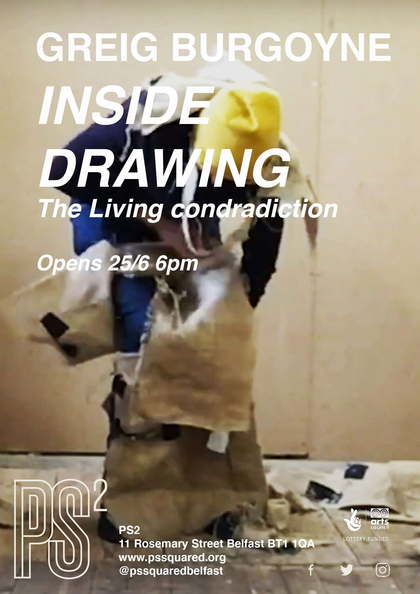

Greig Burgoyne
Inside drawing- The living contradiction
PS2 Belfast
20/6-26/6 with live performance 26/6 6pm onwards

Meaning is invisible, but the visible is not the contradiction of the visible. The visible itself has an inner framework- membrane, and the invisible is the secret counterpart of the visible. It appears only within it.. one cannot see it there and every effort to see it makes it disappear, but it is in the line of the visible. The visible is pregnant with the invisible. The visible and the invisible / Merleau-Ponty

The living contradiction is a five-day residency culminating in a series of works that respond to the site that is PS2. Through installation, film and live performance Burgoyne’s practice is a rule based, process led but expansive drawing practice wrestling body, site relations and their subsequent paradoxes. Often verging on the absurd, the outcomes he sees as residual scraps of that forming and unforming that is the interplay between appearance and presentness. During his time in PS2 he seeks to continue his focus on phenomenological concerns around invisibility and visibility e.g. what is present when we draw, and where is this actuality located.
The title of this new project, and his first in Belfast, derives from a term discussed by Emmanuel Levinas, living contradiction is namely the past orientated nature of our daily existence alongside a future directed intentionality, as such our lives oscillate between two fluid and divergent paths. In terms of drawing, Burgoyne seeks to both expand and paradoxically disperse the traditional trope of drawing as a means to cover. Contesting that drawing is a manifestation of surfaces or exteriorities, Burgoyne offers up situations that by the act of covering are in fact seeking to unconceal the thingness of drawing that resides within that materiality- its drawingness. In doings so, Inside drawing-The living contradiction offers a series of propositions in the form of installation, film and live performance less based on what has appeared or appearance per se, but instead indicative of drawing as an incessant coming into appearance. Between thing and event, object and subject, embodiment and worlding.

PS²
11 Rosemary Street
Belfast BT1 1QA
UK
Tel: +44 (0)28 90235912
Mob: +44 (0)7733457772
Email: info@pssquared.org

