https://creativeeducationnetwork.com/2018/07/11/the-impact-of-internationalisation-on-the-uca-curriculum-tomasz-john-and-john-sutter/

The impact of internationalisation on the UCA curriculum – Tomasz John and John Sutter
Posted on July 11, 2018 by tonyjreeves
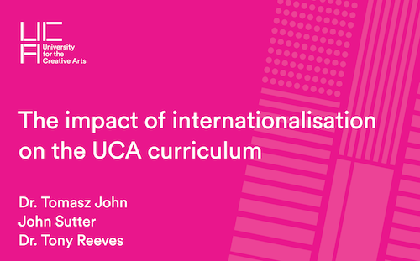

Webinar recording: The impact of internationalisation on the UCA curriculum
- Dr. Tomasz John (EAP Coordinator and researcher in the internationalisation of HE)
- John Sutter (Learning Enhancement Manager)
- Dr. Tony Reeves (Subject Leader, Creative Education)
UCA’s increased focus on internationalisation presents implications for the design and delivery of our courses. Ensuring the success of international students will require inclusive and intercultural approaches to teaching, learning and assessment, and a clear awareness of the linguistic requirements of increasingly international cohorts.
In this webinar, UCA’s Dr. Tomasz John and John Sutter outline some key issues and strategies to help course teams prepare for an increasingly international student body. Hosted by Dr. Tony Reeves, this webinar will be of interest to anyone involved in designing curricula, preparing teaching sessions or writing documentation for international students.
View the webinar recording
Download the recording as an audio file
Approximate structure of discussion:
- 1m 20 – What does an increasingly internationalised university look like?
- 3m 10 – What are the implications of the new internationalisation strategy for UCA curriculum?
- 6m 40 – Tips for enhancing curriculum design and delivery
- 16m – Giving students more voice in co-creating curriculum
- 17m 30 – How will academic staff be supported in developing an increasingly internationalised curriculum?
- 24m 50 – How does internationalisation affect how we communicate with students?
- 31m 30 – The issues that the ‘wellbeing’ agenda presents for international students
- 36m 20 – The importance of making expectations and assumptions more explicit

