The Bedsheet: from linen cupboard to art gallery
Beverly Ayling-Smith
International Textile Research Centre, University for the Creative Arts, Falkner Road, Farnham, GU9 7DS
baylingsmith.t1@ucreative.ac.uk

Dr. Beverly Ayling-Smith is an artist and researcher. Her doctoral research examined how cloth can be used as a metaphor for loss and how it can connect with the emotions of the viewer. Beverly has exhibited widely in the UK and internationally, has work in the Whitworth Art Gallery collection in the UK and in collections in the USA. She has presented her research at international conferences and has had her work published in the UK.

The bedsheet: from linen cupboard to art gallery

Abstract
The choice of material in the creation of artwork is vital to the communication of the meaning of the work.
Bedsheets act as silent witnesses to many natural processes in life such as birth, puberty, pleasure, disease, decay and death. At a time of day when we are wearing little clothing, or perhaps none at all, the bedsheet is in contact with the body for many hours every night, soaking up sweat and bodily fluids to create a very personal cloth impregnated with the identity of a person. The bedsheet can become a material on which to literally or metaphorically write our meanings and messages to the world.
This paper will discuss the materiality of the bedsheet, an everyday and humble cloth. It will reference the work of artists including Ewa Kuryluk who used sheets in her work and draw on my own research into the use of materials to carry metaphors of grief and loss. It will be illustrated by my recent works using bedsheets to make a connection with the emotions of the viewer.

Keywords: textiles, cloth, grief, bedsheet, art, metaphor

Cloth as metaphor
The choice of material in the creation of artwork is vital to the communication of the meaning of the work, be it concept, narrative or metaphor. Our daily experience and interaction with cloth means that we have an intimate, but usually unspoken knowledge and range of emotions associated with it. Textiles have a memory, they bear witness to life events and are at the core of everyday experience. The domestic collection of textiles called ‘the laundry’ encompasses clothing as well as household linens and mediates between our bodies and the world, involving the senses, becoming a repository of memories, which can be activated in a moment by the sight of a fabric, the touch or smell of cloth or the rustle of textile as it moves.
The relationship between text and textiles, words and cloth is apparent in the metaphors we use to think and to express our emotions, thoughts and feelings.
For many years metaphors were considered solely as a feature of language, figures of speech and an area of study for linguists and philosophers. In recent years metaphor has become recognised as also being a mode of cognition – a way in which we think and ascribe meaning to thoughts and emotions.
Metaphor is a commonly used linguistic tool that enables the understanding of a concept by the use of more familiar concepts or imagery. The term metaphor comes from the Greek metaphora which means to transfer or transport. In using metaphor there is a transfer of meaning from one domain of knowledge to another (Modell 1997, 106). Zoltán Kövecses defines this as “understanding one conceptual domain in terms of another conceptual domain” (2010, 4). This is true not just in language but also in our thought processes as well, as the “human conceptual system is metaphorically structured and defined” (Lakoff and Johnson 1980, 6). Arnold Modell has stated that “metaphor is central to the imagination” and that “metaphor (is) the currency of the mind” (2009, 6). Typically, metaphors are used to enable the understanding of vague concepts by using concepts that are more clearly defined in our experience.
Although common in everyday speech, metaphors are particularly prevalent in poetry and literature. Poets and novelists particularly use image based metaphors employing techniques such as extensions, elaborations, questioning and combining of metaphors to create “a novel and unconventional language” (Kövecses 2010, 53). The use of metaphors is particularly useful for understanding and discussing emotions. An emotion that is as complex as grief requires figures of speech such as metaphors and similes to enable the understanding and communication of the feelings being experienced. Modell suggests that translating feelings beyond our control into metaphors “provides us with a schema that enables some degree of organisation and control” (1997, 107).
The use of the particular definition of metaphor as one thing standing in for another has echoes of the symbolic. Psychoanalytical theory has emphasised the importance of symbolic imagery and in The Interpretation of Dreams first published in 1900, Freud posited that the images in dreams act as a carrier of meaning where, as Modell describes, “something objectionable is replaced by something that is less objectionable” (1997, 106). Symbols can be thought of as impersonal metaphors whose meaning is derived from myth. Freud proposed that symbols in dreams have fixed meanings which can be decoded. Symbols have been defined as something representing something else in an arbitrary fashion, “an emblem, token or sign” which may be a colour or something immaterial. For example, a dream about teeth falling out is not a metaphor for concern about physical deterioration but is a symbol for apparently unrelated trauma. Whilst symbols are a one-to-one sign for something, metaphor is an “implied indirect comparison between two, often unlike things” (Brandl, n.d.). Modell suggests that dreaming generates visual metaphors and that metaphor can be thought of as a thought process, a “fundamental and indispensable structure of human understanding, a basic and irreducible unit of mental functioning”. This would suggest that metaphors are used to understand the interactions of our body in the world. Our internal thoughts and feelings are “projected outwards as metaphoric categories applied to the real world, while at the same time the interaction with the real world can be categorized metaphorically” (Modell 1997, 109).
We therefore have a way of thinking about emotions and traumatic events through the use of metaphors that are internal or private. These metaphors can be used by an artist to express feelings and emotions within the artwork itself and “offered to the viewing public to be shared” (Modell 1997, 109). Placing works of art in the public domain, which have been created from traumatic private experience and expressed by the use of private visual metaphors, may mean that it is not immediately apparent to the viewer what the work is about. But the common visual imagery shared by the individuals of a culture may resonate with the private metaphors of the viewer.
Kövecses concludes that some conceptual metaphors do seem to be near universal and that they develop from ‘certain commonalities in human experience’ (Kövecses 2010, 217). The common experience of interacting with cloth and the encounter with the clothes of the deceased, either to keep as a reminder or to sort through before disposal, means that the creation of artwork using cloth as a metaphor for life is immediately accessible across cultural boundaries. Modell also states that:
Metaphor is central to the communication and interpretation of unconscious meaning. One therapeutic effect of making the unconscious conscious is the creation of new meanings that expand the sense of the agency of the self. There is then a synergistic effect: with an expanded sense of agency there is also an expanded awareness of the complexity of metaphor, which, in turn, can recontextualize the traumatic memories (2009, 10).

When discussing painting, Virgil Aldrich proposes that there are three components needed to create a visual metaphor (in painting); the materials, the subject matter and the content. This could be applied to textile art, with the colours, textures and fabrics used as the materials. The subject matter is also equivalent, and the content is the outcome of the interaction of the material(s) and the subject matter. Aldrich describes the interaction of the components as a “transfiguration of the material and the subject matter in the content or emergent meaning” (1968, 79). Carl Hausman explains how the use of metaphor works in relation to visual metaphors and works of art.
Art shares with verbal metaphors the incorporation of meaning units from the world as it is apprehended literally, that is, in terms of standard, conventional contexts. Meanings are brought together in contexts that are strange in relation to the literally understood world, and they are transformed through a kind of interaction that is constituted by internal relations, just as the elements or terms of a verbal metaphor understood as antecedently significant have their significance changed when they interact internally with the other terms in their constitutive functions (1989, 142).
The fact that metaphors can convey ideas that are difficult to put into words has been used by grief counsellors in group therapy creative writing sessions to allow the bereaved to acknowledge and express their feelings of loss and also to decrease their sense of isolation.
Textile artists also use metaphor to create work which conveys a feeling or emotion. For example, the textile artist Michele Walker has created work as an act of mourning for her mother who died from Alzheimer’s disease. Called ‘Memoriam’, it is a made from layered plastic sheeting and wire wool. Made in the tradition of a commemorative quilt, the stitching of the clear plastic surface layer is based on the crease patterns of Walker’s own skin. The wire wool is used as a metaphor for decay but is subject to decay itself over time - the pain Walker experienced in creating the quilt using wire wool was a physical manifestation of the emotional pain of losing her mother to the disease. The border of the quilt is of knotted wire wool is a fringe and references the way her mother used to continually twist her hair in the latter stages of her Alzheimer’s disease. The quilt is traditionally an inherited item passed from generation to generation, retaining memory, but Walker’s quilt is used instead to mark the loss of that memory through disease.

The materiality of cloth
The use of such a ubiquitous substance as textile in artwork involves a transformation from a basic common material - a humble cloth such as a bedsheet - into an artwork of depth by exploring the poetics of its materiality.
The term materiality can be used to describe both the physical properties of cloth but also its ability to contain within it layers of meaning to convey complex ideas and emotional states. Rather than just a description of its functionality, it is this materiality that allows for the properties of the cloth and its associated appearance and the way it works, acts and feels to enable emotional connections to be made.
The functional materiality of cloth includes properties such as its weave structure, or in the case of non-woven textiles, its pattern of fibres, colour, surface pattern and texture. All these contribute to the way the cloth drapes and folds and the way in which it can be manipulated. Its fragility and susceptibility to decay and degree of impermanence inform the artists choices as to which cloth is chosen to be used in a particular work - how its performance relates to the outcome. The sensory experience for the user - visual or tactile, creates an interaction, an emotional value, an interaction, a cathexis. Be it through structure or texture, odour, temperature or weight each and all inform the way in which the viewer experiences, and responds to, the textile. The artist Ewa Kuryluk has written that:
Light, portable and flexible, cloth is ideal for picturing the flow and ruptures of inner life. Cloth, as it is folded and unfolded, stored away and unrolled, seems suitable for representing memory, both as a texture woven in a laborious process, and as a sequence of images and words impregnating the fabric with mercurial speed (1991, 180).
The nature of cloth and its associations with the body also has sensual aspects as described by Germano Celant writing about the use of cloth in the work of Louise Bourgeois:
A tactile and substantial element that can be taken as epidermis, as carnal epiphany of a fluidity or a rigidity. In addition, fabric always implies something that lies beneath, alluding to a substance that looks to be veiled, if not shadowy. A subterranean almost always carnal world, one linked to suffering and pain, to joy, and to physical and concrete memories that appear through the outlines of the woven surface (2010, 13).
It is in this way that cloth can evoke the sensuous and more complex layers of meaning by the interweaving of technique with culture, references and narrative when used in the creation of artwork. As Janis Jefferies has described, “the materiality of cloth…lies in the way it receives the human imprint; cloth smells of mortality as much as it carries the signs of sweated…labour” (2007, 284).
Arguably, one of the cloths with which we have the most physical contact is the bedsheet and in thinking about cloth as bedsheet we first we might consider what the bedsheet actually is. This plain woven broadloom cloth usually has hems at the top and bottom, the top hem being larger so as to identify which end is which. The sides are sometimes hemmed but often the selvedges or finished edges as it is made on the loom are used as the side seams. Bedsheets were traditionally made from linen – hence the term household linens, and later from cotton or silk. They were a component of the trousseau brought by the bride to her new household, embroidered with monograms and added to with both new and inherited linens over the years.
The smooth piles of clean bedsheets in the linen cupboard, ironed and folded speak of purity and order, cleanliness and care. As the poet Collete Wartz has written “Orderliness. Harmony. Piles of sheets in the wardrobe. Lavender in the linen”. (Colette Wartz cited in Bachelard 1994, 79). Gaston Bachelard described how “memories come flooding in when we look back upon the shelf on which the lace trim batiste and muslin pieces lay on top of the heavier material” suggesting that the piles of folded sheets contain within them the memory both of the family and of the events in the physical body for which the sheets have been present. (Bachelard 1994, 79)
“A wardrobe– that is, armoire, or linen cupboard,” writes Milosz – “is filled with the mute tumult of memories” (Milosz cited in Bachelard 1994, 79). In Greek mythology Mnemosyne was the personification of memory, and was thought of as the mother of the Muses. The Greeks considered memory to be the birthplace of inspiration and Mnemosyne was a female, draped in lengths of cloth.

Bedsheets are nightly in contact with the body, with its skin and so they absorb the fluids emanating from it. Mary Douglas states that all margins are dangerous and that the orifices of the body represent the (bodily) margins of the body (1994, 150). Anything issuing forth from the body such as blood, milk, urine, faeces, saliva and tears has traversed the boundary of the body and will be absorbed by the sheet. The sheet then becomes a repository of what Julia Kristeva described as the abject – something that was originally a part of the body which has been expelled and is now other. A reminder of physicality and activity, a stained and creased record of what has gone before.
In her article ‘On cloth, stigma and shame’ Jenni Sorkin argues that stains elicit the idea of shame, and she draws the distinction between self-staining - nosebleeds, vomiting, bedwetting etc. with staining of another. “To stain another is to mark. To be marked is dark. This darkness is constant foreboding and permanent grief” (2001, 79). Yet the stain is one which is used to represent emotional experience and trauma - for example the stain of rejection and the lifelong grief it caused in the work of Louise Bourgeois. Pennina Barnett argues that “as cloth clings to the body so it becomes a second skin, a metaphor for the layer between ourselves and others” (2008, 203). In her essay ‘Stain’, she associates the idea of stain with Kristeva’s concept of the abject - the bodily fluids “such as blood mucous, saliva, semen, excreta attract our attention and curiosity, yet elicit horror and disgust” (2008, 204). She also asserts that the abject represents an in-between, as these fluids are not quite separate from the body but at the same time are not actually part of the body. Nothing is likely to create such an extreme feeling of disgust, almost nauseating, than the thought of sleeping in someone else’s used and stained (‘soiled’) sheets particularly if this is discovered after the event.
This nightly absorption of different sorts of bodily fluids and the revulsion that it induces sits alongside the endless task of the laundering of bedsheets and the drive to achieve order in the linen cupboard.

The bedsheet can also reference the absent body – in ‘Le Lit Defait’ by Eugene Delacroix the tousled sheets speak of intimacy and pleasure as if the bed has only recently been vacated and is still warm. Piles of bedsheets imply piles of bodies suggestive of desire – or perhaps of violence, as is echoed in Tracey Emin’s work ‘My bed’.
The textile artist Anne Wilson uses hair to repair holes in traditional household linens. The mending of linens with hair echoes the tending and mending processes undertaken by the family who owned the cloths. Repeatedly used, then washed, ironed and mended, time and time again, these cloths, used for celebrations and family gatherings, hold the memory and history of the family. Stitching with hair onto these cloths to mend the holes recalls the painstaking labour of mending, and creating a new cloth, like a shroud to hold the memory of the family.
Wilson uses a combination of the pure and the abject in her work. The pure is represented by the use of white cloth, linen, and the patient labour of women in the laundering and repair of the cloth. This is contrasted by the use of hair – a reminder of the abject absent body, the holes suggesting the orifices and wounds rife with disease or decay.
Edmund White, writing about the bed-sheets used by the Polish artist Ewa Kuryluk lists the different functions of the bed-sheet:
to cover the sick, the operable, the dying, the dead. They are soaked in night sweats, fever sweats, death sweats. They conceal the emaciated or wounded body in a toga of modesty and expose its most shameful details in a clinging chiton of intimacy … the sheets thrown over the corpse in the morgue; the sheets the lover draws over the exposed shoulder of his sleeping partner; the sheet the child wets and that must be stripped, carried off, changed; the sheet shredded into tourniquets, dressings, sanitary belts; the sheet that reminds the wife of her virginal past; the sheet that suggests to the virgin a future, of lust (1987, 17).
Kuryluk uses thin cotton sheets as her medium on which to draw her figures, evoking Veronicas veil. She says the cotton has the organic quality of skin and describes it as a “membrane of memory”, which she scars with her felt pens. In her early work, she kept the sheets flat and drew the folds onto the surface. But in the 1970’s and 80’s she began making them more three dimensional, like piles of shrouds scattered on the ground.
In contrast to the solidity and permanence of the linen cupboard in the home – the packing up of Kuryluks painted cloths into a single suitcase speaks of the art of the exile or perhaps of the refugee. Forced into voluntary exile by the declaration of Martial law in Poland while she was organising an exhibition of her work in Boston, Kuryluk seemingly responded to this by working on cloth which is draped over chairs or hung on strings in the gallery like laundry hung out to dry. It can be packed up at a moment’s notice and taken to another venue and shown in an infinite variety of combinations and orientations.
Working on sheets in this way Kuryluk says gives her the feeling that “I take prints out of myself, that I externalize impressions, that I unroll and cut into pieces the scroll of memory with imprints of face and of gestures, to become visible on sheets, shrouds and tablecloths”.
Kuryluk produced work for an exhibition of Erotic Art making drawings on bedsheets showing the outlines of a couple and developed the idea of a room of memories with “depicted objects reduced to shadows and contours” (1981, 268).

Using a bedsheet in an art gallery relocates the liminal surface, the boundary between the private cloth, private self, body and being, into the public cloth of ceremonial birthing and funeral shroud, a public space, open and available, inviting scrutiny and evaluation.
Removal from the domestic (female) setting/domain of washing and ironing to the art gallery dominated by the masculine artist, the bedsheet retains its liminal status – not of one world or the other but of both. It is a witness to traumatic events and passions and able to become, by translocation and transformation, a powerful resource to be a carrier of memory and transmitter of emotions.
In my own work, in the piece ‘Seven’ I have used bedsheets, hanging in the style of shrouds from the seventeenth century. This style of shroud may be familiar as it was used in the sculpture of John Donne in St Paul’s Cathedral.
John Donne was a metaphysical poet and former Dean of St Paul’s. He was known to have sat for the painting of his portrait in his shroud and had the portrait by his bedside in the weeks leading up to his death.
In my work, ‘Seven’, however, the sheets are empty, but the number seven references the seven people of my acquaintance who died in a short period of time and so for me, they reference the absent body. Using the number seven is a way of honouring and remembering those who died. Adjacent to the seven hanging sheets are piles of sheets, ready to be used, suggesting that one day – we will all be shrouded.
In contrast to the elegance, presence and eternal memorialisation in the sculpture of John Donne in his shroud, bedsheets are usually seen flat, smooth and horizontal, reminding us of rest, repose and sleep. In ‘The Iliad’, Homer described Hypnos and Thanatos (Sleep and Death) as twin brothers and the sons of Nyx and Erebos (Night and Darkness). The notices of a person’s death, printed in the newspaper often emphasise that the person died peacefully. When someone we love dies, the world seems to stand still, as the loss makes its impact on our lives.
In my piece ‘One day at a time’ the death notices printed in the newspaper have been printed onto a sheet, torn into individual notices and stitched onto another sheet - one at a time. It was made every day from October 2015 – October 2016.
This work reflects on the period immediately following bereavement, when, in the grip of overwhelming grief the only way to manage each day is to do something small, an act to get you through, one day at a time. As grief is acknowledged every day, so healing will take place one day at a time.
The series of work called ‘Mendings’ also uses small fragments of bedsheet that have been stained and torn. The pieces are then stitched to mend them, patched and pieced together and then assembled to reference the series of life events, hurts and wounds that make up a person. As Jenni Sorkin writes – “fresh stains are the sores of a fabric, raw wounds that map an event” (2000, 78).
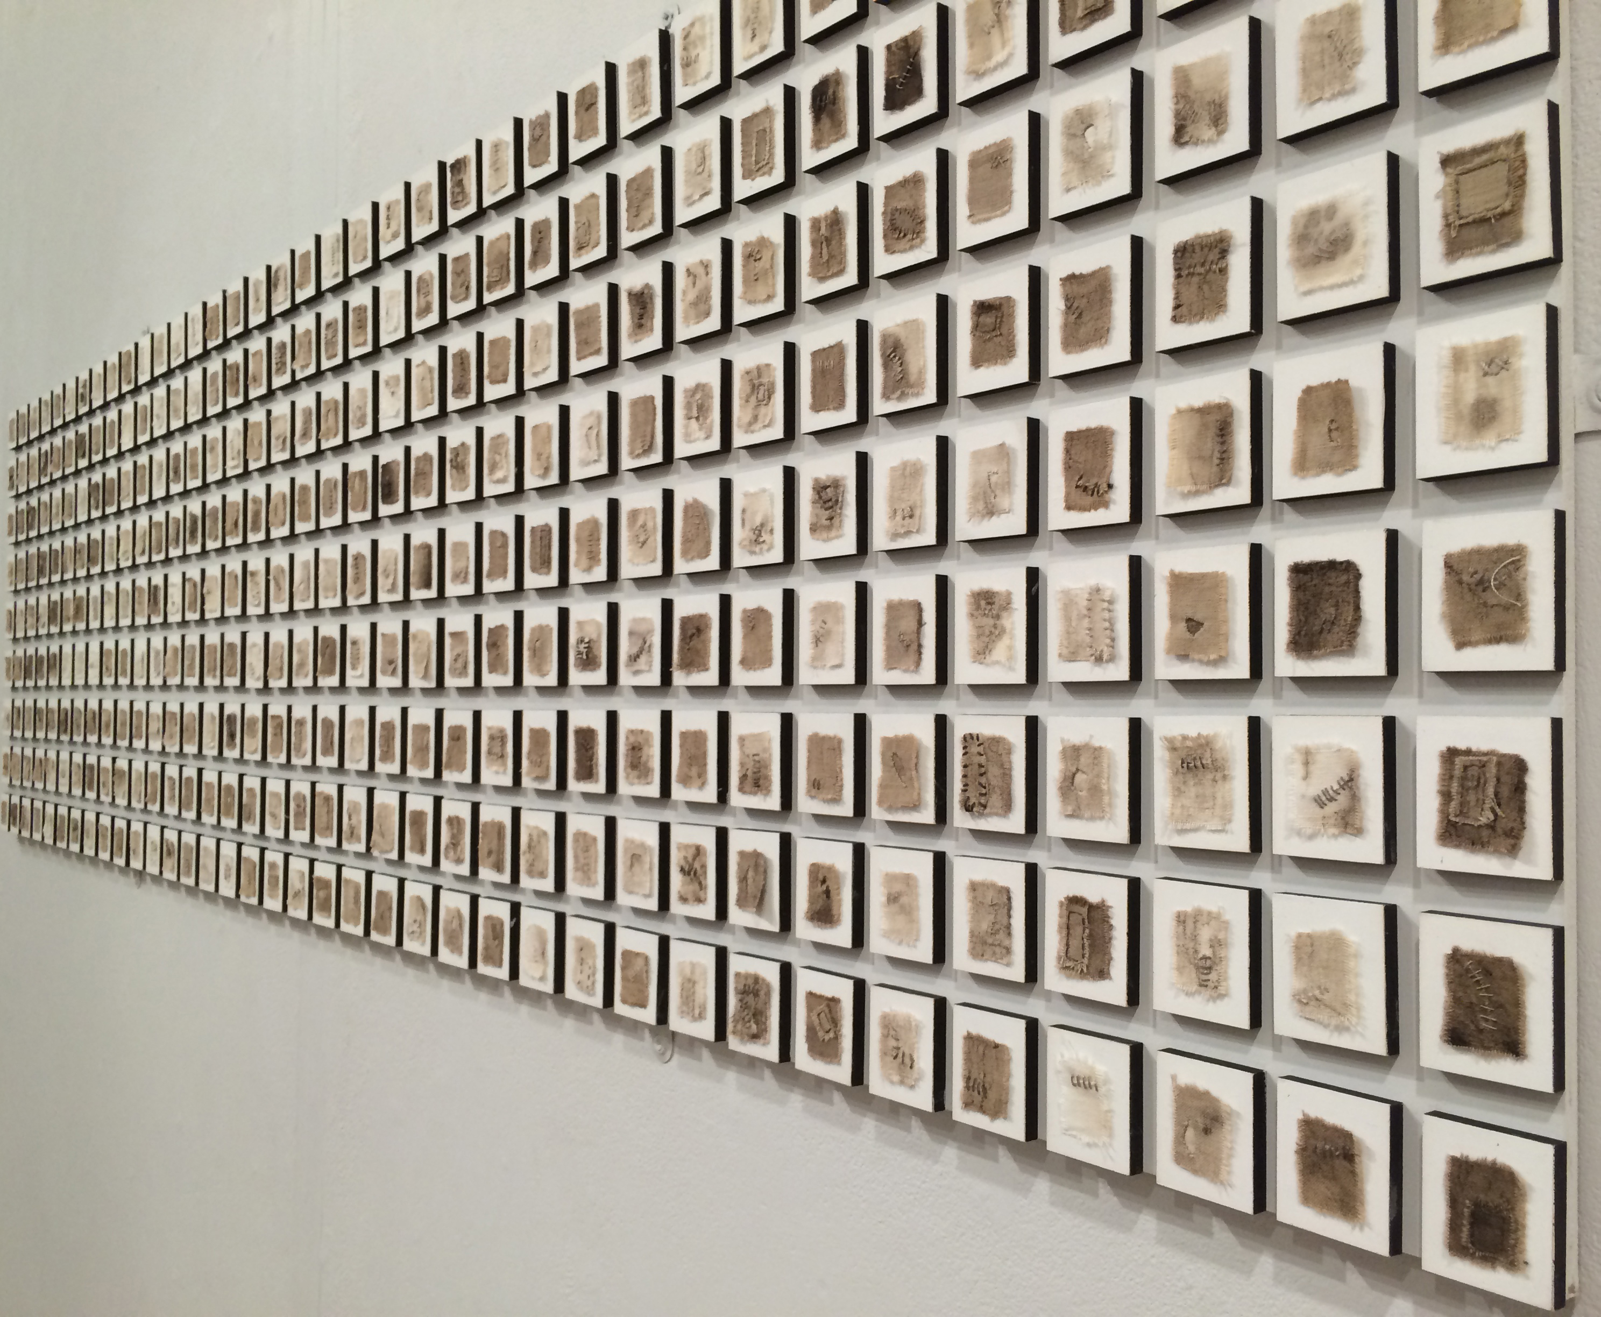
The bedsheets I use have, to me, a special provenance. They are Field hospital bedsheets from the Second World War, found in a bunker in France after the end of the war. Their significance to me is that a member of my family was wounded a few days after D-Day and was hospitalised in France for some time. A personal significance that makes the use of the bedsheet for this work the most appropriate material for me to use for this type of work at this time.
Whilst it may be the most suitable type of cloth in my work – how it is received and perceived by the audience is also important. The bedsheet will hold many memories for the viewer – it may trigger memories of other artworks that use sheets, or other uses of the sheet. But it is also likely to remind the viewer of their own personal experience of bedsheets – the repeated and endless tasks of washing, folding, ironing and putting away. This care of linen and the processes involved in ironing – those of smoothing, steaming and folding can be seen in this video created during the preparation of the piles of sheets in the work ‘Seven’.
https://vimeo.com/250440299
The intimacy of the touch of the sheet – the covering of the naked body, the witness to pleasure and pain, illness and even death - these memories of the viewer might then be used to compete the artwork – as described by Umberto Eco (1989) – that the work of art may have an undefined meaning which has to be completed by the viewer acting as interpreter, according to their own knowledge and personal experiences.
The use of the bedsheet therefore creates a connection with the audience and allows for exchanges with them to address shared experiences in the world. As Janis Jefferies has written:
The possibility of a shared solace may be achieved by identification via a sense of sight and physical sensation. Each of the senses may be activated by a circuit of interwoven memories, triggered and registered by and in the body or bodies of both the artists and the viewer (Jefferies 2000, 66).
The artwork therefore acts as a catalyst for the viewer to remember, by finding common shared experiences or emotions in their own lives and so “find a better understanding of the self” (Smith 2012, 11).
The materiality of cloth is fundamentally important to how it can be used in textile artwork to work as a medium for conveying ideas thoughts and feelings and a rich site and source of metaphor in many cultures. Elzbieta Grabska wrote that “it is cloth, which after centuries of closeness with the human body, acquires, thanks to the artist’s imagination, new existential and ritual dimensions and becomes a symbol and medium for tracing the passing or the artist’s and our own time” (Kuryluk 1987, 25). The way that cloth is perceived in the gallery is mediated by our own day-to-day experience of it. This makes cloth and, I would argue, the bedsheet a most eloquent substrate to contain, hold and represent emotions and has the potential to make a connection with the viewer whether in the linen cupboard or in the art gallery.
(4432 words)

References

Aldrich, Virgil. 1968. ‘Visual Metaphor’. Journal of Aesthetic Education 2 (1): 73–87.

Bachelard, Gaston. 1994. The Poetics of Space. Boston: Beacon Press.

Barnett, Pennina. 2008. ‘Stain’. In Shame and Sexuality, 203–15. Routledge.

Celant, G. 2010. Louise Bourgeois: The Fabric Works. Skira Editore.

Douglas, Professor Mary. 1966. Purity and Danger: An Analysis of Concepts of Pollution and Taboo. 1st ed. Routledge.

Eco, Umberto, and David Robey. 1989. The Open Work. Translated by Anna Cancogni. Cambridge, Mass: Harvard University Press.

Hausman, Carl R. 1989. Metaphor and Art. Interactionism and Reference in the Verbal and Nonverbal Arts. Cambridge University Press.

Jefferies, Janis. 2000. Selvedges: Janis Jefferies : Writings and Artworks since 1980 / Edited by Victoria Mitchell. Norwich Gallery.

Jefferies, Janis. 2007. ‘Laboured Cloth’. In The Object of Labour: Art, Cloth and Cultural Production, edited by Joan Livingstone and John Ploof. MIT Press.

Kovecses, Zoltan. 2010. Metaphor: A Practical Introduction. Oxford University Press.

Lakoff, George, and Mark Johnson. 1980. Metaphors We Live By. The University of Chicago Press.

Modell, Arnold. 1997. ‘The Synergy of Memory, Affects and Metaphor’. Journal of Analytical Psychology 42: 105–17.

Smith, Matthew. 2012. ‘Relational Viewing: Affect, Trauma and the Viewer in Contemporary Autobiograhical Art.’ London, Ontario, Canada: The University of Western Ontario.

Sorkin, J. 2001. ‘Stain: On Cloth, Stigma and Shame’. Third Text 53.

White, Edmund. 1987. ‘Ewa Kuryluk An Exile’s Art’. In The Fabric of Memory Ewa Kuryluk: Cloth Works 1978 - 1987, 13–20. Wilmette, Illinois: Formations.

