Alien on the inside: the adaptation of Stephen King’s alien possession tales

Wickham Clayton

Abstract: Stephen King’s work, highly informed and influenced by sf traditions of the 1950s and 1960s, often fuses these sensibilities with the genre for which he has become known, horror. This has resulted in a very specific genre hybrid that King has used in two novels adapted for film and television, which I call the alien possession tale. In these stories, humans become subject to the influences of extra-terrestrial consciousnesses, blending the sf alien invasion subgenre with the horror possession subgenre. The Tommyknockers (1988) and Dreamcatcher (2001) blend these two subgenres into distinct hybrid stories. While the novels very clearly highlight both the aesthetics and the inherent fears embedded in the sf narratives from the 1950s and 1960s, the adaptations – The Tommyknockers as television miniseries (US 1993) and Dreamcatcher as a feature film (Kasdan US 2003)—tend to capitalise and focus upon the elements of the genre for which is known King as a master: horror. This article addresses this genre hybridity and the shifting genre emphasis between original narrative and adaptation. It looks at the horror tendencies within the adaptations, which mute sf elements, and King’s straight possession tale Desperation (novel 1996; television miniseries US 2006) to show similarities in depiction. This is done to demonstrate the tension between stories developed by King and adaptations marketed towards audiences familiar with him as a horror writer.

In the March 1971 issue of Cavalier, three years before he published his first novel, Stephen King published a short story entitled ‘I Am the Doorway’, wherein an astronaut returns from a disastrous mission, finds himself undergoing physical transformation, experiencing visions of an unearthly realm, sleepwalking and harbouring the uncontrollable impulse to kill. Throughout the course of the tale, it becomes explicitly suggested that on this mission, the astronaut has become a vessel for alien control. Not only does this idea recur in longer form in two of King’s later novels, but it also has clear roots in sf stories of the 1950s and 1960s, an acknowledged influence on King himself (see Danse).
Darrell Schweitzer has described ‘I Am the Doorway’ as ‘substantially sf … But the thrust here is again toward horror’ (203). This approach to genre hybridity, particularly with respect to sf and horror, can be seen in two of King’s novels, The Tommyknockers (1988) and Dreamcatcher (2001) – the first adapted into a miniseries (US 1993), the second into a major feature film (Kasdan US 2003) – which I would categorise, like ‘I Am the Doorway’, as alien possession stories. John Sears, evoking the critical work of Heidi Stregnell, extensively establishes King as a writer of genre hybrid fiction, although he is popularly known for his association with the horror genre. This association dominates the discourse and promotion of his products and significantly affects textual transference in the process of adaptation, despite the generic content of his writing.
King’s alien possession stories can be seen not only as a combination of sf and horror but more precisely a fusion of two specific subgenres of each. First, the alien possession narrative, as developed by King, adopts the overall framework of an alien invasion narrative as seen in sf. While ultimately these are stories about alien efforts to dominate the whole of Earth’s population in some form, they can be broadly split between extraterrestrials attempting to either control (as in The Tommyknockers) or destroy (as in Dreamcatcher) the human race. Classic texts from this subgenre take several approaches to the idea of alien invasion, though arguably the endgame for the aliens is to destroy humanity. Several key texts are a part of this tradition, all approaching the idea in different ways. H.G. Wells’ novel The War of the Worlds (1898) (and its multiple adaptations on film, television and radio) depicts an alien invasion wherein humans are attacked using machines and weapons. In cinema, Invasion of the Body Snatchers (Siegel US 1956) and its remakes are about aliens that make copies of humans to replace them and infiltrate society. John Carpenter’s film The Thing (US 1982), as well as the original novella Who Goes There? (Campbell 1948), play on a similar narrative premise, focusing on an alien being that tries to imitate the physical aspects of the creatures it consumes. Furthermore, the bulk of the popular oeuvre of H. P. Lovecraft, who is especially influential on King (see Danse 80–1), is of note because Lovecraft often writes of powerful alien beings who have inhabited earth long before humans and lie dormant until evoked by those who are too curious. A key example of an alien invasion story that overtly utilises the method of controlling humans, in the same way as can be seen in The Tommyknockers, is the television series The Quatermass Experiment (UK 1953). This is a story similar to ‘I Am the Doorway’ and centres on a disastrous space exploration wherein the only surviving astronaut is infected by an alien consciousness. The sequel to The Quatermass Experiment, Quatermass II (UK 1955) not only expands upon this idea but also introduces the concept of multiple cases of infection by alien consciousnesses, which can communicate through a collective consciousness as well. These narrative notions from the first two Quatermass series hold strong links with The Tommyknockers as will be shown later. This approach of introducing alien infection, or rather possession, of humans, has some crossover with horror, as we will see. Overall, these texts not only demonstrate a subgeneric tendency but also indicate a specific genre within which King firmly and explicitly situates himself.
In the second instance, there is also the use of the narrative techniques of the horror genre’s possession films. These stories often are framed within religious contexts; one of the most significant cinematic offerings of this type is The Exorcist (Friedkin US 1973) and its source novel by William Peter Blatty (1971). In these stories, human figures act as conduits for the behaviours of other, stronger intelligences, typically demons. This is often accompanied by the deterioration, or at least transformation, of the human body’s conceived ‘healthy’ state, along with the commission of acts contrary to the human’s initial personality and frequently opposed to that person’s long-term wellbeing. The Exorcist, for example, centres on the possession of a young girl, Regan (Linda Blair). Once the demon takes hold of her, she exhibits uncharacteristic behaviours—swearing, violence, sexual aggressiveness—and is subject to further supernatural acts such as levitation and speaking in Latin backwards. Her body deteriorates as she grows pale and thin, and cuts herself. Stacey Abbott, writing on representations of the possessed body through performance and special effects, states that ‘The possessed body in cinema is by definition categorically interstitial, and if not formless, its boundaries are blurred as the body contorts, pulsates and extends beyond its traditional shape’ (143). This physical conceptualisation of possession, and the fears inherent in such stories, are considered both by King and the adaptations of his work, but in different ways, especially where the generic foundations of these stories are concerned.
While the novels are considered sf/horror hybrids, recontextualising the sf stories to focus on the fears surrounding possession reframes the adaptations into texts more firmly horror in generic orientation. These stories, which do have a stronger sf grounding than most of King’s other work, still contain inflections of horror. This is a claim that is supported by King himself, who once stated of the macabre that ‘sooner or later my mind always seems to turn back in that direction’ (qtd in Winter 124). The adaptations, by contrast, feature possessed characters undergoing physical changes—skin rashes and irritation, developing skin rips and tears, tooth loss, strange eye colouration—to be discussed in depth below. While it could be argued that King’s stories depict characters in this way as well, these physical qualities are consistently visualised, whereas in prose they are only brought to the fore when King chooses to do so, at key moments. Consequently, with a stronger focus on such possession (sometimes by nature of the media), the adaptations ultimately link these stories more closely to horror, which becomes central to the shifting generic categorisation of the adaptations. A text that I will here use as a study in contrast to The Tommyknockers and Dreamcatcher is Desperation (King 1996), a story about a group of people terrorised initially by a possessed police officer. Desperation is an example of King using the possession narrative, incorporating demonic and supernatural influences, resulting in a story that is non-hybrid possession horror.
In a discussion wherein King identifies art’s value through the statement a work of art makes as opposed to a text’s construction (which is quite telling in itself), he makes links between distinct popular stories created by others without acknowledging their similarities: ‘In many cases—particularly in the fifties and then again in the early seventies—the fears expressed are socio-political in nature, a fact that gives such disparate pictures as Don Siegel’s Invasion of the Body Snatchers and William Friedkin’s The Exorcist a crazily convincing documentary feel’. (Danse 156) Through this quotation, we can see that King is identifying these texts as ‘disparate’, one an sf alien invasion story, the other a horror possession story, which centre on different iterations of essentially the same fears: the body and consciousness being used or replaced; seeing this happen to somebody else from the outside. King would later combine elements of these stories (resulting in the two hybrid novels discussed here), revealing that these stories are not so disparate and that, whatever the socio-political context, they still utilise similar narrative strategies and stylistic elements, which allowed them to be combined for his later alien possession novels.
In both Dreamcatcher and The Tommyknockers, King integrates the alien invasion and possession subgenres, incorporating details that, by turns explicitly and implicitly, conjure the concept of nuclear energy and radiation. The resulting stories then concentrate on alien efforts to take over Earth through the possession of human conduits, often with the goal of destroying Earth’s natives once this usurpation is complete, frequently playing subtly on atomic age fears. This is by no means an original idea. Roz Kaveney identifies the 1950s as ‘a heyday of novels about alien invasion’ (39) while Geoff King and Tanya Krzywinska also note that a key theme of 1950s sf was ‘the suggestion that people are being “substituted” or “depersonalised” as a result of alien encounters’ (4). Invasion of the Body Snatchers and The Thing / Who Goes There at the very least play with this concept, if not completely adopt it; while these films centre on aliens that have made ‘copies’ of humans, so that characters (who are truly alien approximations) behave in unusual ways, similar to possession. In a panel from a 1954 comic book story entitled ‘The Report’ (297), wherein the crew members of a spaceship become inhabited by alien intelligences, we can see the early stages of the resulting physical transformation into aliens. In this panel, set in a space ship, a male figure in a beige and red jump suit stands on the right of the frame facing another on the left, in something resembling an over-the shoulder shot in film. A primate with a collar stands between them. The figure on the right has sunken lips, as though his teeth are missing, a patch of skin on the left side of his head indicates missing hair, and he is extending his hands to show fingers without fingernails. Speech bubbles show the figure on the left saying ‘Oh my Lord! Wh-what’s happened to you?!! Your hair… teeth…!’ The figure on the right replies, ‘And… and… fingernails..! Gone..! Gone! Captain, there has… to be… ex-explanation? Am I… mad?!!’ (Tomb of Terror #16; ellipses and emphasis in original). As frequently stated by King, comics of the 1950s and 1960s were formative and influential texts for him, and while it cannot be claimed he read this particular story, it is illustrative of common narrative structures which he later adopted in his writing.
King’s alien possession narratives therefore provide a combination of horror (the genre he is popularly associated with) and sf (a genre he has cited as an influence), and establish a unique subset of narratives that King may not have invented but has developed and adapted to his own purposes and which, successfully or not, have been adapted on more than one occasion. Within this article, I use Desperation, The Tommyknockers and Dreamcatcher to show that, despite the fact that King’s focus in the novels is primarily on sf tropes, in the adaptations the film and television versions foreground elements of horror.

Possessed by spiritual forces: Desperation
The case of Desperation, as well as King’s hybrid stories and their adaptations discussed below, highlight two interlinked problems with adapting King’s work into audiovisual media. The first is that King’s writing foregrounds the internal thoughts and experiences of his characters, which have not been fully realised in many of the adaptations. Mark Jancovich identifies this, stating that King writes ‘highly personal and interior novels in which we watch his characters’ thought processes. The drama of the novels takes place as much within these thought processes as within the moments of action and violence’ (99). Furthermore, this failure to explore internal experience within the adaptations in turn creates a lessening of the fears which are directly borrowed from and intrinsically associated with King’s sf influences, as will be discussed below.
The primary subject for possession in Desperation is police officer Collie Entragian. Entragian is possessed by a demon named Tak, who seeks other hosts once the bodies deteriorate beyond usefulness. Because the possessing entity is a demon instead of an alien, the novel and the miniseries can be seen as single-genre texts, specifically horror. The tagline on the promotional flyer for the original airing on ABC in America states: ‘Evil. Lives. Here’, clearly establishing generic expectation of horror. This is an extension of Patrick Lucanio’s distinction between horror and sf: ‘the monster/villain of the horror film represents what the film presumes to be absolute evil: an incarnation, as it were, of the devil’ (7). In the case of Desperation, this representation is almost literalised, with a demon as stand-in for the devil. Furthermore, the linguistic link between Lucanio’s identification of ‘absolute evil’ and the ‘Evil’ from the poster’s tagline as a generic signifier of horror is precise.
As we will see, in the novels The Tommyknockers and Dreamcatcher, the stories are shown through alternating perspectives of the humans involved, both possessed and not, and occasionally from the perspective of the alien ‘Mr. Gray’ in Dreamcatcher. However, while King communicates through internalised prose and the experience of the characters in Desperation, we are not privy to the thoughts of those being possessed but to the thoughts of the possessor: the demon, Tak on his experience inside a human body. King writes of Tak inhabiting Ellen’s body, ‘It closed its Ellen-eyes, focusing inward at first, but only for a second—it was unpleasant. This body had already begun to fail. It wasn’t a matter of decay so much as intensity; the force inside it—can de lach, heart of the unformed—was literally pounding it to pieces’ (354; emphasis in original). There are no clear visual equivalencies or point of view shots within the adaptation.

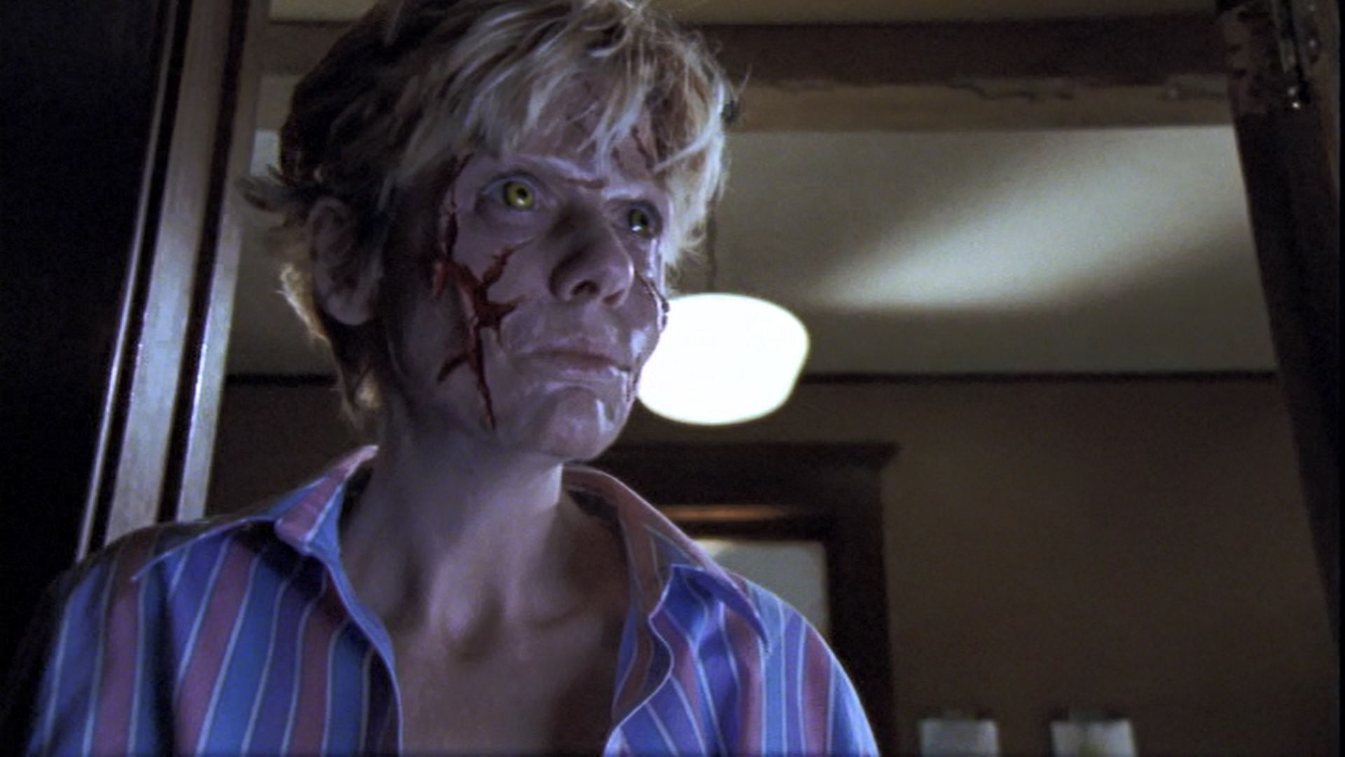
Figure 1- Desperation. Lionsgate, 2006
The deterioration of the bodies Tak inhabits is due to the fact that the spirit is too large to comfortably fit inside a human body. When Entragian first appears in the novel, King writes: ‘His skin was an uncomfortable-looking pink, and Peter guessed that, for all his size, this man got along with the sun no better than Mary did. His eyes were bright gray, direct but with no emotion in them’ (9). While the physical changes are revealed very gradually throughout the story, they are later starkly apparent: ‘The cop’s mouth had the sunken, infirm look of lips with no teeth to back them up, and blood ran from the corners in little streams. One of his eyes was a cauldron of gore—except for an occasional gray flash from its swimming depths, it could have been a plucked socket. A shiny mat of blood covered the top half of his khaki shirt’ (155). Here, we can see King’s depiction of one particular physical change which is similar to alien possession—missing teeth are significant in the alien possession novels, discussed below—but largely the depiction is quite different from those we will see in King’s alien possession stories. It highlights King’s vision of demonic possession as distinct from alien possession, demonstrating a stylistic extension of his approach to horror versus horror/sf hybrids.
Desperation, however, exhibits parallels with the other two adaptations. Much like in King’s novel, the skin is blistered and shows a rash, not dissimilar to the visual depiction of the byrus, a living alien parasitic substance resembling red-gold fungus growing on people in Dreamcatcher. The rendering of physical manifestations of possession is taken further in Desperation in the depiction of Ellen (Sylva Kelegian) once Tak enters her body. Her face contains large lesions, similar to Reagan in The Exorcist, but also to King’s description in the novel of a demon too big to fit comfortably inside a human body. This is unique to Desperation, whereas skin redness and rashes, is a common depiction of possession, whether it be demonic or alien, and occurs in other adaptations. Here, as in the alien possession adaptations, there is a specific visual focus on the eyes of the possessed. Whereas those possessed in The Tommyknockers bear glowing green eyes, and Jonesy (Damien Lewis) and Duddits (Donnie Wahlberg) in Dreamcatcher have yellow-green eyes, the possessed characters in Desperation have bright yellow eyes. All of these physical similarities identify a cohesive set of codes for the viewer to understand what possession is, or rather, that it is.
These details, while subtle, point towards both the difficulty in adapting King’s interiority to an audiovisual text, as well as to some distinctive links in both the prosaic and visual portrayals of possession. Furthermore, these links continue when expanding from a more stringently horror-oriented possession story, to the hybrid sf/horror stories of The Tommyknockers and Dreamcatcher. However, there is also a distinctive way that King communicates the experience of possession, specifically by utilising the interior experience of a person being possessed, as well as the core fears that King plays upon in his writing. We will also see that there is a further failure within the adaptations to create these distinctive elements, resulting in a loss, or at least a faltering, of generic hybridity in the transfer from page to screen.

Alien possession in Dreamcatcher and The Tommyknockers
Lucanio’s discussion of the conventions of the alien invasion film firmly establishes the generic hybridity of both The Tommyknockers and Dreamcatcher and of their adaptations. Lucanio points towards the iconographic relevance of certain sf elements, some of which can be linked to these texts: machinery, specifically flying saucers (61–7), special effects (67–9) and landscapes, or more precisely, the idea of Earth and nature as a source of both hardship and assistance (73–4). Flying saucers are featured in both stories and their adaptations: Dreamcatcher and its film version include sequences where the grounded alien ship is attacked by the military and defended by aliens, and The Tommyknockers culminates in the unearthing of a long-buried space ship. Furthermore, machinery is of significance in The Tommyknockers more broadly because the townspeople, possessed by aliens, build machines beyond anything comprehensible to contemporary scientists. In the adaptations, special effects are used to depict the unearthly events and the aliens (costumes, angles and lighting in The Tommyknockers; primarily CGI in Dreamcatcher). This, however, is often true of the horror film as well; Desperation evidences this through the effects used to show the deterioration of the bodies of Collie Entragian and Ellen, as well as some CGI showing Tak’s final climactic confrontation with Johnny Marinville (Tom Skerritt), a writer who is arguably the focus of the story. Finally, Earth provides a difficult terrain to traverse in Dreamcatcher and proves isolating to the aliens in The Tommyknockers. Therefore, the planet itself becomes the undoing of the aliens—the aliens fail to cope with the environment in Dreamcatcher, and in The Tommyknockers Earth subjects the aliens to subterranean burial. So while the possession elements do establish a horror sensibility—which dominates in the adaptations—these stories are distinct from the ‘pure’ horror of Desperation.
There is a strong consistency between Dreamcatcher and The Tommyknockers and their adaptations in the way that alien possession is rendered. King’s prose, and his depiction of heavily internalised perspectives, clearly articulates shifts in the moods and emotions of those being possessed by alien intelligences, in conjunction with his explicit depictions of physical changes that occur through morphing or physical mutilation. However, in adaptation, internal states are not communicated as fluidly where they do appear, with Dreamcatcher attempting this more extensively, although the physical changes are adapted with more consistency.
Dreamcatcher contains a single primary case of alien possession, which occurs amidst the broader context of a failed attempt at world domination. The single case is that of Jonesy, one of the four friends who fall afoul of the alien invasion. Jonesy encounters one of the aliens, who, upon physical death, transfers his consciousness to Jonesy’s body, without eradicating Jonesy’s self-awareness. The alien consciousness, whom Jonesy calls ‘Mr. Gray’, takes over Jonesy’s body, while Jonesy’s protects himself within an envisioned stronghold in his own mind. The rest of the populace in the immediate area, and many of the military people assigned to keep these people and the aliens contained, become infected by the aforementioned ‘byrus’, which grows at a fast rate and overtakes the host in a different manner. First a fungus infects a host and imbues him or her with telepathic abilities, and in some cases implants the host with a creature—‘byrum’ to the aliens, ‘shit weasel’ to the humans—to gestate and eventually eat its way out through the host’s anus. The telepathic abilities obtained by all of those infected by the byrus not only opens a mental pathway for the aliens, but also allows anyone infected to read the thoughts of others in the same situation. However, the byrus dies quickly, drying up and flaking off, after which the host’s telepathic abilities wear off, and any byrum born die after prolonged exposure to the atmosphere. Furthermore, the aliens themselves similarly cannot withstand Earth’s atmosphere for an extensive period, which is why Jonesy is forced to become host to an alien consciousness: he is the physical body that can be used to fulfil actions necessary to complete their mission.
In discussing his approach to the adaptation, director Lawrence Kasdan identifies his interest in the story with respect to genre:
It’s similar to some of my other work in that it starts out being about a friendship between four friends, then it becomes this other thing, which is an alien invasion movie, so it’s a good combination for me…. I wanted to do a monster movie. Alien is my favourite horror film. It’s really scary to me. And The Exorcist. I wanted to do one that doesn’t just tease you. It’s not a psychological horror film: it’s the real deal … another movie that influenced me was The Silence of the Lambs. It’s really a creature feature, and it’s so smart and realistic and therefore five times more terrifying to me than some slasher movie. (qtd in Longwell 23; ellipses in original)

Kasdan, clearly identifies the hybrid nature of the story, calling it an alien invasion story and a monster movie or creature feature. He invokes Alien (Scott UK/US 1979), an overt sf/horror hybrid, as well as The Exorcist, the key possession film precursor. Kasdan’s indication that he wanted the film to be like these (i.e., ‘the real deal’) demonstrates his desire to make a scary movie; that is, he clearly aims to foreground horror. However, Kasdan fails to intrinsically adopt the sf elements in the adaptation in the way that King does in his prose.

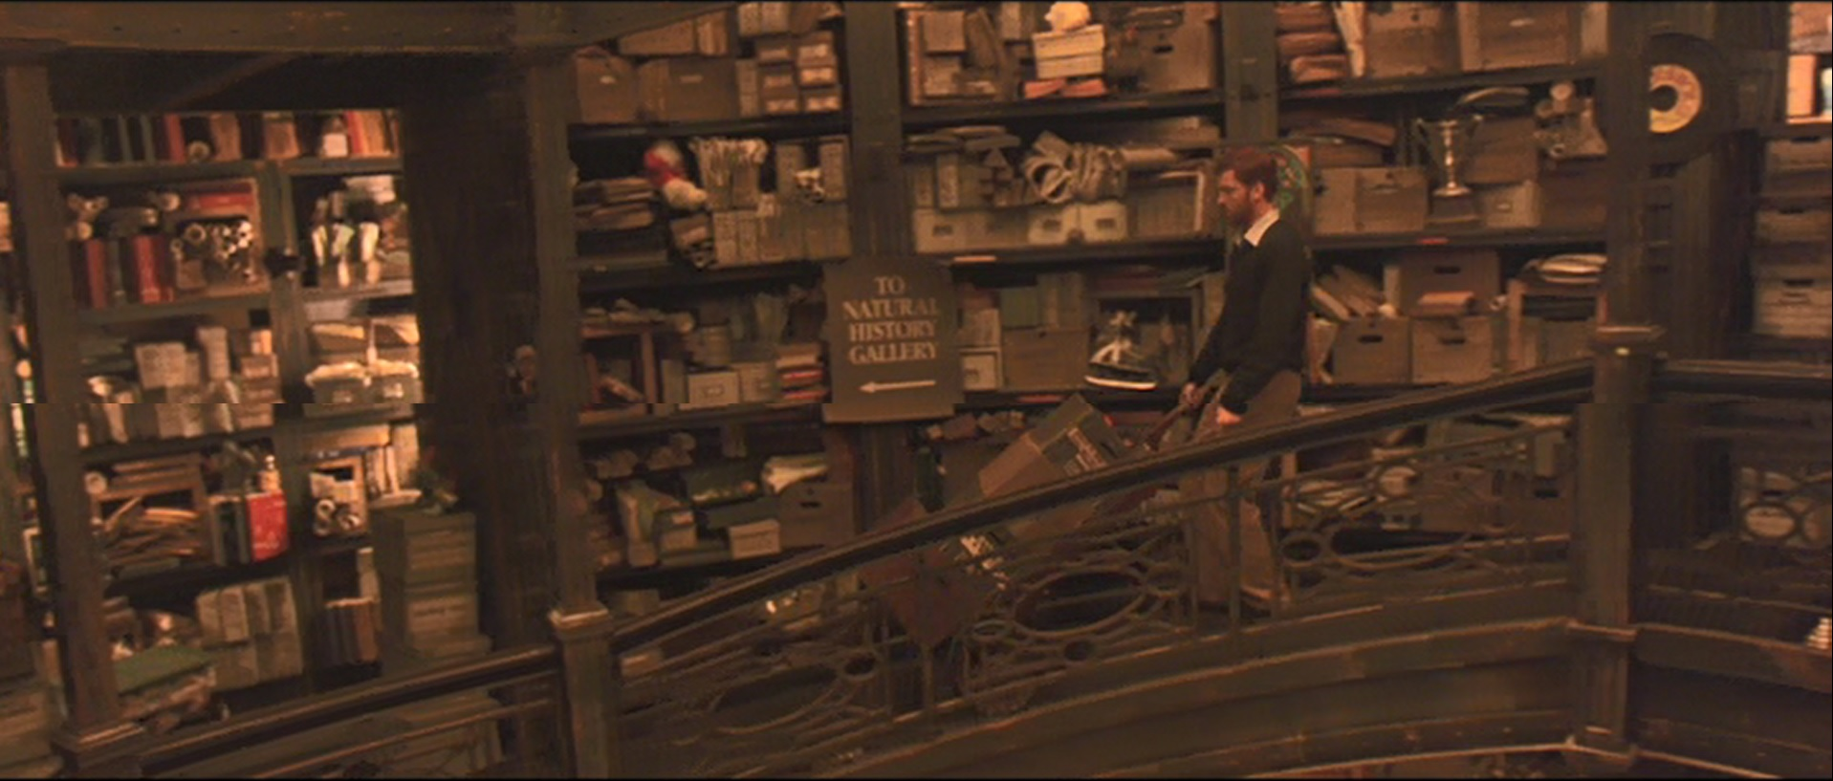
Figure 2- Dreamcatcher. Warner Brothers, 2003.
In the novel King spends an extensive amount of time discussing the Jonesy/Mr. Gray consciousness duality, a process that lends insight into both Jonesy’s mind and, more significantly to generic distinctions, Mr. Gray’s thought processes and identity. A geography, a morphing and changing space of Jonesy’s mind, is rigorously laid out and clear interactions between the two consciousnesses are explored. In one sequence, the alien uses Jonesy’s body to kill his friend Pete, and we can see how King addresses the internal conflict between Jonesy and Mr. Gray:
Then he felt something leap from Mr. Gray’s mind and the stuff growing on Pete did not just twitch but clenched …
You bastard.
Mr. Gray, indifferent to Jonesy’s curse and Jonesy’s anger, made no reply. He faced forward again. (324; emphasis in original)

Here we can see the powers of the alien to control the byrus growing in another person, Jonesy’s ability to sense such effort, the alien’s control over Jonesy’s body and the clear ability for the two consciousnesses to converse. There is also the suggestion that these internal conversations also can occur outwardly. In other words, when either Jonesy or Mr. Gray speaks, Jonesy’s body speaks both sides of this dialogue. This also occurs throughout the film, as changing camera angles suggest different sides of the consciousness speaking from Jonesy’s body, and a clear delineation between the two, as Jonesy’s body speaks Mr. Gray’s words with an English accent.
Such outward externalisation of internal processes does not occur in a similar way in depiction of the other characters and the telepathic abilities they gain after infection with the byrus. In the film the internal thought processes of the book are externalised through scenes of characters in conversation, particularly Henry (Thomas Jane) and rogue military officer Owen (Tom Sizemore), revealing that they know more about each other, and the thoughts of the other person, than they should. Ultimately, it is Jonesy’s internal geographical mapping—the depiction of the library and the office in his mind, for example—and conversation, internally and externally, that sets the adaptation of Dreamcatcher apart from the adaptation of The Tommyknockers, which underplays this insight into the characters’ interiority. This is further borne out in the depictions of Mr. Gray killing Pete (Timothy Olyphant): in the passage above, the ellipses glance over the depiction of the byrus clenching to the point where Pete’s skull cracks—played out through Jonesy’s internal experience of feeling this occur. This interiority is sidestepped in the filmic depiction where, despite at one point showing the byrus visibly clenching, with Jonesy looking out of the window of the stronghold in his mind, Pete is killed when Jonesy’s body somehow physically transforms into a giant shit weasel and bites Pete in half, thereby rendering what is an sf premise in prose into overt horror in the film. Here the adaptation of King’s prose, which highlights internal thoughts and experience, to an audiovisual medium that cannot as explicitly communicate the intricacies of thought, results in a narrative economy favouring action with dominant horror visuals over the deliberation needed to establish the literary elements that communicate the sf elements.
In The Tommyknockers, King’s characters are ultimately being psychically guided by aliens in a spaceship buried in the woods behind the house of Bobbi Anderson. Anderson is the first person to discover a piece of the ship jutting from under the ground, and he begins digging it out, becoming increasingly obsessed with unearthing this structure. The early parts of the book almost wholly focus on Bobbi and her increasing obsession. In one section, Bobbi is shown thinking about the ship extensively, hearing voices of people from her life (a former lecturer and her sister) in her internal monologue/dialogue. In one passage, King writes of Bobbi’s realisation that she is unearthing something extra-terrestrial:
She knew what was really troubling her, and it wasn’t the speed with which the possibility of what the thing might be had occurred to her. It was the feeling of certainty. She would keep an open mind, but the struggle would be to keep it open in favour of what Anne would call ‘sanity.’ Because she knew what she had found, and it filled her with fear and awe and a restless, moving excitement. (31; emphasis in original)

By establishing that Bobbi is troubled by her certainty, there is a distinct implication that she is following a path of thought atypical to her usual patterns, suggesting the influence of another source. Furthermore, King takes a significant amount of time and wordspace to create this transformation, which takes place gradually in the novel. It also creates an awareness of this process, known as ‘becoming’, for the reader; through Bobbi, King creates a template for this process so that the other characters who experience this in the novel can be explored in less detail.
In the miniseries however, the only characters whose internal states are examined at any length are Hilly Brown (Leon Woods) and Becka Paulson (Allyce Beasley). Hilly is a young boy who, through alien influence, builds a vanishing contraption for his magic performances, ultimately disappearing his younger brother David (Paul McIver). He is shown in the miniseries, staring out of the window of the bedroom he shares with David and having a one-sided conversation, presumably about how to construct the disappearing machine. Becka is a police deputy who kills her unfaithful husband. She is inspired to do this, in the series, by the host and contestants of a dating gameshow who talk to her directly (in King’s novel, it is a picture of Jesus on her wall, who, it could be argued, is host of a very different gameshow). While this can still be perceived as an internalised state, the use of a gameshow—which features talking, unlike a picture of Jesus, as well as direct-to-audience/camera address—blurs this internalised process. Instead of a picture moving and talking to someone, a television, already a source of light and noise, simply directs that light and noise at the viewer on the other side of the screen, which is ultimately less shocking and dynamic.
Apart from this, the characters are shown to be under alien influence in the adaptation primarily through significant physical changes, as opposed to the intricate internal ruminations in the novels. These physical changes bear certain links not only to the core fears and concerns of King’s stories but also to the sf generic tradition which they follow. However, despite these links, much of what King uses in terms of traditions and fears relevant to sf is lost, along with the inherent fears played upon, when adapted.

Implicit and explicit fears of nuclear armament, and its redaction
In her admittedly generalising essay on sf films of the 1950s and 60s ‘The Imagination of Disaster,’ Susan Sontag writes, ‘One gets the feeling, particularly in the Japanese films but not only there, that a mass trauma exists over the use of nuclear weapons and the possibility of future nuclear wars. Most of the science fiction films bear witness to this trauma, and, in a way, attempt to exorcise it’ (44). Jonathan Lake Crane similarly identifies this tendency, stating ‘While the (atomic) bomb laid the foundation for the Peace Memorial Park in Hiroshima, it also led to the production of an extraordinarily large amount of cultural work that did more than serve as an altar to the dead’ (101; parenthesis added). It is this formative period of the genre that King extensively recounts at the beginning of his book of autobiographical genre criticism, Danse Macabre.
Both of his alien possession novels, Dreamcatcher and The Tommyknockers, retain narrative points that focus on atomic-age fears. In writing on The Tommyknockers, Tony Magistrale argues, ‘Because the nuclear theme dominates the scope of this novel, the reader is always cognizant of nuclear energy when King describes the exotic, invisible power radiating from the Tommyknockers’ (Stephen King 80). Most specifically, King’s discussion of the bodily deterioration or transformation of those possessed reflect both implicitly and explicitly concerns surrounding radiation poisoning. Radiation sickness can manifest in symptoms such as fatigue, nausea, losing hair or teeth and has been linked to some cases of cancer (see Gusev, Guskova and Mettler 33–52).
It is significant to note that physical manifestations of control or possession are highly consistent within King’s stories—he prosaically develops this similarly in each novel—though less consistent between their adaptations. While the adaptations foreground a focus on horrific imagery, including physicality, the way this is envisioned between the adaptations is distinctly different from King’s original texts, as well as from one another. However, the physical horror elements of the novel, particularly regarding physical destruction and deterioration during possession, are firmly retained. In Dreamcatcher particularly, this is explained through both alien ignorance of the body’s needs, such as eating (although this practice is understood in theory), as well as an indifference to the host’s wellbeing, provided the alien’s goal is accomplished. However, the two stories, like Desperation, focus on teeth falling out, which is a concept traced back to sf of the 1950s and 60s. In fact, there are at least fifteen examples in the novel Dreamcatcher of teeth missing or falling out, and it is addressed with a similar consistency in King’s The Tommyknockers. In the adaptations, The Tommyknockers retains this imagery as a significant narrative point but with less consistency than in the novel, while it is ignored altogether within Dreamcatcher.

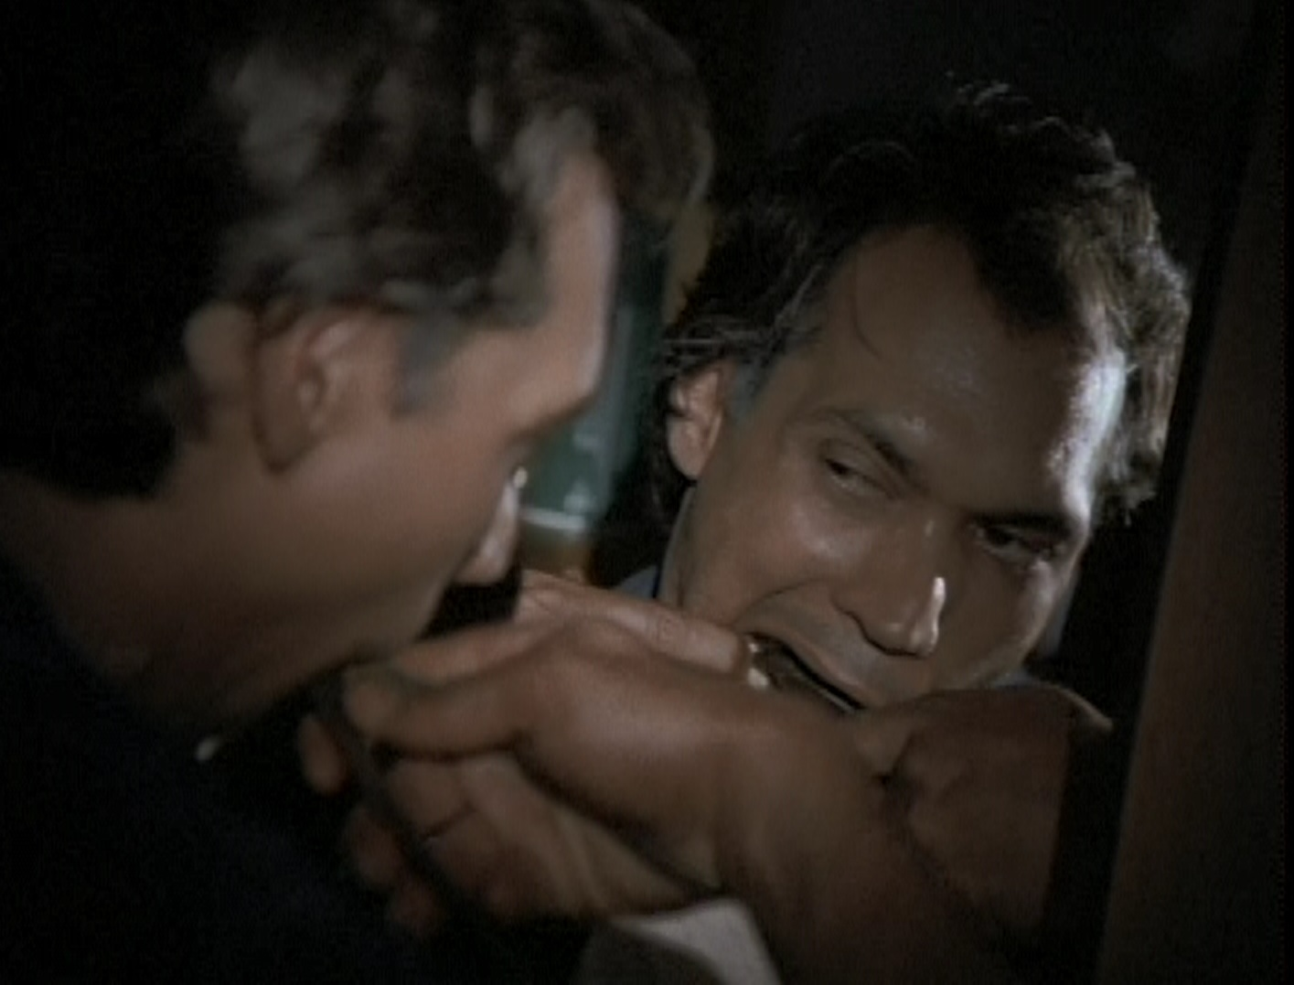
Figure 3- The Tommyknockers. Trimark Pictures, 2000.
With regards to these symptoms in The Tommyknockers, King’s account of hero Jim ‘Gard’ Gardner’s return to the town of Haven, and seeing Bobbi after she starts digging up the spaceship, likens her to the highly publicised case of musician Karen Carpenter, who died of anorexia nervosa: ‘She seemed to be on the last raggedy end of exhaustion. Her eyes, like the eyes of that poor lost woman on the magazine cover, were huge and glittery, her smile the huge brainless grin of a KO’d fighter just before his knees come unhinged’ (123). And very telling is the account of those attending a funeral in Haven, once the townsfolk no longer display as intensely the effects of ‘becoming’. King writes of the ‘outsiders’ (non-residents of Haven) coming into contact with the town’s atmosphere, within the influence of the aliens’ psychic powers:
The outsiders didn’t look healthy. They were pale. Their eyes were dazed. Twice during the eulogy, people left hurriedly, dashed around the corner of the church, and were quietly sick. For others, the nausea was a lower complaint—an uneasy rolling in the bowels not quite serious enough to cause an exit but simply going on and on. (375)

While in the novel the Haven townspeople have grown accustomed to the effects of the aliens possessing them, so this deterioration and sickness at the very least is halted, in the adaptation this exhaustion and bodily deterioration is depicted until the end. The characters look pale, and missing teeth are on display. It is even revealed in the miniseries that Hilly, lapsing into a coma, has a massive brain tumour.
Furthermore, as has been identified earlier, there is a consistency of the depiction of glowing eyes in adaptation, whereas King writes of them—‘bright gray’ for Collie Entrangian and ‘huge and glittery’ for Bobbi Anderson—to depict uncanny humanity. In the adaptations of Dreamcatcher and The Tommyknockers, the eyes of those possessed emit a green or yellow-green glow as discussed above, further establishing the overtly horrific physical depictions within adaptation. This also provides a distinct narrative point as well, as green light in The Tommyknockers is an indication of alien power or presence. In the novel, King only identifies glowing green eyes in Bobbi within a dream by Gard. In the miniseries green glowing from the characters’ eyes indicates a dramatic, instantaneous transition in the alien influence of a host, whereas King tends to depict this change as gradual, as is implied by the length of time it takes Bobbi to succumb (or ‘become’ within the narrative’s context). In the novel Dreamcatcher King clearly identifies the eyes of the aliens and the byrum as having the same black colour, with Jonesy’s eyes only being of significance as Jonesy’s consciousness is either permitted to see or not see out of them, based on Mr. Gray’s control. Furthermore, as an adaptive point, the focus on eye colour also becomes central to adjustments made from the novels in narrative terms. In Dreamcatcher, the film concludes with Duddits, a friend of the central characters who has Down’s syndrome and extremely powerful psychic abilities, revealing himself to be an alien, initially identified through a change in eye colour to yellow-green.
The novel Dreamcatcher thus strongly foregrounds the symptoms that signify cancer, which is also the title of the first of the novel’s three parts, and ultimately fears of radiation sickness. This is most clearly seen in the condition of the two hunters that are discovered by the novel’s central characters. The hunters, Rick McCarthy and Becky Roper, appear unexpectedly to the separated group of central protagonists: Henry and Pete discover Becky in the road, Jonesy finds Rick in the woods while out hunting, and brings him back to the cabin with Beaver. Becky and Rick display a significant amount of stomach troubles, including foul-smelling flatulence. These characters are harbouring the byrum, which, as stated, exit through the anus accompanied by a large amount of blood. In the production featurette DreamWriter—An Interview with Stephen King, King says that ‘I would guess that probably sixty to seventy percent of our first realisation that maybe we have a tumour, we have cancer, that sort of thing, happens in the bathroom. You’ve done your number one or you’ve done your number two and you look in the bowl and there’s blood. And you say “Uh oh, I’ve got a problem”.’
However, it is important to note that the adaptations of King’s novels, while acknowledging fears surrounding radiation sickness and poisoning, do not as clearly or extensively make this link, even though the symptomatic evidence is retained. There is a single clear reference to nuclear power and the effects of radiation in each adaptation. In Dreamcatcher, after feeding McCarthy (Eric Keenleyside) and sending him to bed, Beaver (Jason Lee) says in passing, ‘You don’t suppose he got exposed to radiation, do you?’ The Tommyknockers adaptation retains a scene from the novel where Gard (Jimmy Smiths), under the influence of alcohol, berates a party attendee by evoking the disaster at Chernobyl. However, these are not extensively repeated or linked to the symptoms shown by the possessed.
While in the novels King rarely explicitly connects radiation sickness and possession, on a subtextual level they are inextricable, something lost within the adaptations. King, by foregrounding cancer and teeth falling out repeatedly within his writing, provides extensive space for readers to make this connection. Within the adaptations, the symptoms become a part of the aesthetic template for possession and become easy to overlook without extensive discussion of atomic power and radiation. It is through this key point that the adaptations lose this significant linkage to the sf stories of the 1950s, which results in them being more overtly horror than hybrid narratives. The stylistic similarities to representations of possession in the adaptation of Desperation supports this, as it bears a similar aesthetic template in this regard, without the inherent fears of radiation and atomic power.

Conclusion
Abbott writes that ‘one of the primary sources of anxiety that unites films of possession, whether demonic, spiritual or vampiric, is the fear of loss of control of the body. This loss of control raises questions about the relationship between identity and the body, as the “self” appears lost to possession’ (151). Tanya Krzywinska, using the case study of The Exorcist, similarly argues, ‘I would claim that through our identification with the possessed Regan, The Exorcist works with the pleasures of the annihilation of the contours of the self’ (257). This is borne out through the adaptations of King’s books, which more intricately interweave the elements of the possession narrative and the alien invasion narrative. The Tommyknockers and Dreamcatcher, like Desperation, all centrally focus on fears and mysteries concerning identity and selfhood while aesthetically depicting the deterioration and deconstruction of the human meat vessel, ultimately resulting in fears which are strongly horror-focused in generic tradition and origin.
These concerns and mysteries, while present in King’s prose, are less mysterious, as King utilises this interiority, this seeing through the eyes and thoughts and feelings of his characters, to identify the distinctions between, and blending of, the personalities of the characters in The Tommyknockers and Dreamcatcher and their alien possessors. This is not seen in King’s novel Desperation because, much like the adaptation, there is a clear divisiveness between vessel and possessing spirit. We only hear the voice of Tak in a body whose original consciousness is gone, completely subsumed by the demon.
Furthermore, the traditionally sf concerns of atomic power and the results of nuclear warfare, while addressed in the adaptations, are glossed over, removing these adaptations further from the generic hybrid core of King’s prose, which establishes these fears more deeply, explicitly and extensively. Ultimately, we are able to see where King, incorporating freely his influences in both sf and horror, is relegated to the role of a horror storyteller through this diminishment of non-horror elements in adaptation. Magistrale discusses the significance of King’s name within generic expectation: ‘The viewing public is encouraged to connect the project being advertised with King’s previously established reputation as “America’s master of horror.” King appears to be one of the few writers whose name is infinitely more important, in terms of popular identification, than any of the individual titles from his canon’ (Hollywood 175) In this way, and through these examples of his adaptations, we can see how King the horror writer remains King the horror writer, no matter how hard he tries.

Works Cited
Abbott, Stacey. ‘The Battlefield for the Soul: Special Effects and the Possessed Body’. Special Effects: New Histories/Theories/Contexts. Ed. Dan North, Bob Rehak and Michael S. Duffy. London: British Film Institute, 2015. 141–51.
Basement Rejects. ‘Desperation (2006)’ <http://basementrejects.com/review/desperation-2006/>. Accessed 9 Jul 2016.
Blatty, William Peter. The Exorcist. New York: Bantam Books, 1971.
Campbell Jr., John W. Who Goes There? London: Gollancz, 1948.
Crane, Jonathan Lake. Terror and Everyday Life: Singular Moments in the History of the Horror Film. London: Sage Publications, 1994.
Creed, Barbara. The Monstrous-Feminine: Film, Feminism, Psychoanalysis. London: Routledge, 1993.
Gusev, Igor A., Guskova, Angelina K., and Mettler, Fred A. Medical Management of Radiation Accidents, Second Edition. Boca Raton, FL: CRC Press, 2001.
Herron, Don, ed. Reign of Fear: The Fiction and Film of Stephen King (1982–1989). London: Pan Books, 1988.
Jancovich, Mark. Horror. London: B.T. Batsford, 1992.
Kaveney, Roz. From Alien to The Matrix: Reading Science Fiction Film. London: I.B. Tauris, 2005.
King, Geoff and Krzywinska, Tanya. Science Fiction Cinema: From Outerspace to Cyberspace. London: Wallflower Press, 2000.
King, Stephen. ‘I Am the Doorway’. Night Shift. Sevenoaks: New English Library, 1978. 79–89.
–––––. Danse Macabre. London: Warner Books. 1981.
–––––. The Tommyknockers. London: Hodder & Stoughton, 1988.
–––––. Desperation. London: BCA, 1996.
–––––. Dreamcatcher. London: Hodder & Stoughton, 2001.
Kristeva, Julia. Powers of Horror: An Essay on Abjection. New York, NY: Columbia UP, 1982.
Krzywinska, Tanya ‘Demon Daddies: Gender, Ecstasy and Terror in the Possession Film’. The Horror Film Reader. Eds Alain Silver and James Ursini. New York: Limelight Editions, 2000. 247–67
Leitch, Thomas. Film Adaptation and Its Discontents: From Gone With the Wind to The Passion of the Christ. Baltimore, MD: Johns Hopkins UP, 2007.
Longwell, Todd. ‘Dreamweaver: Genre Master Lawrence Kasdan Takes Plunge into the realm of horror with Dreamcatcher’. Cinefantastique 35:2 (April/May 2003): 20–3, 76–7.
Lucanio, Patrick. Them or Us: Archetypal Interpretations of Fifties Alien Invasion Films. Bloomington: Indiana UP, 1987.
Magistrale, Tony. Landscape of Fear: Stephen King’s American Gothic. Wisconsin: The Popular Press, 1988.
Magistrale, Tony. Stephen King: The Second Decade, Danse Macabre to The Dark Half. New York: Twayne Publishers, 1992.
–––––. Hollywood’s Stephen King. Basingstoke: Palgrave Macmillan, 2003.
Powell, Bob. ‘The Report.’ [1954] The Horror! The Horror!: Comic Books the Government Didn’t Want You to Read! Ed Jim Trombetta. New York: Abrams Books, 2010. 297–301.
Schweitzer, Darrell. ‘Fear and the Future: Stephen King as a Science Fiction Writer’. Reign of Fear: The Fiction and Film of Stephen King (1982–1989). Ed Don Herron. London: Pan Books, 1988.193–207.
Sears, John. Stephen King’s Gothic, Cardiff: U of Wales P, 2011.
Sontag, Susan. ‘The Imagination of Disaster’. [1965] Liquid Metal: The Science Fiction Film Reader. Ed Sean Redmond. London: Wallflower Press, 2004. 40–7.
Wells, H. G. The War of the Worlds, London: William Heinemann. 1898.
Winter, Douglas. The Art of Darkness – Life and Fiction of the Master of the Macabre: Stephen King, London: New English Library, 1989.

Later published in Night Shift (1978).
See Sears, p. 5–8. The titles of some critical studies about King’s work are quite telling: Landscape of Fear (Magistrale), Stephen King’s Gothic (Sears) and Reign of Fear (Herron). Even the title of King’s own book of autobiographical criticism, Danse Macabre (1981), indicates this.
This story was originally created for film as The Thing from Another World (Nyby/Hawks USA 1951). This story does not incorporate the alien-making-copies element of the narrative and instead opts for depicting the alien as a form of vampire, draining the living of their blood. However, John Carpenter clearly has a connection to this original film, as children are seen watching it on television in his film Halloween (US 1978).
See also Kristeva and Creed for discussions of the possessed body.
For example, King writes, ‘As a kid I cut my teeth on William B. Gaines’s horror comics—Weird Science, Tales from the Crypt, Tales from the Vault—plus all the Gaines imitators’ (Danse 36).
See http://basementrejects.com/wp-content/uploads/2014/09/desperation-movie-poster-review-stephen-king.jpg.
John Sears identifies the sf/horror generic hybrid nature of The Tommyknockers, and by extension Dreamcatcher, as inherently gothic (90). With respect to the buried spacecraft in The Tommyknockers, Sears sees further links to the gothic: ‘the potential of the flying saucer as a vehicle of Gothic motifs, especially one long-buried and now exhumed, containing apparently resurrected aliens, a flying saucer as a symbolic crypt, is not missed by King’ (87).
Sears also sees this as inherently gothic, as it demonstrates a critical approach to unbridled scientific discovery in the hands of humans (90).
Adjustments is here used as defined by Thomas Leitch: ‘By far the most common approach to adaptation is adjustment, whereby a promising earlier text is rendered more suitable for filming by one or more of a wide variety of strategies’ (98). This can be seen as the theoretical basis for all changes made between these particular source texts and their adaptations.

