DESIGNTRANSPOSAL WORKSHOP:

VISUALISING THROUGH THE GYRE
KATARINA DIMITRIJEVIC – KRAALD 2015
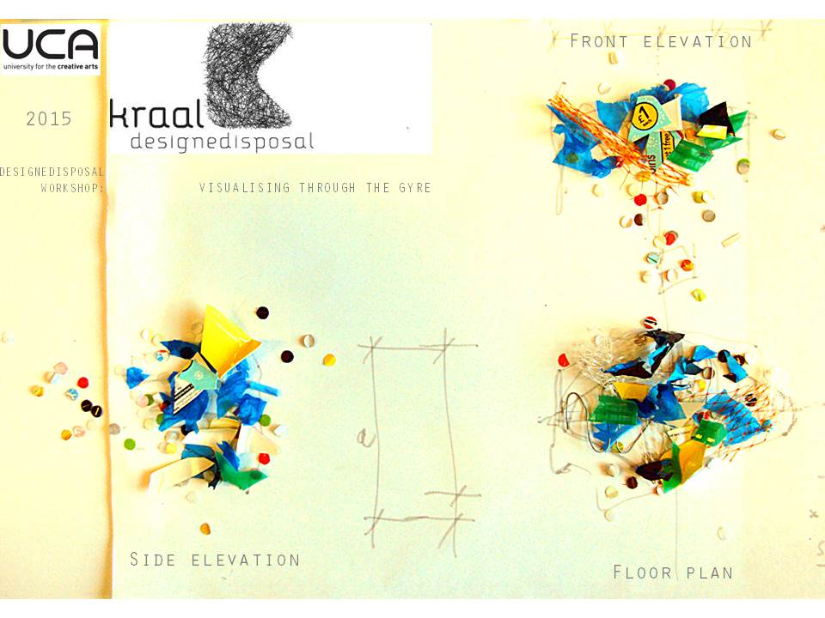
Figure 1: KraalD, 2015, Visualising through the gyre.

CO-CREATIVE DEPOLLUTION
We live in a plastic debris era. In the first decade of the twenty-first century plastic production has quadrupled in comparason to the last century. Our oceans are the largest unprotected ecosystem on Earth. Anthropogenic litter is present in all marine habitats, from the coast to the most remote points in the oceans. Plastic and metal are the most prevalent litter item found on the deep sea bed. Plastic waste is concentrated in five rotating currents, known as gyres (Maximenko et al., 2012). Marine research has revealed that synthetic polymers are a toxic pollutant, as they are spread throughout all the world's oceans. Currently 269,000 tons of plastic composed of 5.25 trillion particles are afloat at sea (Eriksen et al., 2014). The impacts of plastic pollution after entering the food chain, through ingestion are: cancer, malformation and impaired reproductive ability (Takada, 2013). The public’s conception of this problem is founded on descriptions of the North Pacific gyre as a large scale island of trash. Sadly this wicked problem is more complex then it seems, as the large scale ocean cleanup will solve what meets the naked eye only.
Using the design and craft axiom, how can we gaze into the closest gyre to Europe, in the North Atlantic? I suggest to approaching this problem through the process of making. This workshop proposes the collaborative visualization through the North Atlantic Gyre using a co-creative strategy as a framework for future thinking and action towards global marine depollution. We can visualise the problem as a radiating microplastic cloud, which the workshop will approach like lantern fish, which eat up to 24,000 tons of plastics per year (Davidson & Asch, 2011).

WORKSHOP Introduction

''Our sense of reality once shaped by our complex sensory interplay with the seasons, sky, forest, wildlife, savanna, desert, rivers, seas, and the night sky increasingly came to be shaped by technology and artificial realities. Urban blight, sprawl, disorder, and ugliness have become, all to too often, the norm. Compulsive consumption, perhaps a form of grieving or perhaps evidence of mere boredom, is a response to the fact that we find ourselves exiles and strangers in a diminished world that we once called home.” (Orr 2004).
The workshop’s primary objective is to visualize the future possibilities for ocean plastic depollution, using plastic disposal to co-create a 3D gyre installation. It will incorporate joyful activism, trash aesthetics and craft making.

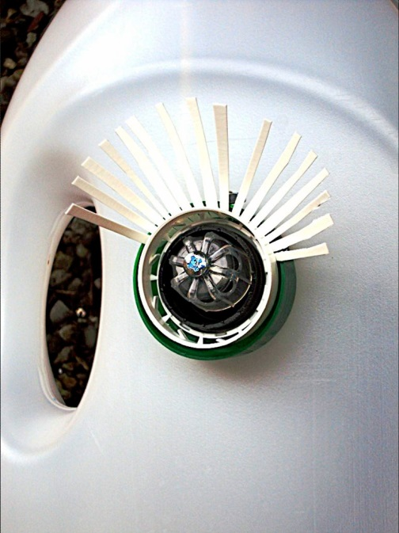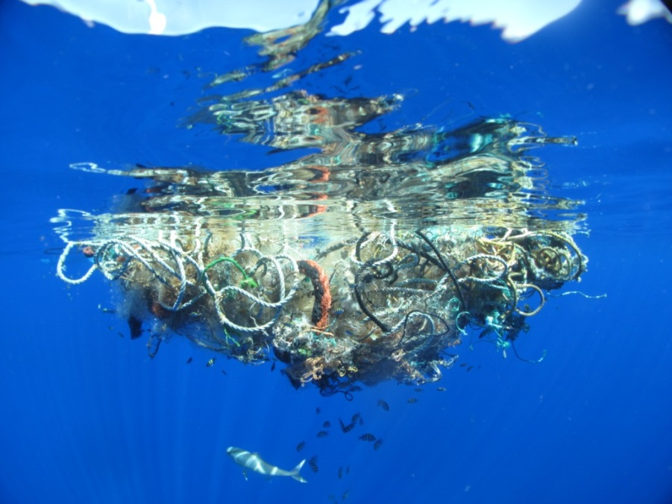
Figure 2: KraalD, 2012, Boki-penetrating gaze, Cityself Anima
Figure 3: Lindsey Hoshaw, 2009, Under the surface, Great Pacific Garbage Patch

The workshop will be a participatory platform, facilitating rather than dictating. It proposes that a changing relation to disposal is a changing relation to oneself. The future aim of this ongoing design research is to co-create new discard values and induce community relation towards urban-ocean plastic waste on a small everyday scale. The process of making and visualizing will be initiated from the lantern fish’s point of view and their mundane entanglement with gyre. Thus this workshop will attempt to socially narrate the quality of everyday life and global progress in more holistic terms than only the economic indicator of GDP or scientific marine data. When we transgress the surplus-driven consumer culture, taking the seemingly useless discarded plastic and transforming it into designed objects and 3D installations, we reveal how disposed materiality can contain a dimension for spaces of possibility, creating new values and even hope for global depollution.disposed materiality can contain a dimension for spaces of possibility, creating new values and even hope for global depollution.

WORKSHOP PROGRAMME
Workshop agenda for half a day (4 hours approx.):
- Introduction to the five subtropical gyres and global marine pollution (10 min).
- Objectives of the session; lantern fish as a reuse muse (10 min).
- Opportunities overview: co-creative strategy as a framework for future thinking and action (10 min)
- Collaborative craft and design making session A (60min).
- Coffee break (15 min).
- Collaborative craft and design making session B (60min).
- In-depth opportunities discussion and mapping (30 min).
- Everyday futures: how can I help? Internal self-dialogue vs. ego-elf (30 min).

PROPOSED WORKSHOP REQUIREMENTS

- The workshop is open to all students to participate, and is aimed at novice to intermediate level craft and design hand manufacturing techniques.
- Desirable requirement: bring along plastic trash that you have accumulated in the 24 hours prior to workshop, e.g. yellow, orange, fuscia, green and blue plastic bottles, opal white milk bottles, coloured bottle caps, coloured food packaging, blue plastic bags, plastic mesh.
- Overall workshop requirements: visual presentation equipment and dedicated space for making.
- Basic hand tools: shears, scissors, paper punches, paper guillotine, staplers, hand drill.
- New materials: 10m x 0.2mm and 0.5mm galvanised wire, cable ties, nylon string and rope, ceiling hook/s for suspension if possible.
- Visiting guests: shoal of lantern fish, reused plastic rubbish from Rochester.
- Making space: 3D installation will require to be suspended from the existing ceiling/slab if possible.

I trash therefore we are

https://twitter.com/kraald
https://www.facebook.com/KraalD
http://www.etsy.com/shop/KraalD
http://ucreative.academia.edu/KatarinaDimitrijevic

REFERENCing

Davison, P., Asch, R.G., 2011, Plastic ingestion by mesopelagic fishes in the North Pacific Subtropical Gyre. Mar Ecol
Prog Ser 432: 173−180, Available at:http://www.int-res.com/abstracts/meps/v432/p173-180/[Accessed 20 January 15].
Eriksen, M., Maximenko, N., Thiel, M., Cummins, A., Lattin, G., Wilson, S., Hafner, J., Zellers, A., Rifman, S. 2013. Plastic pollution in the South Pacific subtropical gyre. Marine Pollution Bulletin. doi.org/10.1016/j.marpolbul.2012.12.021
Eriksen, M., Lebreton, C.M., Carson, H.S., Moore, J.C., Borerro, J.C., Galgani, F., Ryan, J., 2014. Plastic Pollution in the World's Oceans: More than 5 Trillion Plastic Pieces Weighing over 250,000 Tons Afloat at Sea, Available at: http://journals.plos.org/plosone/article?id=10.1371/journal.pone.0111913
Hawkins, G., 2006,. The Ethics of Waste – How we relate to waste. 1st ed. United States of America: Rowman & Littlefield Publishers, INC.
KraalD, 2013, Trash Aesthetics By KraalD, [ONLINE]. Available at: http://www.designsonearth.com/trash-aesthetics-by-kraald/.[Accessed 30 August 14].
Maximenko, N., J. Hafner, and P. Niiler, 2012. Pathways of marine debris from trajectories of Lagrangian drifters. Marine Pollution Bulletin 65, 51-62.
Orr, D, 2004. The nature of design: Ecology, culture, and human intention. 2nd ed. USA: Oxford University Press New ED Edition.
Takada,H.,2013, Microplastics and the Threat to Our Seafood, Tokyo University of Agriculture and Technology, Available at: http://www.oceanhealthindex.org/News/Microplastics
The ocean cleanup. 2015. [ONLINE] Available at:http://www.theoceancleanup.com/the-problem.html

