Facets of User-Assigned Tags and Their Effectiveness in Image Retrieval

Nicky Ransom (UCA) and Pauline Rafferty (Aberystwyth University)

Purpose: This study considers the value of user-assigned image tags by comparing the facets that are represented in image tags with those that are present in image queries to see if there is a similarity in the way that users describe and search for images.

Methodology: A sample dataset was created by downloading a selection of images and associated tags from Flickr, the online photo-sharing web site. The tags were categorised using image facets from Shatford’s matrix, which has been widely used in previous research into image indexing and retrieval. The facets present in the image tags were then compared with the results of previous research into image queries.

Findings: The results reveal that there are broad similarities between the facets present in image tags and queries, with people and objects being the most common facet, followed by location. However, the results also show that there are differences in the level of specificity between tags and queries, with image tags containing more generic terms and image queries consisting of more specific terms. The study concludes that users do describe and search for images using similar image facets, but that measures to close the gap between specific queries and generic tags would improve the value of user tags in indexing image collections.

Originality/value: Research into tagging has tended to focus on textual resources with less research into non-textual documents. In particular, little research has been undertaken into how user tags compare to the terms used in search queries, particularly in the context of digital images.

Keywords: image retrieval; user tagging;

Classification: Research paper

Introduction
Advances in digital image technologies over the last few decades have resulted in an explosion in the availability of digital images. Whereas traditional picture libraries had intermediaries to help users access images (Enser, 2008), the advent of online image databases has resulted in users carrying out their own searches and so accurate and comprehensive indexing has become critical for resource discovery (Matusiak, 2006; Trant, 2008a). Researchers have been investigating ways to improve image indexing, but unlike the full-text searching techniques that can be utilized with written documents, accessing the intellectual content of images is much harder to achieve due to the ‘significant philosophical and practical problems’ of creating indexing terms for visual content (Rafferty and Hidderley, 2005:52).

The recent development of Web 2.0 technologies, with their emphasis on user contribution, active participation and the harnessing of collective intelligence (O’Reilly, 2005), has been seen as offering a potential solution to the problems of scalability of traditional techniques. In particular, interest has grown in the use of ‘tagging’ as a potential means of indexing online content. Tagging, also known as social classification, collaborative tagging, or user-tagging, is a Web 2.0 feature that allows users to add their own keywords or ‘tags’ to online documents and images so that they can organise resources for themselves, share them with others, and find resources that others have tagged. One of the earliest web sites to offer this feature was Delicious (http://delicious.com), an online social bookmarking application launched in 2003, followed a year later by Flickr (http://www.flickr.com), an online photo sharing web site: tagging has since been adopted by many other internet applications.

The vocabulary that develops as a result of user tagging is sometimes referred to as a ‘folksonomy’ (Vander Wall, 2007). Initially, there was speculation that user tagging would replace traditional indexing practices (Shirky, 2006) as it was flexible, abundant and cheaper to produce than more traditional methods (Hammond et al, 2005). It was also suggested that its democratic nature would ‘better reflect the peoples’ conceptual model’ (Munk and Mork, 2007: 17). However, research has revealed that tag vocabularies are full of inconsistencies and inaccuracies (Golder and Huberman, 2006), and the general consensus now is that user-tagging is likely to complement rather than replace formal classification systems (Hunter et al, 2008; Macgregor and McCulloch, 2006; Matusiak, 2006; Voss, 2007).

Research into user tagging has focused on three main areas: user behaviour and motivations to tag, the social systems in which tagging takes place, and the vocabulary of tags themselves (Trant, 2008a). Much of this research has concentrated on the tagging of textual resources, such as bookmarks in Delicious or blogs in Technorati (http://technorati.com), with fewer studies related to the tagging of images. In spite of early speculation that tags would consist of ‘terms that real users might be expected to use in future when searching’ (Hammond et al, 2005), little research has been undertaken into how user tags compare to the terms used in search queries, particularly in the context of digital images. It is this aspect of image tagging that this study will consider.

The aim of this study is to find out the value of tags for image retrieval by investigating whether the way that users describe images in tags is similar to the way they search for images. Specifically, this study will consider whether image tags describe the same properties or facets of an image as those that are present in image queries. The focus of this study is on image facets rather than individual terms as previous studies have shown that image tags contain a very large number of unique terms (Jansen et al, 2000; Ding and Jacob, 2009), making comparisons with image queries at the level of individual terms difficult to carry out. In order to overcome this difficulty, the individual terms have been grouped into broad categories that reflect different aspects or facets of an image so that a more general pattern of tag usage can be identified.

Image facets have been the subject of numerous studies into image queries as the identification of the aspects of images that form user queries is important in ensuring that the indexing of images can meet user needs. It is of little use, for example, to index the colours present in an image if this is an image facet that does not appear in user queries. Similarly, if most user queries are concerned with finding images of a certain location, this would be an important facet to index comprehensively.

With current interest in the potential of user tagging for online indexing, particularly within the museum community, it is hoped that this research will be of interest to those investigating ways of harnessing the collective indexing potential of user tagging as a means of coping with the challenge of indexing the abundance of images available online.

Three broad research questions underpinned this study. These are:
- Which image facets are described in user tags?
- How do these compare to those found in image queries?
- What implications does this have for the future use of tagging for online indexing?

Image indexing
Enser notes the difficulty of translating visual content into verbal descriptions, especially as some messages contained in images ‘cannot be named’ (2008: 534). In discussing these issues, many writers have referred to the work of Edwin Panofsky (1955) whose discussions of meaning in art images have been influential in subsequent research on this topic (for example, Choi and Rasmussen, 2003; Peters and Stock, 2007; Rafferty and Hidderley, 2005; Shatford, 1986). Panofsky identifies three levels of meaning in a work of art: primary or natural subject matter (pre-iconographical description of objects, events or emotions); secondary or conventional subject matter (iconographical descriptions of themes or concepts); and intrinsic meaning or content (iconological interpretation of the previous two levels, such as symbolic meanings) (1955: 28-31).

Shatford (1986) built on Panofsky’s work by re-interpreting his first two levels as describing what an image was ‘of’ and ‘about’ respectively, noting that the first level could include both generic and specific elements which need to be indexed separately. She combined these three levels – Generic Of, Specific Of, and About - with four facets of image description – Who, What, Where, When – to construct a matrix of indexing possibilities. While Shatford acknowledges that: ‘subjectivity […] enters into almost every aspect of picture indexing’ (1986: 57), she felt that Panofsky’s highest level was too subjective to index with any degree of consistency and it was therefore disregarded in her model. This matrix has since ‘figured prominently in the literature’ (Enser, 2008: 533), suggesting its continuing value in image indexing.

Issues of subjectivity in image indexing have also featured in the work of subsequent researchers. Whereas traditional image indexing assumes that there is only one interpretation of an image, theories of cognitive psychology suggest that meaning does not reside in the image itself but is constructed by the user in the process of viewing an image (Greisdorf and O’Connor, 2002; Rafferty and Hidderley, 2007). An image can therefore mean different things to different people, resulting in the difficulty of capturing all the ‘impressions invoked by an image’ (Greisdorf and O’Connor, 2002: 7). Greisdorf and O’Connor acknowledge that the higher levels of meaning contained in images, such as symbolic values, abstract concepts and emotions, are particularly difficult to index successfully, and that these attributes are currently ‘untapped by traditional indexing techniques’ (2002: 9), yet are often present in users’ descriptions of images. Further difficulties in indexing occur because some information, particularly specific image aspects such as people’s names or geographic locations, cannot be determined from the image content itself but requires information extrinsic to the image (Enser et al, 2007; Hastings, 1995; Jaimes and Chang, 2000). It has also been noted that the meaning of an image can change over time (Rafferty, 2009).

Subject analysis is only one part of the indexing process and other image access points have been noted as important for indexing (Hollink et al, 2004; Jaimes and Chang, 2000; Layne, 1994; Turner, 1997). These include biographical attributes, such as those relating to the creation and subsequent history of an image, as well as physical attributes, such as size and technique. With advances in technology and the development of content-based image processing, image retrieval has also become concerned with accessing lower level content-based attributes, such as colour, shape and texture (Enser et al, 2007). While the inclusion of content-based features has potentially widened the range of image attributes that could be captured during the indexing process, Enser et al emphasise that:

In general, users’ interest in images lies in their inferred semantic content, and a retrieval facility which returns candidate images lacking in semantic integrity has little or no operational value (2007: 468).

The assigning of indexing terms to describe images is only part of the information retrieval process. The success of an image retrieval system depends on how well the assigned index terms match the terms provided by users in their searches.

User query analysis
The first major study into user queries, undertaken by Enser and McGregor (1992), investigated queries received by the Hulton Deutsch photograph library, a collection of images used primarily by the press. After analysing the queries, the researchers developed a scheme that classified queries in a matrix of four criteria based on the properties of uniqueness and refinement, with the majority of queries falling into the unique, non-refined category. Although Pu (2003) noted that this framework could be useful for identifying trends in user queries, other studies have found difficulties in distinguishing between unique and non-unique attributes (Armitage and Enser, 1997; Chen, 2001).

Jorgensen (1996) analysed user queries in the domain of art history as part of her investigation into how humans perceive images. Twelve classes of image attribute were identified and grouped into three main types: perceptual (resulting from visual stimulus, such as colour); interpretive (requiring interpretation of perceptual information using general knowledge); and reactive (resulting from personal reactions to an image). The results indicated that interpretive attributes were most common, with searches for objects occurring most frequently. This framework has been used in later research, but both Chen (2001) and Jansen et al (2000) found that it did not easily accommodate the queries in their studies, particularly in a web environment.

In a broader study, Armitage and Enser (1997) analysed queries from seven different picture libraries. After finding difficulties in applying Enser and McGregor’s property of uniqueness, and in order to accommodate the high incidence of refiners that were present in their results, they used a facet matrix based on Shatford’s adaptation of Panofsky’s theories. Their results showed that a high incidence of queries related to specific people or things, specific locations and general people or things, but their report noted significant differences between the results of some of the participating libraries. The Shatford matrix was also used by Choi and Rasmussen (2003) to study queries posed by students of American History. Their findings indicated a greater use of generic terms with generic people or things, events and locations occurring most frequently. Other studies using Shatford’s matrix have reported differing results: Westman and Oittinen (2006) report a high incidence of both specific and generic people or things in their study of queries from journalists, while the results of Van Hooland’s study (2006) of queries posed to a national archives web site show a high incidence of queries related to specific locations.

The studies described so far have shown that different user groups and subject domains have differing information needs. It is also clear that many different query analysis frameworks have been developed, making it difficult to identify general patterns in user queries. One attempt to amalgamate these frameworks was made in research undertaken by Conduit and Rafferty (2007) as part of their work in developing an indexing framework for the Children’s Society. They analysed queries from a broad range of previous research to identify the most commonly occurring image attributes, using Shatford’s matrix as a common framework into which the queries from the other studies were mapped. This framework was chosen as it was ‘generally accepted as a useful foundation for modelling image retrieval systems’ (Conduit and Rafferty, 2007: 901). Their results indicated that the most commonly used facets from this matrix were generic people or things, and specific people or things.

One area of general agreement amongst the research is that queries relating to abstract image facets, such as colour, texture, or emotion, did not occur very often. For example, Hollink et al (2004) found that only 12% of queries were for perceptual image attributes, such as colour or texture, Van Hooland (2006) found that none of Shatford’s abstract facets were present in the queries posed to the National Archives, and a ‘low incidence’ of abstract queries was noted in Armitage and Enser’s study (1997: 294). Pu’s 2003 research into web queries also found a low incidence of perceptual and reactive queries (7.2% and 9.25% respectively).

A newer area of research in user queries relates to user interaction with web-based resources, an area in which ‘little intelligence has been gathered’ (Enser, 2008: 535). There have been some studies of search engine query logs, but these have mostly focused on how image queries differ to textual queries, (Goodrum and Spink, 2001; Pu, 2003), or on the linguistic aspects of queries (Jansen et al, 2000). However, search engine logs can only provide limited information about user behaviour and to date there have been no qualitative studies into web queries (Enser, 2008). Other factors affecting the characteristics of image queries have been noted in the research, such as the familiarity with information retrieval systems or the use of intermediaries in the search process (Chen, 2001; Hollink et al, 2004). It has also been noted that there appear to be differences in the way that users search for images compared to the way that they describe them (Hollink et al, 2004; Jorgensen, 1996).

User tagging
Research into the way that users describe images is not a new phenomenon (see Jorgensen, 1996; Turner, 1995), but the appearance in 2004 of image tagging applications on the web has prompted a flurry of discussion and research into user tagging and its potential for indexing the mass of digital images now available. Early discussions focused on descriptive accounts of tagging systems (Hammond et al, 2005; Mathes, 2004), comparisons with more traditional forms of indexing (Matusiak, 2006; Peterson, 2006), and discussions of the strengths and limitations of user tagging (Golder and Huberman, 2006; Mathes, 2004; Matusiak, 2006; Munk and Mork, 2007; Peters and Stock, 2007).
The literature suggests that some general patterns of tag usage can be identified. All of the studies confirm Mathes’ (2004) early predictions that tagging systems would conform to the Zipfian power law, where a small number of tags are used by a large number of users, leaving a ‘long tail’ of infrequently used tags. There was concern that the number of infrequently used tags would overrun tagging systems, but Guy and Tonkin’s 2006 study of Flickr and Delicious tags found that single use tags only accounted for 10-15% of the total number of tags, confirming the formation of a general consensus on tagging terms that had been identified by other studies (Angus et al, 2008; Golder and Huberman, 2006; Kipp and Campbell, 2007). However, Munk and Mork question whether this agreement in terminology shows ‘a consensus of reflective meaning’ or is the result of ‘a consensus to invest the fewest possible cognitive resources’ (2007: 31).

Other research has looked more closely at the vocabulary of tags and their linguistic properties. It has been found that most tags describe what is depicted in the image, rather than what the image is about (Angus et al, 2008; Balasubramanian et al, 2004; Bischoff, Firan et al 2008; Peters and Stock, 2007), and that the vast majority of tags are nouns (Grefenstette, 2008; Guy and Tonkin, 2006; Heckner et al, 2008; Peters and Stock, 2007), with geographic places being the most commonly reported category in studies on Flickr (Beaudoin, 2007; Bischoff et al, 2008, Ding and Jacob, 2009; Overell et al, 2009). Much of the research into tag vocabulary has focused on vocabulary control and the problems of dealing with ‘uncontrolled and chaotic’ tagging practices (Guy and Tonkin, 2006). Some writers have suggested that educating users would improve the quality of tags, either through formatting guidelines, tag recommendations or other improvements to the user interface (Guy and Tonkin, 2006; Sigurbjornsson and van Zwol, 2008; Voss, 2007). Other studies have investigated how to add structure to tags through the use of tag clusters, ontologies or faceted data (Peters and Stock, 2007; Schmitz, 2006; Specia and Motta, 2007; Weller and Peters, 2008). However, concerns have been expressed about the loss of nuanced meanings that could result from the restriction of tagging vocabulary (Shirky, 2006).

Motivations for tagging fall into two basic categories (Golder and Huberman, 2006; Hammond et al, 2005; Marlow et al, 2006): those that are extrinsic to the tagger, such as social or altruistic motivations, and those that are relative to the tagger, such as organisational or selfish motivations. Whereas early studies hypothesised that users generally tag for their own benefit (Golder and Huberman, 2006; Hammond et al, 2005), more recent research suggest that social motivations are now more common (Ames and Naaman, 2007; Angus et al, 2008; Cox et al, 2008). Various authors note the enthusiasm of users towards image tagging (Angus et al, 2008; Beaudoin, 2007; Marshall, 2009), and that user tags are often ‘appropriate, thorough, and in many cases, authoritatively chosen’ (Winget, 2006: 15). Research into the tagging of museum objects has been particularly enthusiastic about the value of user tags, with one study reporting that over 80% of user tags were new and valuable additions to the museum’s existing metadata (Chun et al., 2006), and another study stating that user tags ‘were of a quality that had not been experienced in other tagging projects’ (Clayton et al, 2008: 12). However, some studies have noted that tags are more useful for clustering data than providing indexing terms as they tend to indicate user interests or goals rather than provide accurate content description (Ding, 2009; Razikin et al, 2008; Zeng and Li, 2008).

To date, few studies have compared user tags with user queries, and those that have (Bischoff et al, 2008; Trant, 2008b), have done so at the level of individual terms rather than a more general consideration of the image facets that are described in user tags. While comparisons at the level of individual terms may be appropriate in the narrow domain of a museum’s collections, comparison of the image facets appearing in queries and tags would provide a broader picture of whether the terms assigned by users are useful for subsequent searching in the wider domain of the internet.

Methodology
Flickr was chosen as the source of data for this study. Launched in 2004, Flickr allows users to upload images for storage online and annotate them with titles, descriptions or tags. Contributors have the choice of making the images publicly visible, only visible to family and friends, or to keep them private. Users can also choose to contribute their images to a Flickr ‘group’, thereby increasing the exposure of their images to a wider audience. In addition, a user can choose to permit others to add tags or comments to their images, although this is not a widely used function of the site (Marlow et al, 2006).
Flickr has been used in previous research investigating various aspects of social networking and folksonomy (for example, Angus et al, 2008; Guy and Tonkin, 2006; Overell et al, 2009; Schmitz, 2006). Its benefits to researchers are that data from the publicly available part of the site is readily accessible through the site’s application programming interface (API), and the use of system data allows researchers to study how end users behave in a real world setting (Nov et L, 2008), rather than in an artificially-constructed laboratory situation, such as used in research by Cunningham and Masoodian (2006), Hastings (1995), or Hollink et al (2004). In addition, images in Flickr are not limited to particular subject domains unlike some earlier research focusing on art history (Chen, 2001; Hastings, 1995), history (Choi and Rasmussen, 2003), or cultural heritage (Trant, 2006; Van Hooland, 2006).

As Cox notes, the ‘sheer scale and flow of Flickr is daunting for analysis’ (2008: 494), with well over three billion images in its dataset (Marshall, 2009). For the purposes of this study, a smaller sample of 250 images was collected. Outcomes of previous research were used to develop three criteria to select these images. Firstly, as Marlow et al note (2006), tagging practices have changed over time as users become familiar with the concept of tagging, and so the images chosen must have been recently uploaded to ensure that the research reflects current tagging behaviour. Secondly, the sample set should not be biased towards the tagging habits of any one individual, so only one image from each user was selected. Finally, only tags written in English were included in the study to enable the researcher to classify them correctly. In addition, the researcher needed access to the images in order that the correct meaning of a tag could be deduced. As discussed by Angus et al, it might be difficult to accurately determine the meaning of each tag ‘due to the complex nature of image interpretation’ (2008: 93), and so it was decided that the tags would not be looked at in isolation but their categorization would be informed by the image itself. In this way, any ambiguity in terms used, such as homonyms or abbreviations, could be accurately interpreted.

A pilot study was carried out to download details about the 250 most recent images from Flickr, selecting only one image per user. A program using Flickr’s API was written to download images and associated metadata based on the above criteria. This pilot study revealed two issues that required attention. Firstly, only 23% of images had tags, so it was decided that a total of 2000 images would be downloaded in order to ensure that enough images with tags would be available for the study. Secondly, it was discovered that 24 hours after an image was initially uploaded, additional tags were added to around 7% of the images, but few users added more tags once an image had been online for more than 24 hours. It was decided therefore that the program would need to select images that had been online for at least 24 hours, and this was achieved by asking the program to search for images from the 1000th page of Flickr’s recently uploaded stream.

The amended program to collect the data from Flickr reflected the following requirements:
- A total of 2000 images were to be downloaded.
- The images were to be selected from the 1000th page of Flickr’s most recently uploaded stream.
- Only one image per user would be selected.
- For each image, the program would download the image and the associated metadata, including image ID, image title, tags, user ID, the date of upload, and the URL of the image.

The program was executed on 26 June 2009 and the results were saved to an Excel spreadsheet. The dataset was checked to ensure its compliance with the selection criteria. A sample of the data collected is shown in Appendix A. Initial analysis of the dataset determined the percentage of users who tag images and the average number of tags assigned per image. This allowed some conclusions to be drawn about general tagging practices which informed discussions about the usefulness of tags for image retrieval. Next, all the images without tags were removed from the dataset, and any images with non-English tags were also removed. A random selection of 250 images from the remaining dataset was then selected for the tag categorization process.

Each tag was categorised using the facets from the Shatford matrix (see Table 1). This framework was chosen because of its frequent use in image retrieval research, making it ‘well established for the analysis of image content’, and because of its ‘dual applicability […] to the characterisation of both images and the queries which address those images’ (Armitage and Enser, 1997: 294). A coding sheet was devised using data from previous research (Armitage and Enser, 1997; Conduit and Rafferty, 2007; Shatford, 1986) with additional coding decisions noted as the categorisation process proceeded. Appendix B gives details of the coding sheet used, and sample tags from the current study are shown in Appendix C.

 | Specific | Generic | Abstract
Who? | Individually named person, group, or thing (S1) | Kind of person, group or thing (G1) | Mythical or fictitious being (A1)
What? | Individually named event or action (S2) | Kind of event, action or condition (G2) | Emotion or abstraction (A2)
Where? | Individually named geographical location (S3) | Kind of place: geographical or architectural (G3) | Place symbolised (A3)
When? | Linear time: date or period (S4) | Cyclical time: season or time of day (G4) | Emotion or abstraction symbolised by time (A4)
Table 1. Shatford facet matrix (source: Armitage & Enser, 1997: 290)

Each tag was categorised with reference to its accompanying image to ensure that its meaning was captured as accurately as possible, and reference was also made to other areas of Flickr and to general reference materials to help deduce the meaning of some tags, such as geographic locations or tags denoting membership of a Flickr group. In general, each tag was assigned to only one category within the matrix as each tag represented only one image attribute. However, judgements were made by the researcher regarding the need to assign multiple word tags to more than one category if more than one facet was contained within the tag, such as the tag ‘20090511alaska’ which was separated into a date and a location tag. In addition, some single word tags were combined if that would more accurately reflect the probable meaning, such as the tags ‘for’ and ‘sale’. Any tags that could not be assigned to one of the facets were recorded in a separate category for later analysis.

The results of the categorisation process were then compared to those found in previous studies into image queries to determine if the facets that are used to describe images match the facets used in image queries. A range of previous research into user queries using the Shatford matrix was consulted and the results were combined and normalised to produce an overall picture of user queries for comparison with the outcome of the tag analysis. Details of the previous studies consulted are given in Table 2, showing that a range of different subject areas and levels of expertise were included to avoid the results becoming skewed by any one particular user group.

Name of study | User group of study
Westman & Oittinen (2006) | Journalists and archivists in newspaper editorial office
Van Hooland (2006) | Users of a national archive web site
Conduit & Rafferty (2007) | Combination of 7 previous studies covering art history, history, publishing, local history, and history of medicine
Table 2. Previous studies into user queries using Shatford matrix

Statistical analysis of image tags
The initial download of 2000 images included 1246 images (62%) without any tags, and 754 images (38%) with at least one tag (see Figure 1). The total number of tags assigned to these 754 images was 3941, giving a mean average of 5.2 tags per image (see Table 3). However, as has been found by other studies, (Ames and Naaman, 2007; Angus et al, 2008; Sigurbjornsson and van Zwol, 2008; Winget, 2006), there was a wide difference in the number of tags per image, ranging from 1 to 49 tags, but the majority of users (66%) assign five or less tags to their images (see Figure 2).

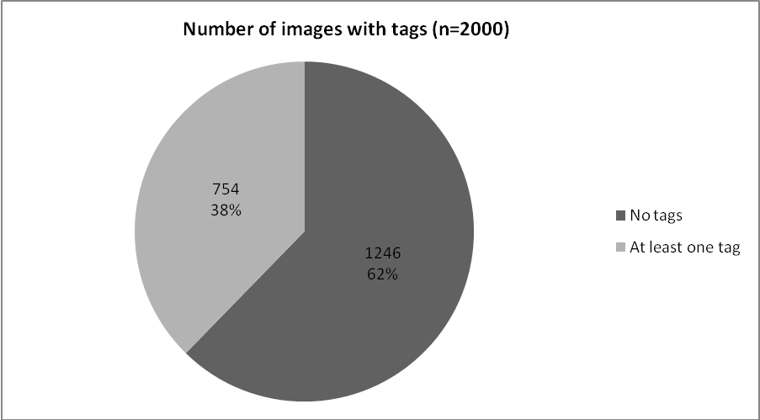
Figure 1. Number of images with tags

 | All tagged images  (n=754) | Images in sample set  (n=250)
Total number of tags | 3941 | 1082
Mean number of tags per image | 5.2 | 4.5
Median number of tags per image | 4 | 3
Modal number of tags per image | 1 | 1
Maximum number of tags per image | 49 | 28
Table 3. Statistical analysis of tagged images

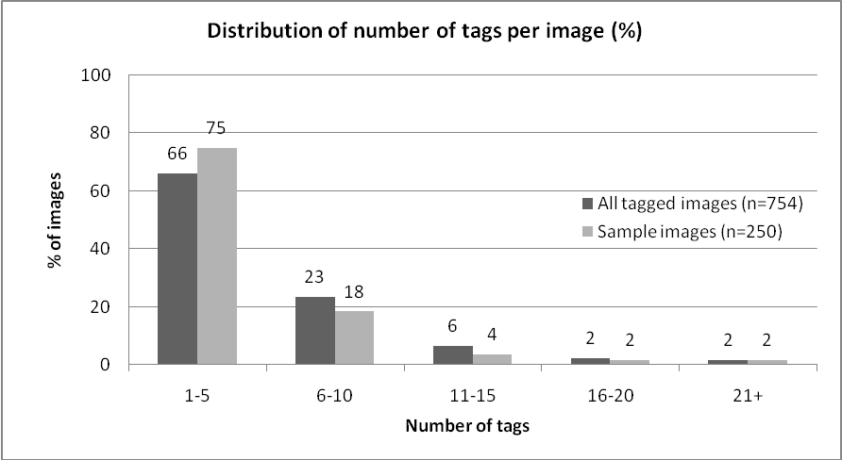
Figure 2. Distribution of number of tags per image
Of these 754 images, 199 had tags that included foreign words (26%), leaving a total of 553 images with tags in English. From these, a random selection of 250 images was chosen to create a sample set for the tag categorisation process. Analysis of this set showed a similar tag distribution to the larger dataset, although the largest number of tags for a single image was 28 which marginally lowered both the mean and the median averages (see Table 3).

Categorisation of image tags
The tags were then categorised using Shatford’s matrix. A total of 78% (839 tags) were able to be categorised, leaving 22% (243 tags) which could not be assigned to any of the categories. As can be seen from Figure 3, generic tags were used most frequently, accounting for more than half of all tags (59%), with a third (33%) of tags related to specific categories, and only 8% of tags assigned to abstract categories. Looking at the results in more detail, Figure 4 shows that most tags were categorised as G1 Generic Who (38%, 321 tags), with 19% (158 tags) categorised as S3 Specific Where, and 12% (97 tags each as S1 Specific Who and G2 Generic What. A list of the facets in order of ranking is given in Table 4.
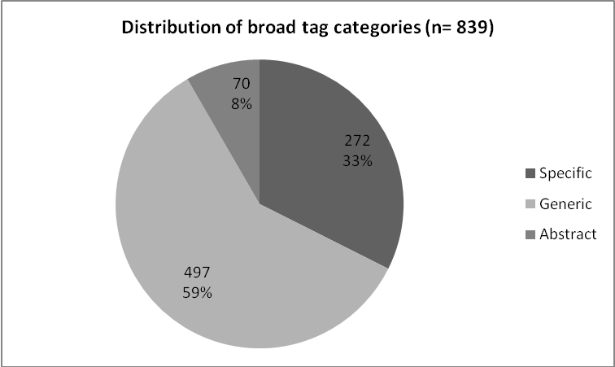
Figure 3. Distribution of broad tag categories
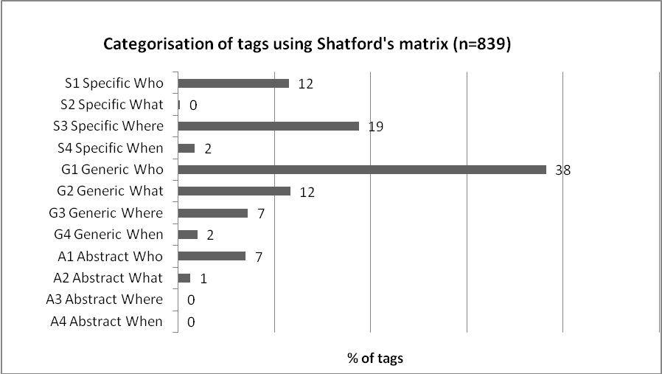
Figure 4. Categorisation of tags using Shatford's matrix

Rank | Facet | % of tags | No. of tags
1 | G1 Generic Who | 38.1 | 321
2 | S3 Specific Where | 18.8 | 158
3 | S1 Specific Who | 11.6 | 97
4 | G2 Generic What | 11.6 | 97
5 | G3 Generic Where | 7.3 | 61
6 | A1 Abstract Who | 7.3 | 60
7 | G4 Generic When | 2.0 | 17
8 | S4 Specific When | 1.8 | 15
9 | A2 Abstract What | 1.3 | 11
10 | S2 Specific What | 0.2 | 2
11 | A3 Abstract Where | 0 | 0
12 | A4 Abstract When | 0 | 0
Table 4. Ranking of tag facets

To ensure that the images with large numbers of tags did not dominate the results, those images with 15 or more tags (12 images) were removed from the statistical analysis to see if this affected the results. However, it was found that the percentages in each category remained broadly the same as before. A further analysis of the data was made to see if the behaviour of users who assigned a larger than average number of tags was different to those who assigned a smaller number. The results, shown in Figure 5, show that users who assign five or more tags tend to use marginally more generic tags than users who assign four or less tags, but in general, the pattern remain the same.

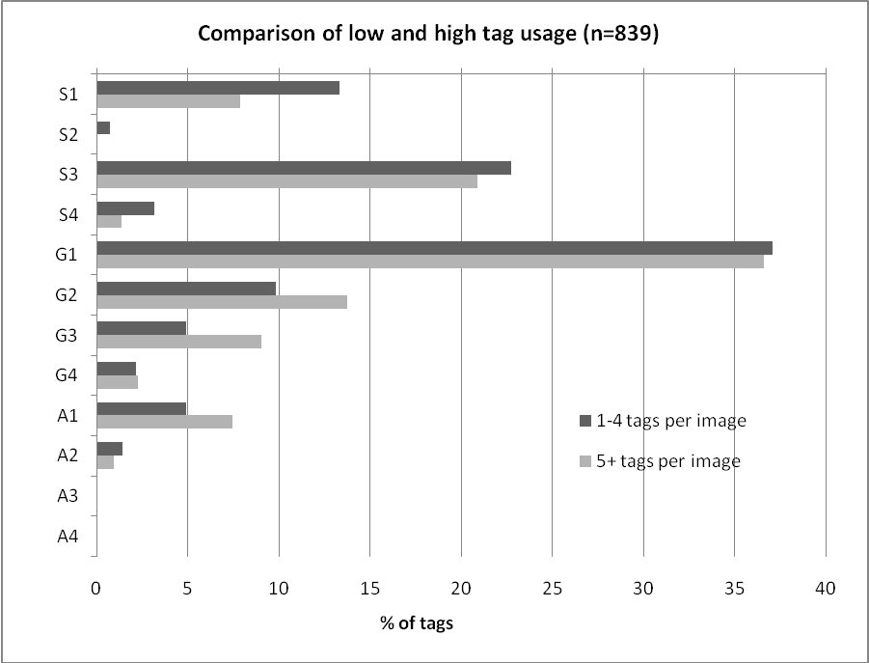
Figure 5. Comparison of low and high tag usage

The tags that could not be categorised using Shatford’s matrix were analysed to identify any common themes and the results are presented in Figure 6. The majority of the tags (170 out of 234 tags) relate to the production of the image and its eventual use (the first five categories on the graph in Figure 6), accounting for 15% of the total number of tags in the sample set. See Appendix D for examples of the tags that were coded in the ‘Other’ categories.
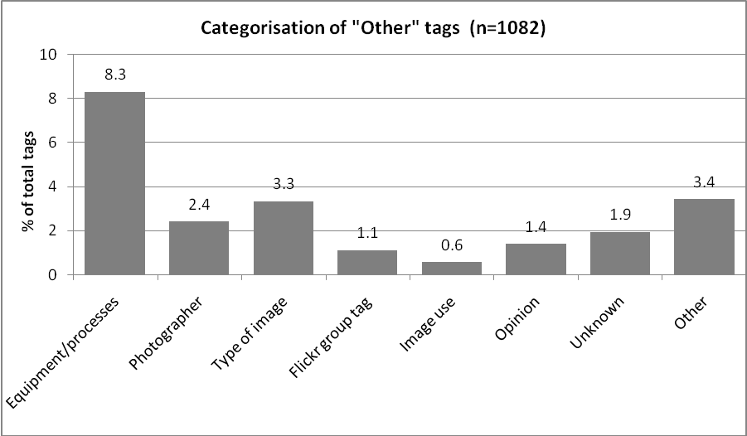
Figure 6. Categorisation of ‘Other’ tags

Comparison with categorisation of image queries
The results of the categorisation process were compared with the results of previous research into image queries. Figure 7 shows that while the majority of queries are for specific categories (62%), the majority of tags fall into generic categories (59%), with abstract categories accounting for very few queries or tags (3% for queries and 8% for tags).

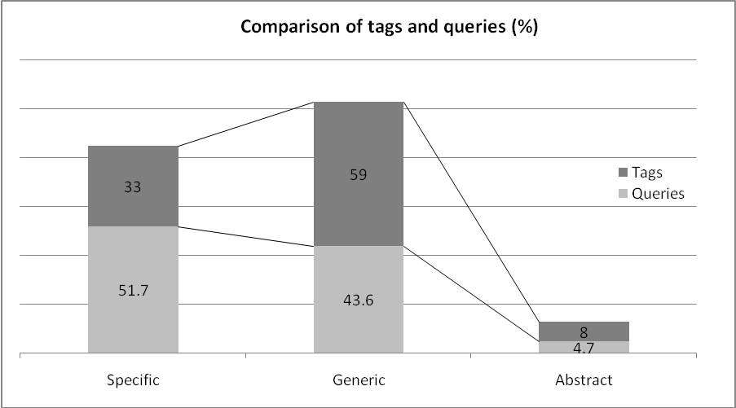
Figure 7. Comparison of tags and queries by broad category
A more detailed comparison of queries and tags using Shatford’s matrix is given in Figure 8. From this, it can be seen that there are significant differences in some of the categories. For example, there are more queries in the S1 Specific Who and S4 Specific Where categories, but significantly more tags in the G1 Generic Who category.
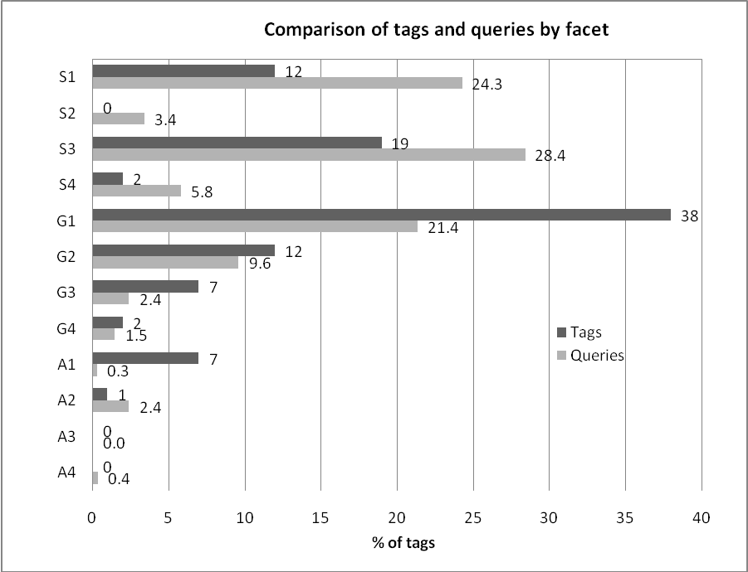
Figure 8. Comparison of tags and queries by individual facet
In order to see whether any of the individual query studies were overly skewing the figures for the user queries, the results of the individual studies were compared (see Figure 9). From this comparison, it appears that the results of the Van Hooland study are quite different to the other two studies, particularly in the case of the S3 Specific Where and G1 Generic Who categories. Therefore, the Van Hooland study was removed, and the remaining query studies were compared with the results of the tag analysis: the results are shown in Figure 10. While the difference between the incidence of tags and queries for S3 Specific Where category has been reduced, there are still significant differences between the results in the S1 Specific Who and G1 Generic Who categories.
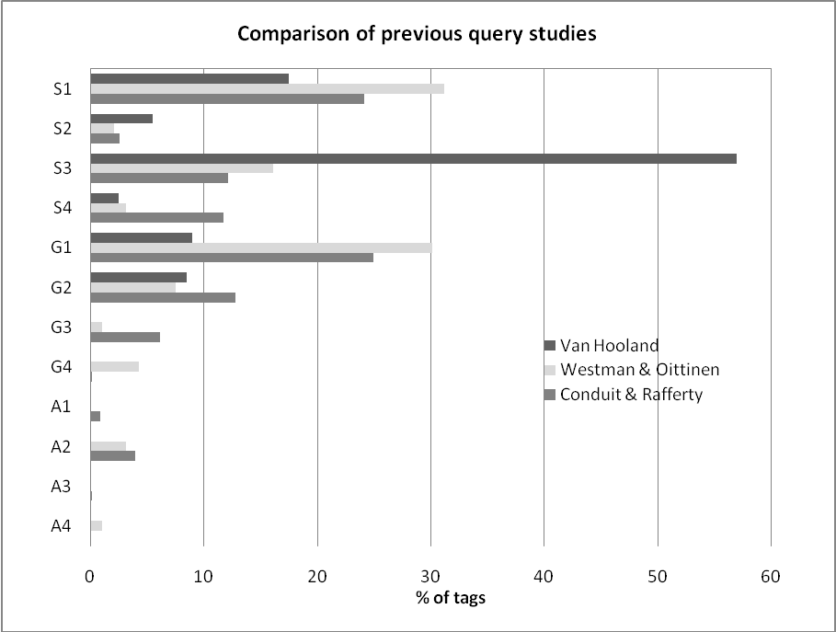
Figure 9. Comparison of previous query studies

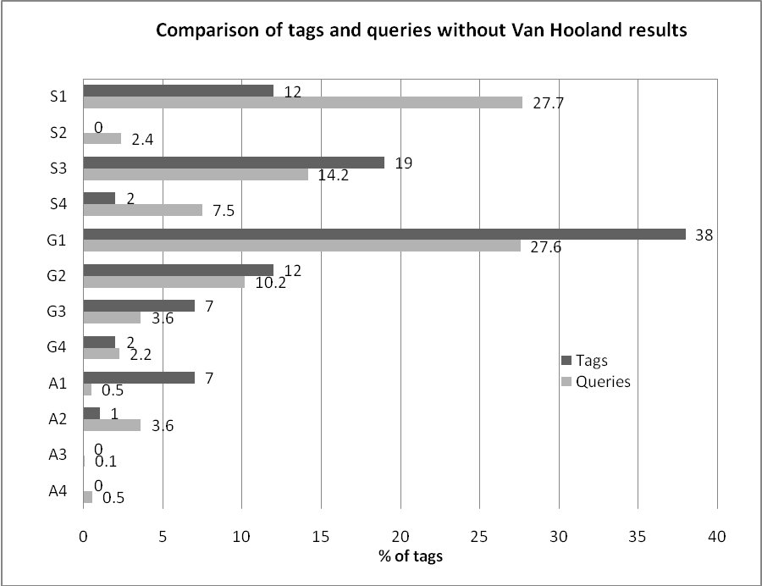
Figure 10. Comparison of tags and queries without Van Hooland results
A further analysis was made to amalgamate the specific, generic and abstract levels of the four facets of Who, What, Where and When to see if any patterns could be deduced (see Figure 11). This analysis shows that in the current study there is a strong similarity in the way that users tag images within these four facets when compared to previous research on image queries. The Who facet (people or objects) is the most commonly occurring in both tags and queries, accounting for 57% of tags and 56% of queries. The next most common facet is Where, but there is less correlation between tags and queries, with 26% of tags relating to this facet but only 18% of queries. The What facet is represented in similar quantities in both tags and queries (13% and 16% respectively), with the final facet, When, accounting for the smallest number of occurrences: 4% of tags and 10% of queries.
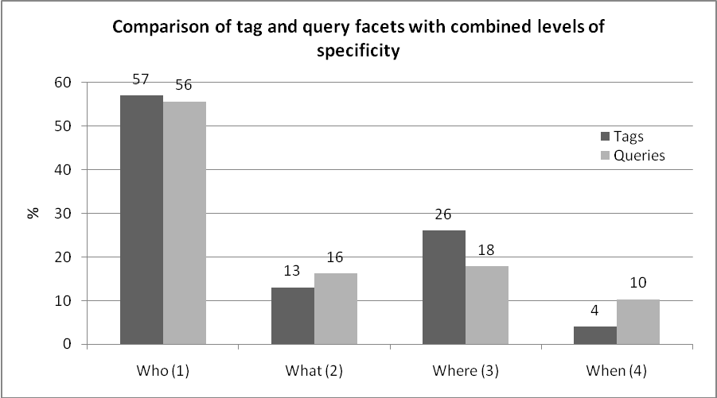
Figure 11. Comparison of tag and query facets with combined levels of specificity

From this analysis, it appears that while users describe and search for images using similar facets, it is the level of specificity or abstraction that differs between image tags and image queries.

Discussion
The results confirm earlier research into image tagging (Hollink et al, 2004; Tamburrino, Schonmann et al, 2008), which showed that generic terms are more commonly used in image descriptions than specific terms, particularly by novice users such as the current user group (Beaudoin, 2008). The study also confirms that abstract terms are rarely used when describing images (Balasubramanian et al, 2004; Beaudoin, 2007; Hollink et al, 2004; Jorgensen, 1996). The most commonly occurring image facets identified in the tags in this study were people and objects (Who facet), followed by locations (Where facet). This is in line with findings in previous studies into the ways in which users describe images, although there are disagreements about which of these two facets has the highest incidence: Bischoff et al (2008), Overell et al (2009), and Jorgensen (1998) suggest that people and objects appear most often in image descriptions, but Beaudoin (2007), Marshall (2009), Schmitz (2006), and Sigurbjornsson and van Zwol (2008) found that location attributes were more prevalent.
When comparing image tags with query terms, the results of this research show that there are clear similarities in the facets that are present in tags and in query terms, with terms relating to people and objects, or locations being the most commonly used in both cases. This would suggest that the image attributes included by users in their image tags are the same as those that are of interest to users in their searches. On the other hand, the study noted differences in the specificity of terms used, with generic terms being more widely used in image tags and specific terms appearing more often in search queries, which could point to a limitation of image tags in that they may not contain the particular terms that appear in user queries.
While other research has also found similarities between the way that users describe and search for images, (Bischoff et al, 2008; Jorgensen, 1996), some studies have concluded that this is not the case and that users search for and describe images in different ways (Goodrum, 2005; Trant, 2009). Enser (2008), in acknowledging the differences between the results from various studies, suggests that they may be explained by the different domains in which the studies were carried out. For example, Marshall’s (2009) study concentrated on images of one particular location which may explain the high incidence of location tags.
The choice of the domain in this study is one of the factors that should be taken into account when considering the results in a wider context. Firstly, the results of this study suggest a low level of interest in tagging on Flickr, with only 38% of images having tags. This is lower than the levels of tagging found in other studies on Flickr where over 60% of images were tagged (Marshall, 2009; Winget, 2006). One possible reason for the higher incidence of tagging in Winget’s study is that the images were chosen from Flickr’s ‘interestingness’ photostream: one of the criteria for inclusion in this photostream is that an image should have a large number of tags. Studies into tagging in the cultural heritage collections also report higher levels of tagging than the current study, with researchers noting the public’s enthusiasm for tagging museum objects (Chun et al, 2006; Clayton et al, 2008; Trant, 2008b). The tagging behaviour of the Flickr users in this study may therefore not be representative of all taggers. The reasons for the low incidence of tagging in this study are unclear, although it has been suggested that tagging is not important for Flickr users as most browse the collection rather than carrying out a direct search (Cox et al, 2008). Another factor that may have influenced the results is the limited sample size in this study, and a larger data set may have given different results. However, several other studies have noted that there appears to be a “significant consensus” (Marshall, 2009: 241) between users when they assign terms (Balasubramanian et al, 2004; Von Ahn and Dabbish, 2004) and so the results from this study may be more representative of a wider range of Flickr users than the sample size would suggest.
A second domain-related factor requiring discussion is the level of subject knowledge of the users represented in the current study. It has been noted in previous studies that levels of subject knowledge can affect the terms used in indexing and searching, with experts tending to use more specific terms than novice users (Beaudoin, 2008; Golder and Huberman, 2006). In this study, tags and queries were collected from different domains as there was no existing research on image facets in Flickr queries and it was beyond the scope of this small scale study to collect query data. However, a broad range of previous query studies were included to lessen the effect of domain on the results. For example, the broad scope of Conduit and Rafferty’s study (2007) included some very subject-specific domains, such as Chen’s 2001 study of art history students, as well as studies involving more general purpose picture archives, such as Enser and McGregor’s study of queries to the Hulton Deutsch Collection. Armitage and Enser’s 1997 research concludes that
“there are observable similarities in image query formulation across a range of different libraries and that, despite variations in library rationale, stock and user profile, a general characterisation of queries can be formulated” (294).
As far as tags are concerned, while Flickr is a non-subject-specific image web site, it should be noted that users generally tag their own images (Marlow et al, 2006) and could therefore be considered ‘experts’ in this respect. It is possible, therefore, that differences in domain may not have affected the results to any great degree, but further research into tags and queries from the same domain would provide more conclusive results.
Some aspects of tagging behaviour may have also affected the results, particularly the inclusion of synonyms, such as ‘cat’ and ‘cats’ or ‘woods’ and ‘forest’, in a tag set. This was particularly problematic in the S3 Specific Where category where several versions of a place name may appear in one tag set, for example, ‘lauderdale, fort lauderdale, ft lauderdale, fll’. While the use of synonyms increases the likelihood of a match between search terms and image tags, it does affect the percentage of tags in each category in this study. A further investigation would be needed to see the full effect of this practice on the results. There are many other aspects of tagging behaviour that could also affect the value of tags for retrieval, such as homonyms, misspelling, and the use of foreign words, but as this research is concerned only with the facets represented by the tags, the ‘correctness’ of each tag has been ignored in this study.
The categorisation of the image tags and the use of Shatford’s matrix also require some discussion. Time and resource limitations meant that the categorisation process was carried out by a single researcher and was therefore prone to a high degree of subjectivity. The researcher tried to compensate for this by reviewing the whole tag set more than once to ensure consistency in the categories assigned, but if the process had been carried out by more than one researcher, a higher degree of objectivity might have been achieved in the results. However, other research has noted a relatively high level of agreement between reviewers when categorising queries (Bischoff et al, 2008; Chen, 2001; Hollink et al, 2004), indicating that the results may not change significantly if more than one reviewer had been involved.
As has been noted in other studies, difficulties were encountered in applying Shatford’s categories to the tag set in this study (Armitage and Enser, 1997; Beaudoin, 2008; Bischoff et al, 2008; Hollink et al, 2004). One area of difficulty was in determining the difference between specific and generic facets, particularly relating to location (Where). The researcher’s decision to assign any named location to S1 Specific Where meant that tags naming countries, for example, were labelled as Specific. However, as noted by Armitage and Enser (1997), and Marshall (2009), the use of such broad geographical tags has limited value in general retrieval as they could potentially return too many results. Reclassifying these tags as Generic would, however, have further widened the gap in specificity between image tags and query terms in this study. Problems were also encountered in categorising tags in the Abstract facets, as there was limited information in the literature to guide the researcher in determining the correct code. However, the low incidence of abstract tags meant that these difficulties did not greatly affect the final results. There were also issues in the applicability of Shatford’s facets to the full range of tags present in the dataset: 22% of tags fell outside Shatford’s 12 categories. The majority (15%) of these tags were related to the photographer, the camera, or the intended use of the image. Angus et al (2008) suggest that tags such as these may only be useful for the individual uploading the photograph and are therefore not valuable in a general retrieval situation, so this limitation of Shatford’s matrix may not be significant when considering the usefulness of tags for retrieval purposes.
Another observation about the use of Shatford’s matrix concerns the broad nature of some of the facets. It was apparent that the majority (57%) of tags fell into the Who facets, but the structure of the matrix does not allow more detailed information to be discovered about the percentage of people, animals or objects that are included in this figure. As most studies support the view that people and objects form a large percentage of the tags and queries related to images (Bischoff et al, 2008; Jorgensen, 1998; Overell et al, 2009; Sigurbjornsson and van Zwol, 2008), a categorisation framework that allows for a more detailed look at these areas would give more useful information about the needs and behaviours of users.
Finally, an important point to note is that none of the query studies included in this research were carried out in an online environment as little such research exists (Enser, 2008; Jansen, 2008). It is therefore not clear whether the query studies used here reflect the way that users actually search online. However, Cunningham and Masoodian’s 2006 study into general online image searching identified that a large proportion (70%) of image searches were for specific requests, so there may be some similarities between on- and off-line search strategies. This is certainly an area that would benefit from further research to determine the nature of user behaviour and image needs when searching for images online.
This study has concentrated on the use of image tags. Another avenue of research would be to investigate the effectiveness of other user-supplied descriptions, such as image titles or captions, to see how they would compare with image query terms. If, as has been suggested, they contain more specific descriptions than image tags, (Enser et al, 2007; Van Hooland, 2006), they could provide more specific indexing terms which would in turn lead to greater retrieval success. While the results of this research suggest that there are some limitations in using tags for searching because of their generic nature, it has been suggested that measuring the success of tags in terms of how well they perform in direct searches is to ignore their usefulness in browsing (Mathes, 2004). Browsing has been discussed in the literature as an important aspect of image retrieval due to the difficulties of successfully capturing the semantic content of an image in indexing terms (Enser, 2008; Layne, 1994). If the majority of image tags are generic, as this research has shown, their value may come from their ability to group together a range of relevant images from which a user can choose, rather than their ability to match with individual terms in a search query. Therefore, an area for future development could be in developing information systems that include more effective browsing mechanisms to make use of the information present in image tags.
This research has investigated one aspect of image tags, which has been to consider if there are similarities in the image facets that appear in user tags and user search queries. The results have shown that similar image facets are present, but that there are differences in the level of specificity used. This limitation, together with the other problems caused by the uncontrolled nature of tags, supports the view that user tagging alone is not the solution to the problem of providing intellectual access to the millions of images available online. However, this does not mean that user tags are without value, and this study has shown that the tags provided by users do contain the same image attributes that appear in search queries. The challenge now is to find ways of incorporating tagging with other indexing methods to make better use of the potential that user tagging can offer in indexing images online.

Conclusion
The aim of this research was to find out the value of tags for image retrieval by investigating whether the terms used in image tags are similar to the terms used in search queries. Rather than comparing individual terms, Shatford’s matrix of image facets was used to compare the image attributes represented by the tags from images on Flickr with the attributes that had previously been identified in research into image queries.
The results of the research indicate that there are broad similarities between the image attributes represented by image tags and those appearing in image queries, with people and objects being the most common facet, followed by location. This would suggest that the aspects of images that users include in their image tags are the same as those that are of interest to users in their searches. However, the results also show that there are differences in the level of specificity of the terms used, with image tags containing a higher proportion of generic terms and image queries containing a larger number of specific terms. This is a potential problem for retrieval systems trying to create a match between image tags and query terms.
This research points to a need to develop retrieval systems that will bridge this gap between specific queries and generic tags in order to harness the collective power of user tagging and provide for more effective image retrieval. The study has suggested several areas for further research that may help to develop such systems, including the need for a greater understanding of search behaviour in an online environment, an investigation into the use of user titles or captions as a source of more specific indexing terms, and the development of methods to facilitate the use of browsing in image retrieval. It also supports the general consensus that user tagging needs to be incorporated with other indexing methods in order to overcome any limitations that are inherent in its uncontrolled nature. The growth of online image tagging applications over the last few years and the enthusiasm for tagging that has been noted in many studies suggest that, in some environments, end-users enjoy tagging images and can provide tags of a high quality. This study has confirmed that, at a fundamental level, users tag images in a similar way to how they search for images, supporting the notion that user tagging could help to provide a solution to the problems of scalability of traditional indexing techniques and so provide intellectual access to the millions of images that exist online.

Bibliography
Ames, M. and Naaman, M., (2007), “Why we tag: motivations for annotation in mobile and online media”, Paper presented at CHI 2007, San Jose, California, available at http://portal.acm.org/citation.cfm?id=1240772 (accessed 1 April, 2009)
Angus, E., et al., (2008), “General patterns of tag usage among university groups in Flickr”, Online Information Review, 32(1), pp. 89-101.
Armitage, L. and Enser, P., (1997), “Analysis of user need in image archives”, Journal of Information Science, 23(4), pp. 287-299.
Balasubramanian, at al., (2004), “Analysis of user image descriptions and automatic image indexing vocabularies: an exploratory study”, available at: http://web.syr.edu/~diekemar/ruimte/Papers/cormedia2004_balasub.pdf (accessed 3 April, 2009)
Beaudoin, J., (2007), “Flickr image tagging: patterns made visible”, Bulletin of the American Society for Information Science and Technology, (Oct/Nov), pp.26-29.
Beaudoin, J., (2008), “A preliminary investigation of image indexing: the influence of domain knowledge, indexer experience and image characteristics”, paper presented at the 19th Workshop of the American Society for Information Science and Technology Special Interest Group in Classification Research, Columbus, Ohio, available at: http://dlist.sir.arizona.edu/2462/ (accessed 29 August, 2009)
Bischoff, K., et al., (2008), “Can all tags be used for search?”, in Proceedings of the 17th ACM Conference on Information and Knowledge Management, New York, NY: ACM, pp.193-202.
Chen, H., (2001), “An analysis of image queries in the field of art history”, Journal of the American Society for Information Science and Technology, 52(3), pp.260-273.
Chen, H., and Rasmussen, E., (1999), “Intellectual access to images - image database systems”, Library Trends, 48(2), pp.291-302.
Choi, Y., and Rasmussen, E., (2003), “Searching for images: the analysis of users' queries for image retrieval in American History”, Journal of the American Society for Information Science and Technology, 54(6), pp. 498-511.
Chu, H., (2003), Information Representation and Retrieval in the Digital Age, Information Today, Medford.
Chun, S., et al., (2006). “Steve.museum: an ongoing experiment in social tagging, folksonomy, and museums”, paper presented at Museums and the Web, Albuquerque, available at: http://www.archimuse.com/mw2006/papers/wyman/wyman.html (accessed 2 April, 2009)
Clayton, S., at al., (2008), “User tagging of online cultural heritage items”, available from National Library of Australia: http://www.nla.gov.au/nla/staffpaper/2008/documents/user-tagging.pdf (accessed 2 April, 2009)
Conduit, N., and Rafferty, P., (2007), “Constructing an image indexing template for The Children’s Society: users’ queries and archivists’ practice”, Journal of Documentation, 63(6), pp. 898-919.
Cox, A., (2008), “Flickr: a case study of Web 2.0”, Aslib Proceedings: New Information Perspectives, 60(5), pp. 493-516.
Cox, A. et al., (2008), “Flickr: a first look at user behaviour in the context of photography as serious leisure”, Information Research, 13(1), available at: http://InformationR.net/ir/13-1/paper336.html (accessed 26 March, 2009)
Cunningham, S., and Masoodian, M., (2006), “Looking for a picture: an analysis of everyday image information searching”, in Proceedings of the 6th ACM/IEEE-CS Joint Conference on Digital Libraries, ACM: New York, NY, pp. 198-199.
Cunningham, S., et al., (2004), “How people describe their image information needs: A grounded theory analysis of visual arts queries”, in Proceedings of the 4th ACM/IEEE-CS Joint Conference on Digital Libraries, ACM: New York, NY, pp. 47-48.
Ding, Y., and Jacob, E., (2009). “Profiling social networks”, D-Lib Magazine, 15(3/4), available at: http://www.dlib.org/dlib/march09/ding/03ding.html, (accessed 3 May, 2009)
Enser, P., (2008), “The evolution of visual information retrieval”, Journal of Information Science, 34(4), pp. 531–546.
Enser, P., et al., (2007), “Facing the reality of semantic image retrieval”, Journal of Documentation, 63(4), pp. 465-481.
Fidel, R., (1997), “The image retrieval task: implications for the design and evaluation of image databases”, New Review of Hypermedia and Multimedia, 3(1), pp.181-199.
Golder, S., and Huberman, B., (2006), “Usage patterns of collaborative tagging systems”, Journal of Information Science, 32(2), pp.198-208.
Goodrum, A., (2005), “I can't tell you what I want, but I'll know it when I see it”, Reference & User Services Quarterly, 45(1), pp. 46-53.
Goodrum, A., and Spink, A., (2001), “Image searching on the Excite web search engine”, Information Processing & Management, 37(2), pp. 292-311.
Grefenstette, G., (2008), “Comparing the language used in Flickr, general web pages, Yahoo Images, and Wikipedia”, paper presented at the International Conference on Language Resources and Evaluation, available at: http://www.lrec-conf.org/proceedings/lrec2008/workshops/W3_Proceedings.pdf#page=10. (accessed 2 April, 2009)
Greisdorf, H., and O'Connor, B., (2002), “Modelling what users see when they look at images: a cognitive viewpoint”, Journal of Documentation, 58(1), pp. 6-29.
Guy, M., and Tonkin, E., (2006), “Folksonomies: tidying up tags?”, D-Lib Magazine, 12 (1), available at : http://www.dlib.org/dlib/january06/guy/01guy.html, (accessed 29 February, 2009)
Hammond, T., at al., (2005), “Social bookmarking tools (I): a general review”, D-Lib Magazine, 11(4), available at: http://www.dlib.org/dlib/april05/hammond/04hammond.html, (accessed 18 April, 2009)
Hastings, S., (1995), “Index access points in a study of intellectual access to digitized art images”, in D. Bearman (ed.), Multimedia Computing and Museums: Selected Papers from the Third International Conference on Hypermedia and Interactivity in Museums (ICHIM '95 / MCN '95), Vol. 1, Archives and Museums Informatics: Toronto, pp. 299-309.
Heckner, M., et al., (2008), “Tagging tagging. Analysing user keywords in scientific bibliography management systems”, Journal of Digital Information, 9(27), available at: http://journals.tdl.org/jodi/article/view/246/208, (accessed 21 April, 2009)
Hollink, L., et al., (2004), “Classification of user image descriptions”, International Journal of Human-Computer Studies, 61(5), pp. 601-626.
Hunter, J., et al., (2008), “HarvANA - harvesting community tags to enrich collection metadata”, in Proceedings of the 8th ACM/IEEE-CS joint conference on Digital libraries, ACM: New York, NY, pp. 147-156.
Jaimes, R., and Chang, S., (2000), “A conceptual framework for indexing visual information at multiple levels”, paper presented at IS&T/SPIE Internet Imaging, San Jose, CA, available at: https://eprints.kfupm.edu.sa/17006/, (accessed 20 April, 2009)
Jansen, B., (2008), “Searching for digital images on the web”, Journal of Documentation, 64(1), pp. 81-101.
Jansen, B., at al., (2000), “Linguistic aspects of web queries”, paper presented at the annual meeting of the American Society of Information Science, Chicago, IL., available at: http://jimjansen.tripod.com/academic/pubs/asis2000/asis2000.html, (accessed 31 March, 2009)
Jorgensen, C., (1996), “Indexing images: testing an image description template”, paper presented at the ASIS Annual Conference, available at: http://www.asis.org/annual-96/ElectronicProceedings/jorgensen.html, (accessed 2 April, 2009)
Jorgensen, C., (1998), “Attributes of images in describing tasks”, Information Processing and Management, 34(2/3), pp. 161-174.
Jorgensen, C., et al., (2001), “A conceptual framework and empirical research for classifying visual descriptors”, Journal of the American Society for Information Science and Technology, 52(11), pp. 938-947.
Jorgensen, C., (2007), “Image access, the semantic gap, and social tagging as a paradigm shift”, available at: http://dlist.sir.arizona.edu/2064/01/Jorgensen_Update_SIG-CR_2007.doc, (accessed 1 April, 2009)
Kato, M., et al., (2008), “Can social tagging improve web image search?”, in Bailey, J. et al., (eds.), Proceedings of the 9th International Conference on Web Information Systems Engineering, Springer-Verlag: Berlin, pp. 235-249.
Kipp, M., and Campbell, D., (2007), “Patterns and inconsistencies in collaborative tagging systems: an examination of tagging practices”, Proceedings of the American Society for Information Science and Technology, 43(1), pp. 1-18.
Layne, S., (1994), “Some issues in the indexing of images”, Journal of the American Society for Information Science, 45(8), pp. 583-588.
Lee, C., et al., (2009), “Tagging, sharing and the influence of personal experience”, Journal of Digital Information, 10(1), available at http://journals.tdl.org/jodi/article/view/275, (accessed 25 February, 2009)
Lerman, K., et Jones, L., (2007), “Social browsing on Flickr”, paper presented at the International Conference on Weblogs and Social Media, Boulder, CO, available at: . http://www.icwsm.org/papers/3--Lerman-Jones.pdf, (accessed 20 April, 2009)
Macgregor, G., and McCulloch, E., (2006), “Collaborative tagging as a knowledge organisation and resource discovery tool”, Library Review, 55(5), pp. 291-300.
Marlow, C., et al., (2006), “Position paper, tagging, taxonomy, Flickr, article, toread”, paper presented in the Collaborative Web Tagging Workshop at the 15th International World Wide Web Conference, Edinburgh, available at: http://www.semanticmetadata.net/hosted/taggingws-www2006-files/29.pdf, (accessed 2 April, 2009)
Marshall, C., (2009), “No bull, no spin: a comparison of tags with other forms of user metadata”, in Proceedings of the 9th ACM/IEEE-CS Joint Conference on Digital Libraries, ACM: New York, NY, pp. 241-250.
Mathes, A., (2004), “Folksonomies - cooperative classification and communication through shared metadata”, available at: http://www.adammathes.com/academic/computer-mediated-communication/folksonomies.html, (accessed 21 February, 2009)
Matusiak, K., (2006), “Towards user-centered indexing in digital image collections”, OCLC Systems & Services, 22(4), pp. 283-298.
Merholz, P., (2004), “Metadata for the masses”, available at: http://www.adaptivepath.com/ideas/essays/archives/000361.php, (accessed 26 May, 2009)
Morrison, P., (2007), “Why are they tagging, and why do we want them to?”, Bulletin of the American Society for Information Science and Technology, 34(1), available at: http://www.asis.org/Bulletin/Oct-07/morrison.html, (accessed 15 February, 2009)
Morrison, P., (2008), “Tagging and searching: search retrieval effectiveness of folksonomies on the World Wide Web”, Information Processing & Management, 44(4), pp. 1562-1579.
Munk, T., and Mork, K., (2007), “Folksonomy, the power law & the significance of the least effort”, Knowledge Organization, 34(1), pp.16-33.
Naaman, M, et al., (2004), “Context data in geo-referenced digital photo collections”, in Proceedings of the 12th Annual ACM International Conference on Multimedia, ACM: New York, NY, pp. 196-203.
Nov, O., Naaman, M., and Ye, C., (2008), “What drives content tagging: the case of photos on Flickr” in Proceeding of the 26th Annual SIGCHI Conference on Human factors in Computing Systems, ACM: New York, NY, pp. 1097-1100.
O'Reilly, T., (2005), “What is Web 2.0: design patterns and business models for the next generation of software”, available at: http://www.oreillynet.com/lpt/a/6228?page=3#designpatterns, (accessed 26 May, 2009)
Overell, S., et al., (2009), “Classifying tags using open content resources”, in Proceedings of the Second ACM International Conference on Web Search and Data Mining, ACM: New York, NY, pp. 64-73.
Panofsky, E., (1977 [1955]), Meaning in the Visual Arts. Peregrine: London.
Peters, I., and Stock, W., (2007), “Folksonomy and information retrieval”, in Proceedings of the American Society for Information Science and Technology, 44(1), pp.1-28.
Peterson, E., (2006), “Beneath the metadata: some philosophical problems with folksonomy”, D-Lib Magazine, 12(11), available at: http://www.dlib.org/dlib/november06/peterson/11peterson.html, (accessed 17 February, 2009)
Pu, H., (2003), “An analysis of web image queries for search”, in Proceedings of the American Society for Information Science and Technology, 40(1), pp. 340-348.
Pu, H., (2008), “An analysis of failed queries for web image retrieval”, Journal of Information Science, 34(3), pp. 275-289.
Rafferty, P., and Hidderley, R. (2005). Indexing Multimedia and Creative Works: The Problems of Meaning and Interpretation, Aldershot: Ashgate.
Rafferty, P., and Hidderley, R., (2007), “Flickr and democratic indexing: dialogic approaches to indexing”, Aslib Proceedings: New Information Perspectives, 59(4/5), pp. 397-410.
Rafferty, P., (2009), “Informative tagging of images: the importance of modality in interpretation”, paper presented at Congress ISKO-Spain, Valencia, available at: http://dialnet.unirioja.es/, (accessed 3 June, 2009)
Rasmussen, E., (1997), “Indexing Images”, Annual Review of Information Science and Technology, 32, pp. 169-196.
Razikin, K., Goh, et al., (2008), “Weighing the usefulness of social tags for content discovery”, in Buchanan, G., et al., (eds.), Proceedings of the 11th International Conference on Asian Digital Libraries: Universal and Ubiquitous Access to Information Berlin, Springer-Verlag, pp. 51-60.
Rorissa, A., (2008), “User-generated descriptions of individual images versus labels of groups of images: a comparison using basic level theory”, Information Processing & Management, 44(5), pp. 1741–1753.
Schmidt, S., and Stock, W., (2009), “Collective indexing of emotions in images. A study in emotional information retrieval”, Journal of the American Society for Information Science and Technology, 50(5), pp. 863-876.
Schmitz, P., (2006). “Inducing ontology from Flickr tags”, paper presented at the 15th International World Wide Web Conference, Edinburgh, available at: http://citeseerx.ist.psu.edu/viewdoc/download?doi=10.1.1.130.4081&rep =rep1&type=pdf , (accessed 1 April, 2009)
Shatford, S., (1986), “Analyzing the subject of a picture: a theoretical approach”, Cataloging and Classification Quarterly, 6(3), pp. 39-61.
Shirky, C., (2006), “Ontology is overrated: categories, links, and tags”, available at: http://www.shirky.com/writings/ontology_overrated.html, (accessed 19 February, 2009)
Sigurbjornsson, B., and van Zwol, R., (2008), “Flickr tag recommendation based on collective knowledge”, paper presented at the 17th International World Wide Web Conference, Bejing, available at: http://www2008.org/papers/pdf/p327-sigurbjornssonA.pdf, (accessible 1 April, 2009)
Smith, G., (2008), “Tagging: emerging trends”, Bulletin of the American Society for Information Science and Technology, 34(6), available at: http://www.asis.org/Bulletin/Aug-08/AugSep08_Smith.html, (accessed 15 February, 2009)
Specia, L., and Motta, E., (2007), “Integrating folksonomies with the semantic web”, in Franconi, E., (eds.), Proceedings of the 4th European Semantic Web Conference. The Semantic Web: Research and Applications, Springer-Verlag: Berlin, pp.624-639.
Spiteri, L., (2007), “Structure and form of folksonomy tags: the road to the public library catalogue”, Webology, 4(2), available at: http://www.webology.ir/2007/v4n2/a41.html, (accessed 19 April, 2009)
Tamburrino, D., et al., (2008), “The flux: creating a large annotated image database”, paper presented at IS&T/SPIE Electronic Imaging: Image Quality and System Performance V, San Jose, CA, available at: http://infoscience.epfl.ch/record/114219, (accessed 27 March, 2009)
Trant, J., (2006), “Understanding searches of an on-line collections catalogue”, available at: http://conference.archimuse.com/system/files/trantSearchTermAnalysis061220a.pdf, (accessed 20 April, 2009)
Trant, J., (2008a), “Studying social tagging and folksonomy: a review and framework”, Journal of Digital Information, 10(1), available at: http://journals.tdl.org/jodi/article/view/269/278, (accessed 29 January, 2009)
Trant, J., (2008b), “Tagging, folksonomy and art museums: early experiments and ongoing research”, Journal of Digital Information, 10(1), available at: http://journals.tdl.org/jodi/issue/view/65, (accessed 29 January, 2009)
Trant, J., (2009), “Tagging, folksonomy and art museums: results of steve.museum’s research”, http://conference.archimuse.com/files/trantSteveResearchReport2008.pdf, (accessed 30 August, 2009)
Turner, J., (1995), “Comparing user-assigned indexing terms with indexer-assigned indexing terms for storage and retrieval of moving images”, paper presented at the 58th ASIS Annual Meeting, Chicago, available at: http://www.mapageweb.umontreal.ca/turner/english/texts/asis95.htm, (accessed 7 June, 2009)
Turner, J., (1997), “Indexing pictures: some considerations”, paper presented at the Annual Meeting of the Council on Botanical and Horticultural Libraries, Montreal, available at: http://www.mapageweb.umontreal.ca/turner/english/texts/cbhl97.htm, (accessed 7 June, 2009)
Van Hooland, S., (2006), “From spectator to annotator: possibilities offered by user-generated metadata for digital cultural heritage collections”, available at: http://eprints.rclis.org/7156/1/Usergeneratedmetadata.pdf, (accessed 27 March, 2009)
Vander Wall, T., (2007), “Folksonomy”, available at: http://www.vanderwal.net/folksonomy.html, (accessed 27 March, 2009)
von Ahn, L., and Dabbish, L, (2004), “Labeling images with a computer game”, paper presented at CHI 2004, Vienna, available at: http://www.cs.cmu.edu/~biglou/ESP.pdf, (accessed 2 June, 2009)
Voss, J. (2007)., “Tagging, folksonomy & co – renaissance of manual indexing?”, available at: http://arxiv.org/PS_cache/cs/pdf/0701/0701072v2.pdf, (accessed 1 April, 2009)
Weller, K, and Peters, I., (2008), “Seeding, weeding, fertilizing - different tag gardening activities for folksonomy maintenance and enrichment”, paper presented at I-Semantics, Graz, available at: http://i-know.tugraz.at/blog/wp-content/uploads/2008/11/13_seeding-weeding-fertilizing.pdf, (accessed 1 April, 2009)
Westman, S., and Oittinen, P., (2006), “Image retrieval by end-users and intermediaries in a journalistic work context”, in Proceedings of the 1st International Conference on Information Interaction in Context, ACM: New York, NY, pp. 102-110
Winget, M., (2006), “User-defined classification on the online photo sharing site Flickr… or, how I learned to stop worrying and love the million typing monkeys”, paper presented at the 17th Workshop of the American Society for Information Science and Technology Special Interest Group in Classification Research, available at: http://dlist.sir.arizona.edu/1854/01/winget.pdf, (accessed 2 April, 2009)
Zeng, D., and Li, H., (2008), “How useful are tags? - an empirical analysis of collaborative tagging for web pages”, in Proceedings of the IEEE ISI 2008 Paisi, Paccf, and SOCO International Workshops on Intelligence and Security Informatics, Springer-Verlag, Berlin, pp. 320-330.

Appendix A: Sample data
CleanTags | Date Uploaded | Photo ID | Title | UserID | WebURL
 | 20/06/2009 17:45 | 3643785153 | DSC08185 | 29928304@N03 | http://www.flickr.com/photos/29928304@N03/3643785153/
venice blackandwhite italy attesa | 20/06/2009 17:45 | 3644590646 | Lonely stone | 24488377@N08 | http://www.flickr.com/photos/24488377@N08/3644590646/
kenya masaimara cbswt | 20/06/2009 17:45 | 3643784541 | Masai Shehab | 24921083@N03 | http://www.flickr.com/photos/24921083@N03/3643784541/
 | 20/06/2009 17:45 | 3644590370 |  | 33986282@N06 | http://www.flickr.com/photos/33986282@N06/3644590370/
 | 20/06/2009 17:45 | 3643784471 | P6190035 | 8528355@N02 | http://www.flickr.com/photos/8528355@N02/3643784471/
raw | 20/06/2009 17:45 | 3643784503 | DSC_0356.NEF | 34929804@N08 | http://www.flickr.com/photos/34929804@N08/3643784503/
 | 20/06/2009 17:45 | 3643784243 | DSC_5898 | 39018732@N08 | http://www.flickr.com/photos/39018732@N08/3643784243/
wool for ravelry | 20/06/2009 17:45 | 3644590178 | Acrylic mohair | 24704271@N06 | http://www.flickr.com/photos/24704271@N06/3644590178/
 | 20/06/2009 17:44 | 3644590034 | mi waton | 39208073@N08 | http://www.flickr.com/photos/39208073@N08/3644590034/
 | 20/06/2009 17:44 | 3643784037 | TorresCoto10 | 96412596@N00 | http://www.flickr.com/photos/96412596@N00/3643784037/
 | 20/06/2009 17:44 | 3644589918 | IMG_2050.JPG | 30028113@N02 | http://www.flickr.com/photos/30028113@N02/3644589918/
 | 20/06/2009 17:44 | 3644589832 | IMG_3377 | 35042472@N08 | http://www.flickr.com/photos/35042472@N08/3644589832/
 | 20/06/2009 17:44 | 3643783619 | P4121178 | 13348685@N07 | http://www.flickr.com/photos/13348685@N07/3643783619/
geek pr | 20/06/2009 17:44 | 3643783637 | DIY is pain | 24352398@N08 | http://www.flickr.com/photos/24352398@N08/3643783637/
 | 20/06/2009 17:44 | 3644589540 | CANVAS CIRCLES1 | 38324399@N06 | http://www.flickr.com/photos/38324399@N06/3644589540/
sparshjun2009 | 20/06/2009 17:44 | 3643783313 | Sparsh, Jun 2009 009 | 26571293@N08 | http://www.flickr.com/photos/26571293@N08/3643783313/
city cloud mist tree silhouette fog capetown | 20/06/2009 17:44 | 3644589140 | City of Clouds | 32419885@N07 | http://www.flickr.com/photos/32419885@N07/3644589140/
Table 5. Sample data from Flickr download

Appendix B: Coding sheet
Shatford's categories as amended by Armitage & Enser |  |  | Shatford's examples | Armitage & Enser’s examples | Conduit & Rafferty’s examples
S1 | Specific Who | Individually named person, group, thing | Guaranty Building | Napoleon | specific person or thing; brand name
S2 | Specific What | Individually named event, action | 1980 Rose Bowl | Martyrdom of St. Lawrence | -
S3 | Specific Where | Individually named geographical location | New York; Mars | Ranelagh Gardens; the moon | country; city; institution/building; OS grid reference;
S4 | Specific When | linear time: date or period | June 1885; renaissance | 1799; 50s; 20th C; Victorian | historical period; date image created; date object in image created
G1 | Generic Who | kind of person or thing | skyscraper; actress; woman; oil painting | Suffragettes; writers | age range; gender; building material; colour; description of garment; self-portrait
G2 | Generic What | kind of event, action, condition | football game; death; decay; sleep; buying | dolphin leap; anaesthesia; entertained; ceremony | weather; lighting conditions;
G3 | Generic Where | kind of place: geographical, architectural | landscape, cityscape; interior; planet | game reserves; asylums; kitchen | indoors/ outdoors; urban/rural
G4 | Generic When | cyclical time: season, time of day | spring; night | night; dawn; equinox | day/night; season; time of day;
A1 | Abstract Who | mythical or fictitious being | academic art; modern architecture; muse | Janus' head; King Arthur | -
A2 | Abstract What | emotion or abstraction | commerce; sorrow | iconography; allegory; phobia; vanity | concepts; emotion; mood;
A3 | Abstract Where | place symbolised | paradise; Bethlehem; Mount Olympus; Jerusalem | - | -
A4 | Abstract When | emotion, abstraction symbolised by time | rarely used - Father Time; | - | -
Table 6. Coding sheet with coding examples from other research

Appendix C: Examples of coded tags
 | Specific | Generic | Abstract
Who? | S1: Alexandra  Nine Inch Nails  Harley Davidson | G1: woman  tree  toddler  building | A1: art  friends  family  Bulbasaur
What? | S2: Lemans2009 | G2: sewing  fundraiser  50th birthday  natural light | A2: business  travel  worry  scary
Where? | S3: Grand Canyon  Tel Aviv  Rum River  USA | G3: desert  garden  downtown  street | A3: (none)
When? | S4: 2009  June 16-19  Miocene | G4: summer  evening  dusk | A4: (none)
Table 7. Example of how tags in the current study were coded

Appendix D: Examples of ‘Other’ tags
Category | Sample tags
Equipment /processes | nikond200  macro  photoshop  mobile  shozu  iso3200
Photographer | takenbymark  joeynashoriginals  photoboet  pwillsportfolio  jasonphillipsdjason
Type of image | photo  bw  scannedfromprints  bestofcolourlowres  screenshot
Flickr group tag | beinspired  macrolicious  tweaktoday
Image use | secondlife  profile  webdesign  avatar
Opinion | cute  cool  fun  pretty  funky  surreal
Unknown | ami8avis  mhpc  frm  tanatan
Other | oneofmypics  daytrip  thingsthatareinspiringme  ilovebirdies anotheraliceinwonderlandshotnextweekithink
Table 8. Examples of tags that could not be categorised using Shatford's matrix

